**SEMESTER - 5**

**SEMESTER - 6**

**Acknowledgement**

We wish to express our gratitude to all the people involved in contributing this project of our website “BrokersBunch”. We take this opportunity to thank all who have helped us during the project work.

We would like to thank our college, St. Xavier’s College (Autonomous) for providing us the opportunity to work on project and gain experience from the same. We present our heartful thanks to the Vice Principal, **Dr. (Fr.) Johnson Mundupuzhakal** for sharing his generous time and knowledge with us which helped us to complete this project on time and present it to the examiners.

Genuine thanks to **Ms. Nithya Nadar**, our internal guide for her critical reviews of the project which help us to make this more presentable. Her gentle support and direction guided us in all aspects of the project. It has been pleasure to work with **“Hauper Technologies Pvt. Ltd.”**, and we appreciate the cooperation of the staff. Our special thanks to the external guide **Mr. Abhishek Shah** for his kind review of the project.

We would also like to thank all the faculty members of St. Xavier’s College (Autonomous) for their tangible, but always unspoken support for this project.

Last but not the least we would like to express our sincere thanks to our parents for their precious support and their motivation for completing this project.

**INDEX**

**INDEX**

**Sr. No. TOPIC PAGE NO.**

1. SCREEN LAYOUTS……………………………………………………….1
2. REPORT LAYOUTS……………………………………………………….29
3. CONCLUSION..……………………………………………………………52
4. BIBLIOGRAPHY…………………………………………………………..53

**Screen Layouts**

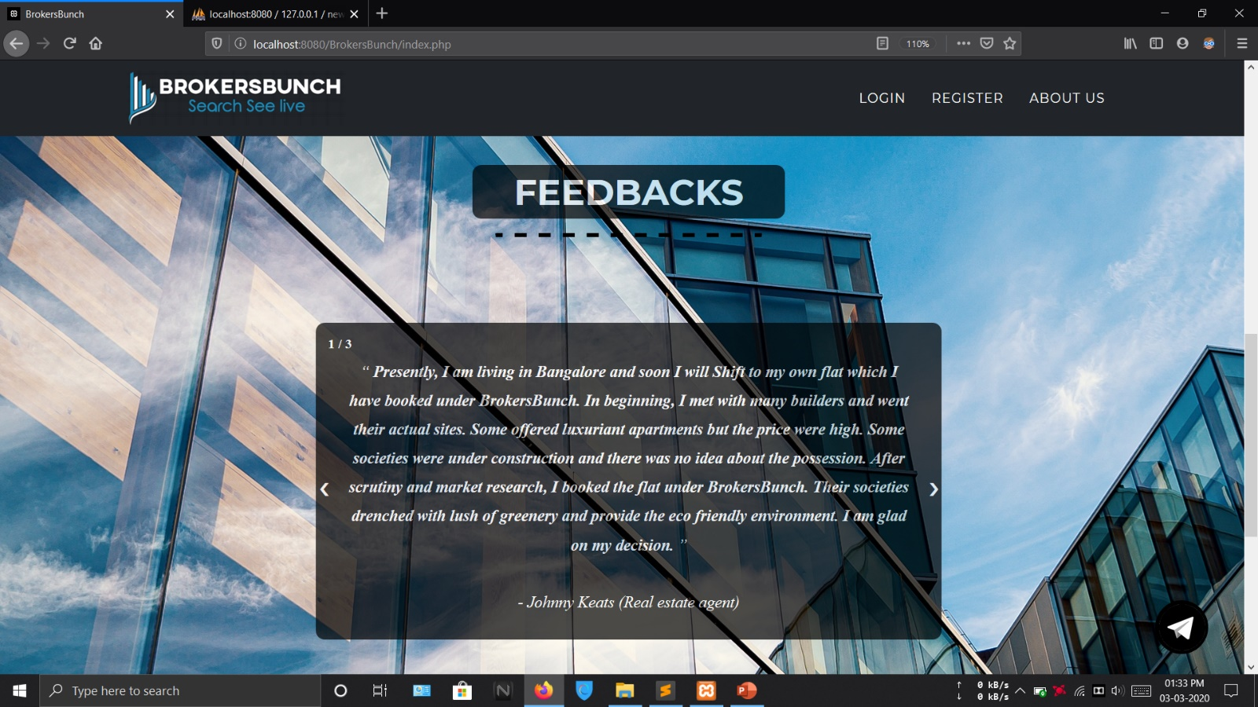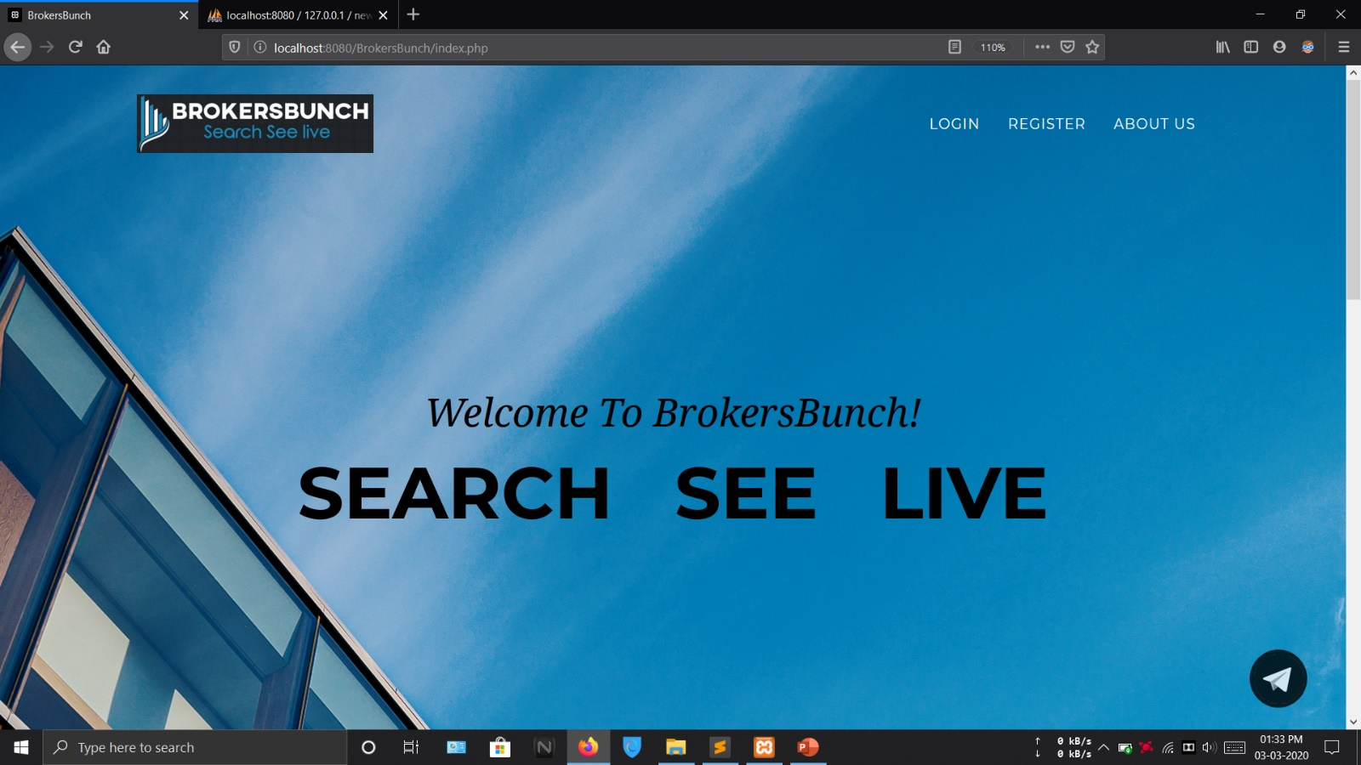**HOMEPAGE**

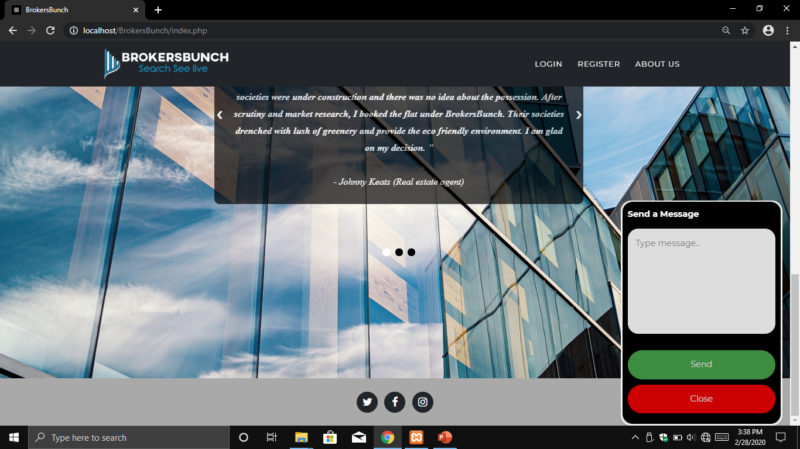**CHAT**

This form allows broker and client to solve any queries through chatting. This form appears on every page of web application. Hence accessible from anywhere throughout the application.

**ABOUT US**

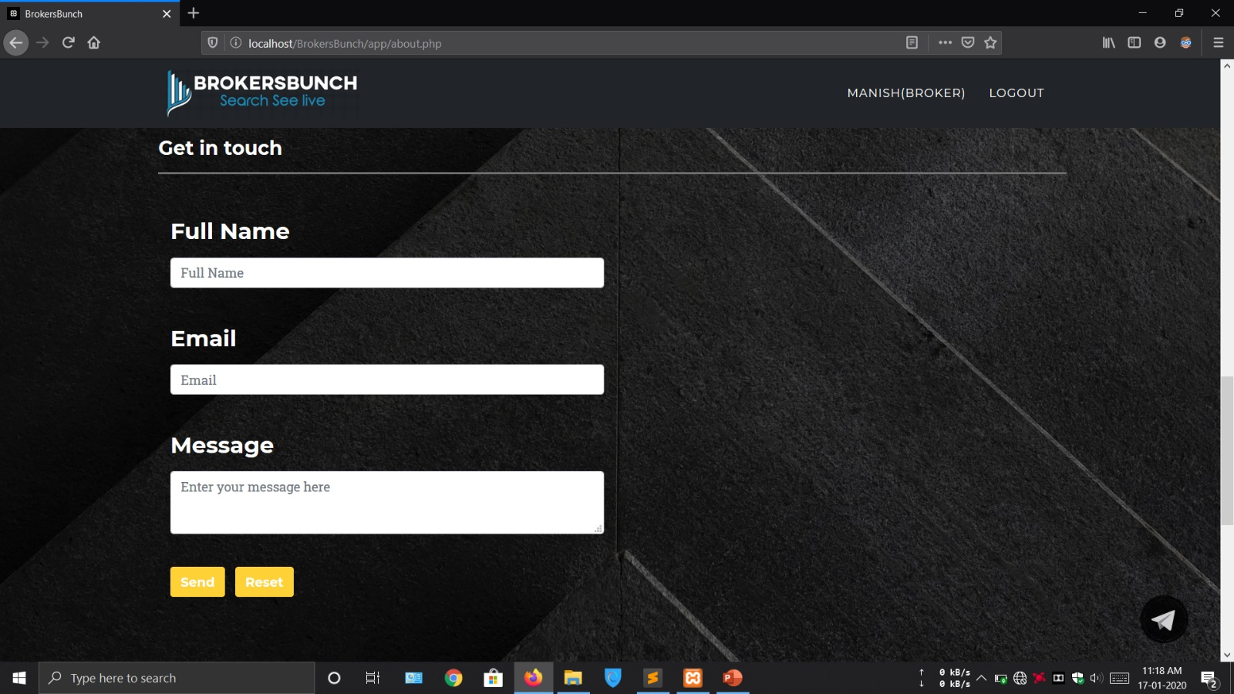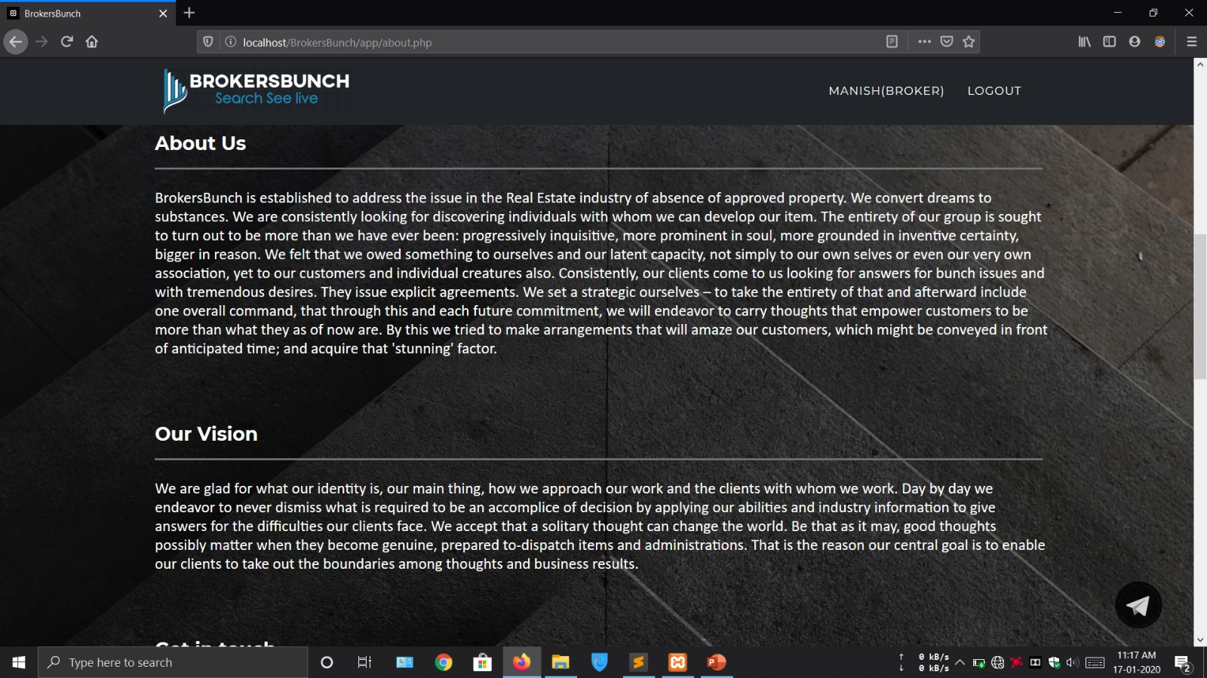

This form allows to contact to system administration in case of any help for working of the application or any issue about the application.

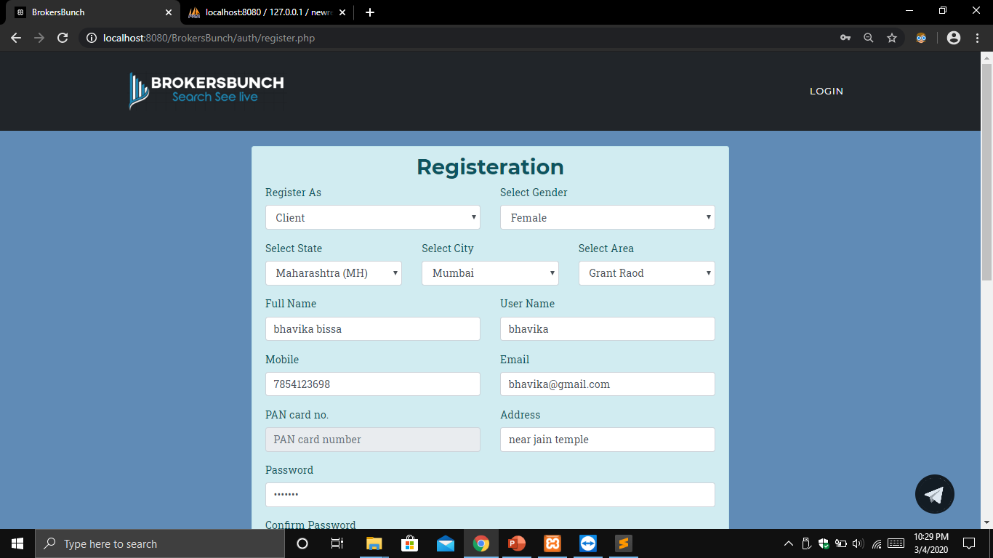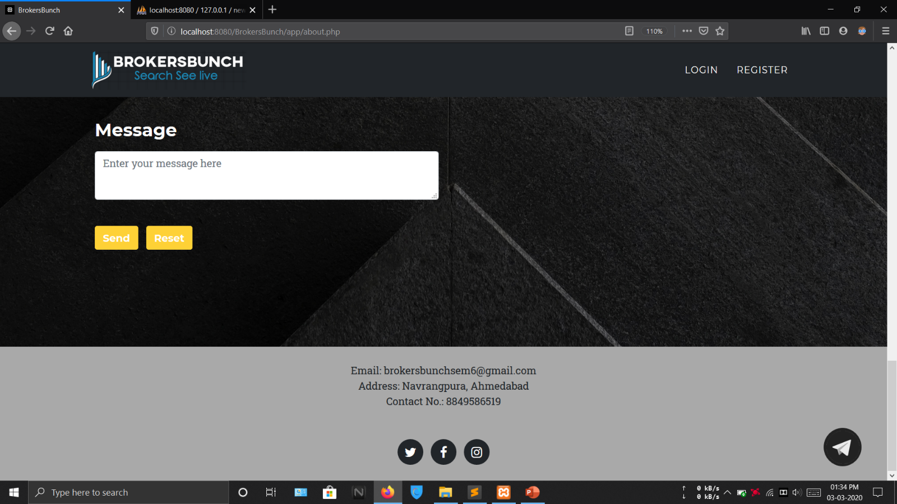**REGISTERATION**

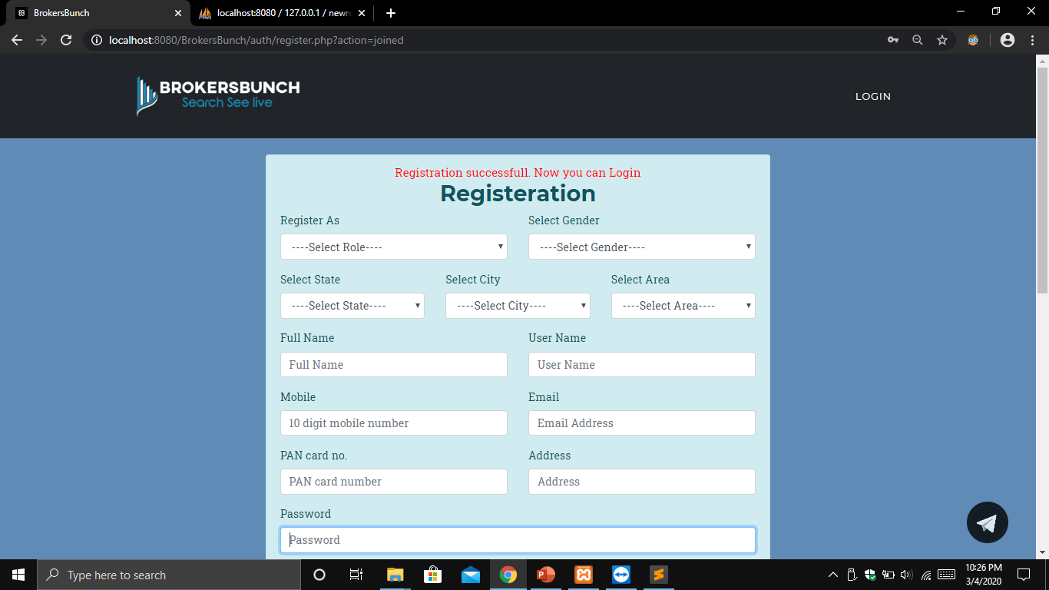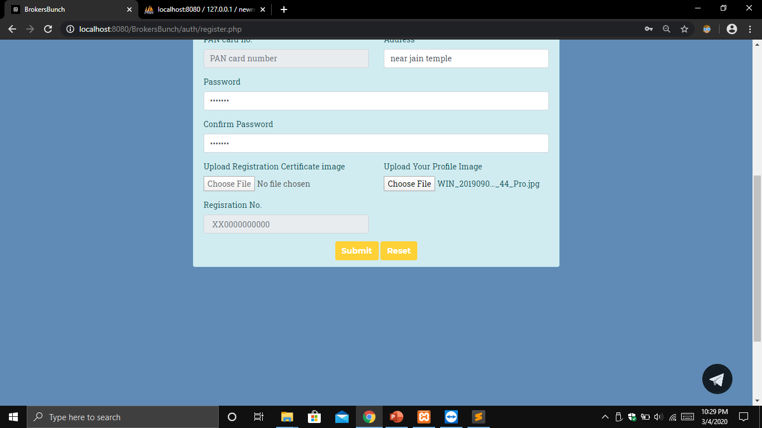This form allows the user to register in order to use the application. User can register on basis of their type, i.e. as client or broker using field of user type. Details will be saved accordingly.

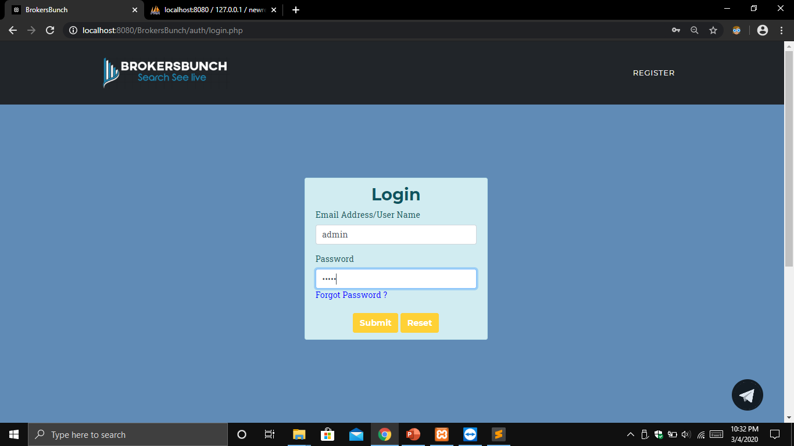**ADMIN LAYOUTS**

**LOGIN**

This form allows admin to login by providing the credentials. Credentials are authenticated if true then redirected to its dashboard.

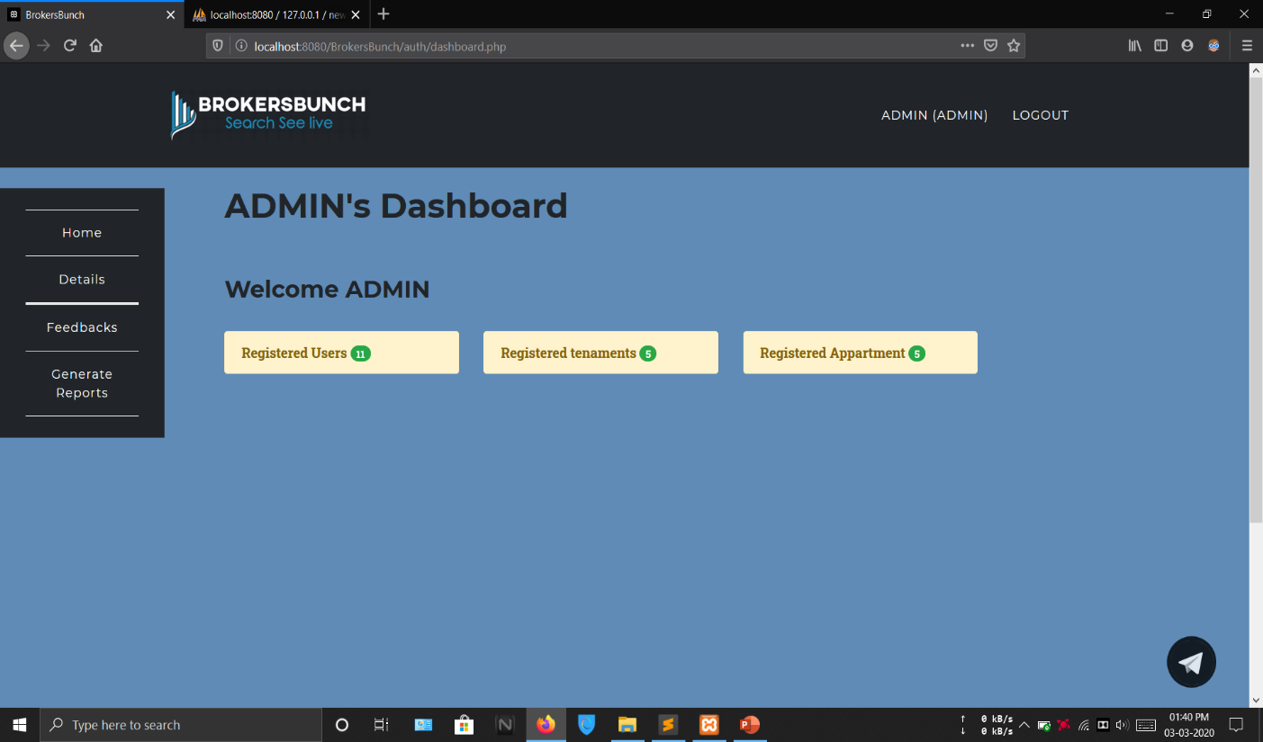**ADMIN’S DASHBOARD**

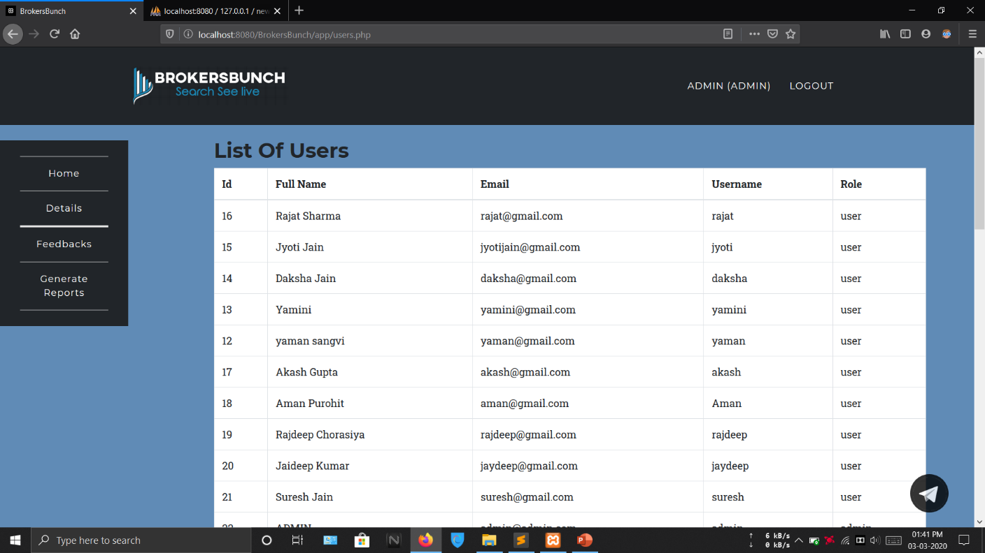**LIST OF USERS**

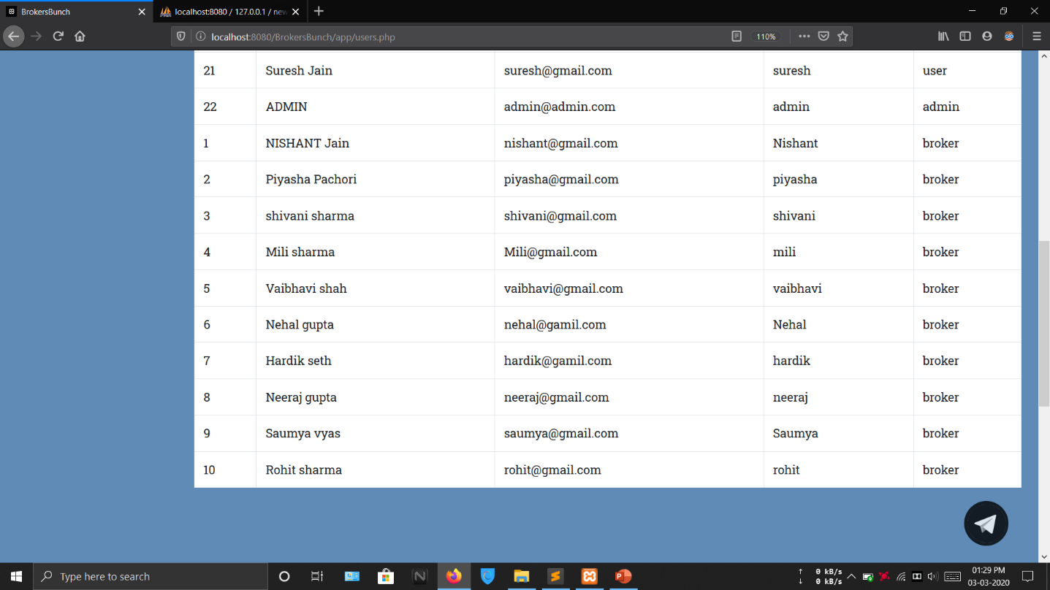

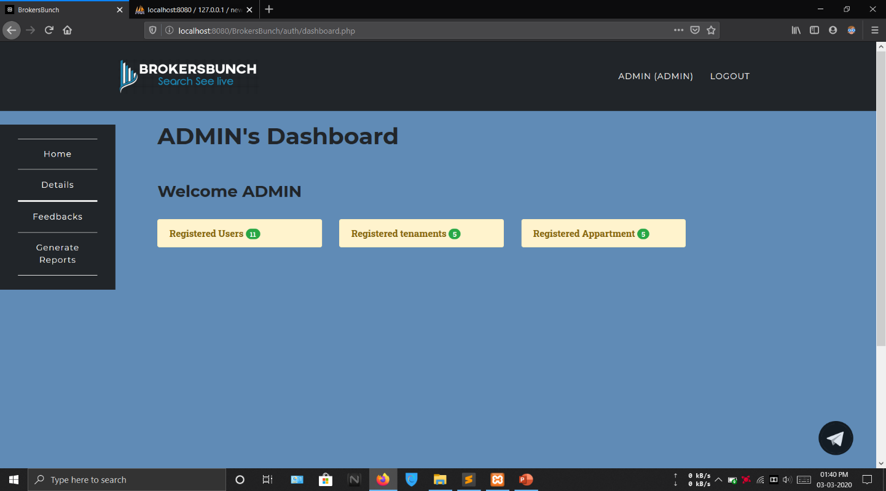**REGISTERED TENAMENTS**

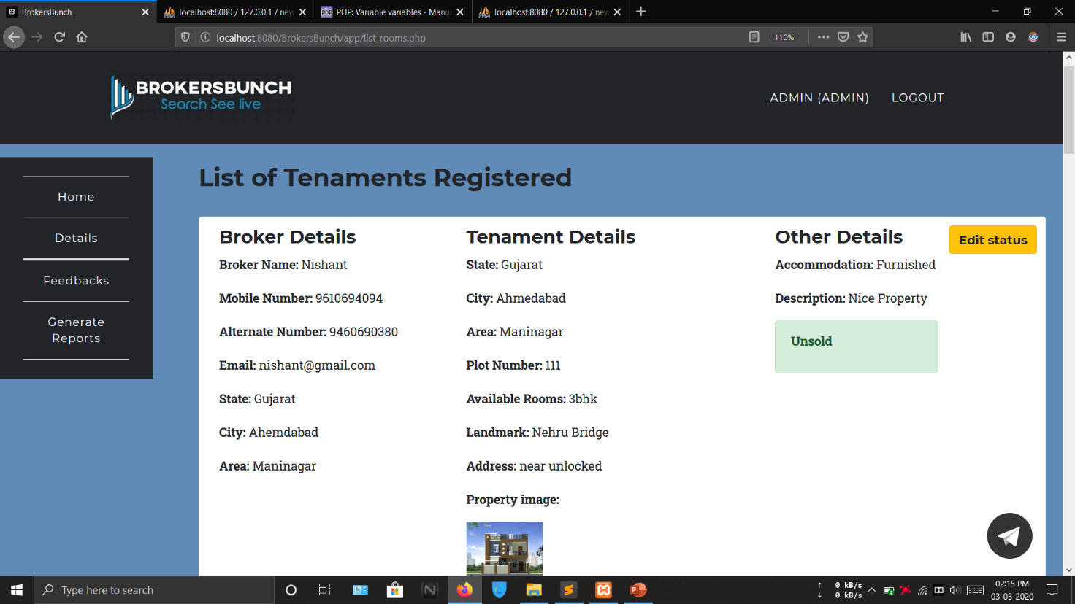

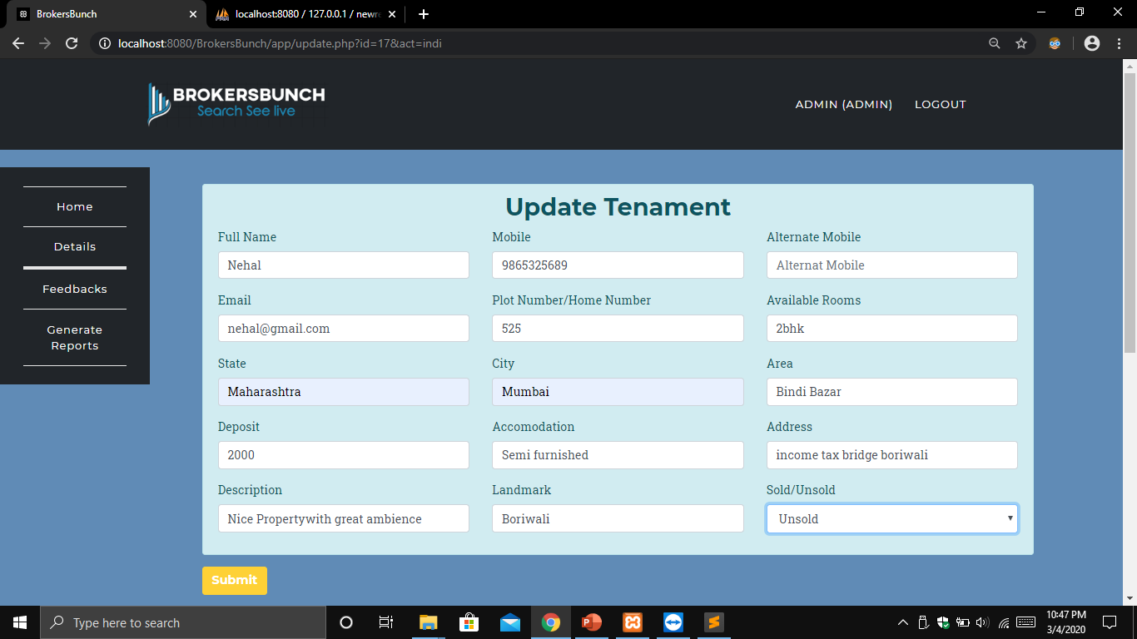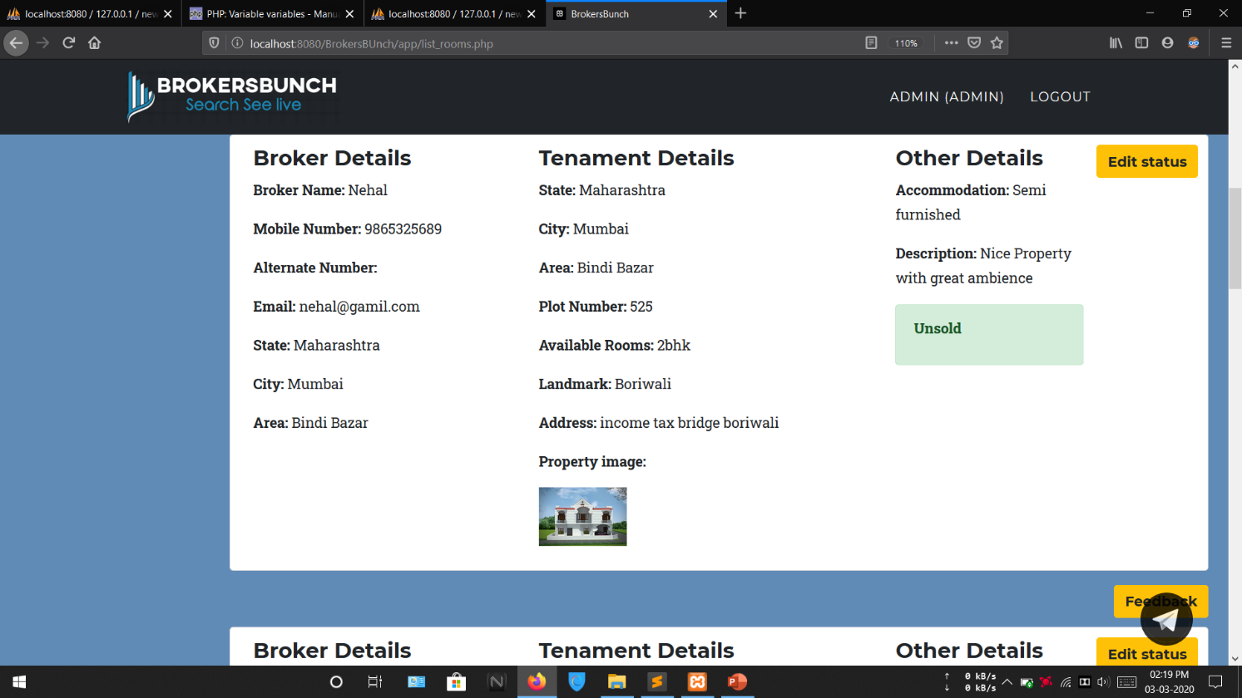This form allows admin to edit the status of the tenements using only sold/unsold field. If the property is sold it will not appear in the search option of the client side.

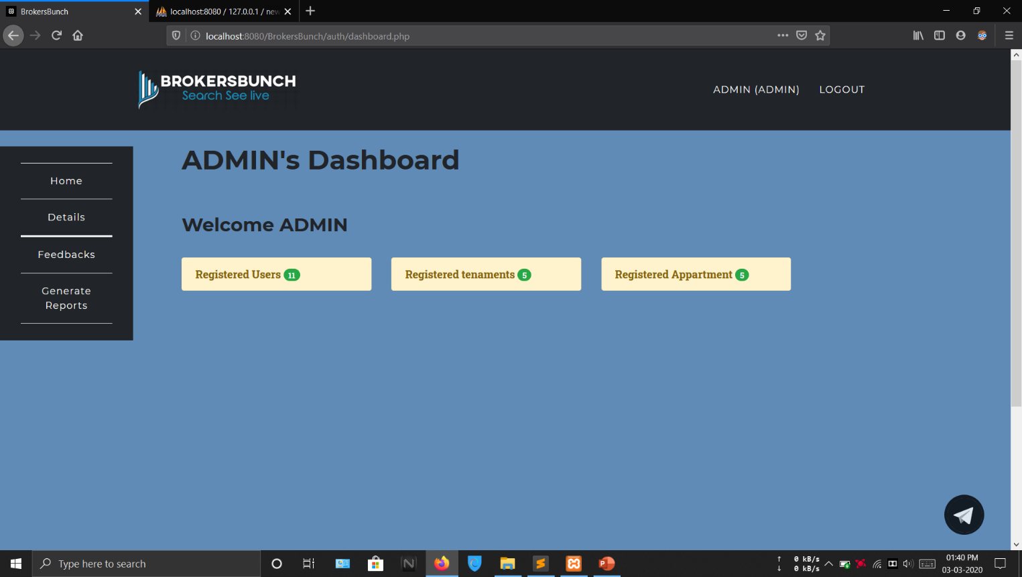**REGISTERED APPARTMENT**

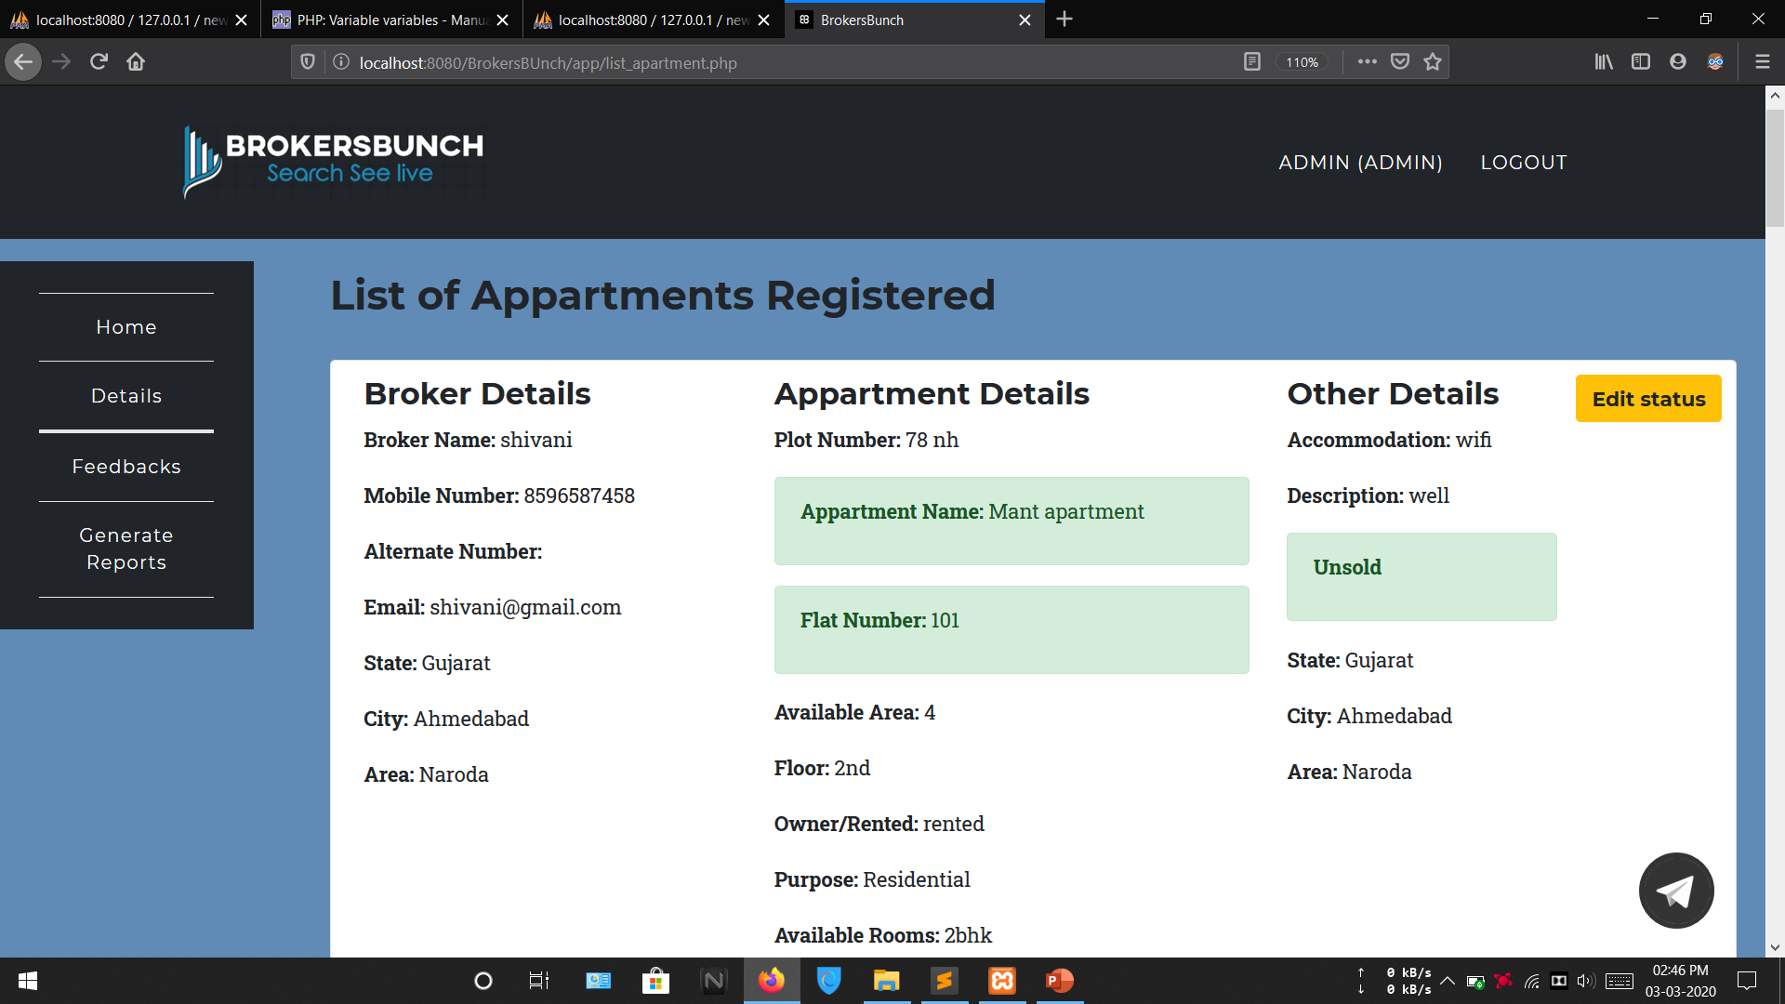

his form allows admin to edit the status of the tenaments using sold/unsold field. If the property is sold it will not appear in the search option of the client side.

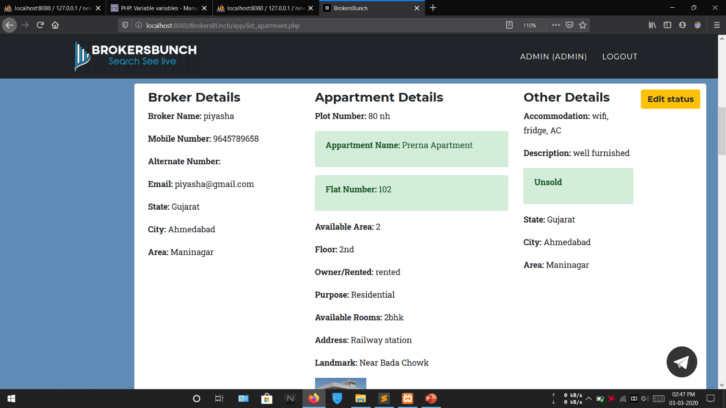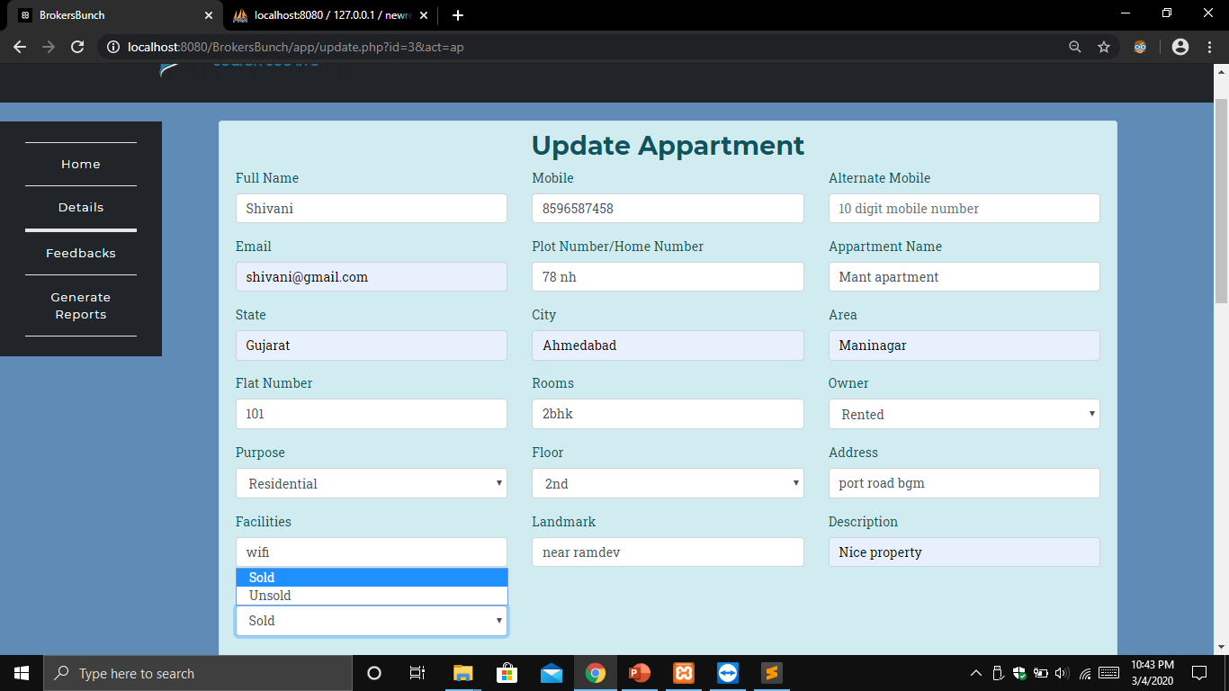This form allows admin to edit the status of the apartments using only sold/unsold field. If the property is sold it will not appear in the search option of the client side

**VIEW ALL PROPERTIES**

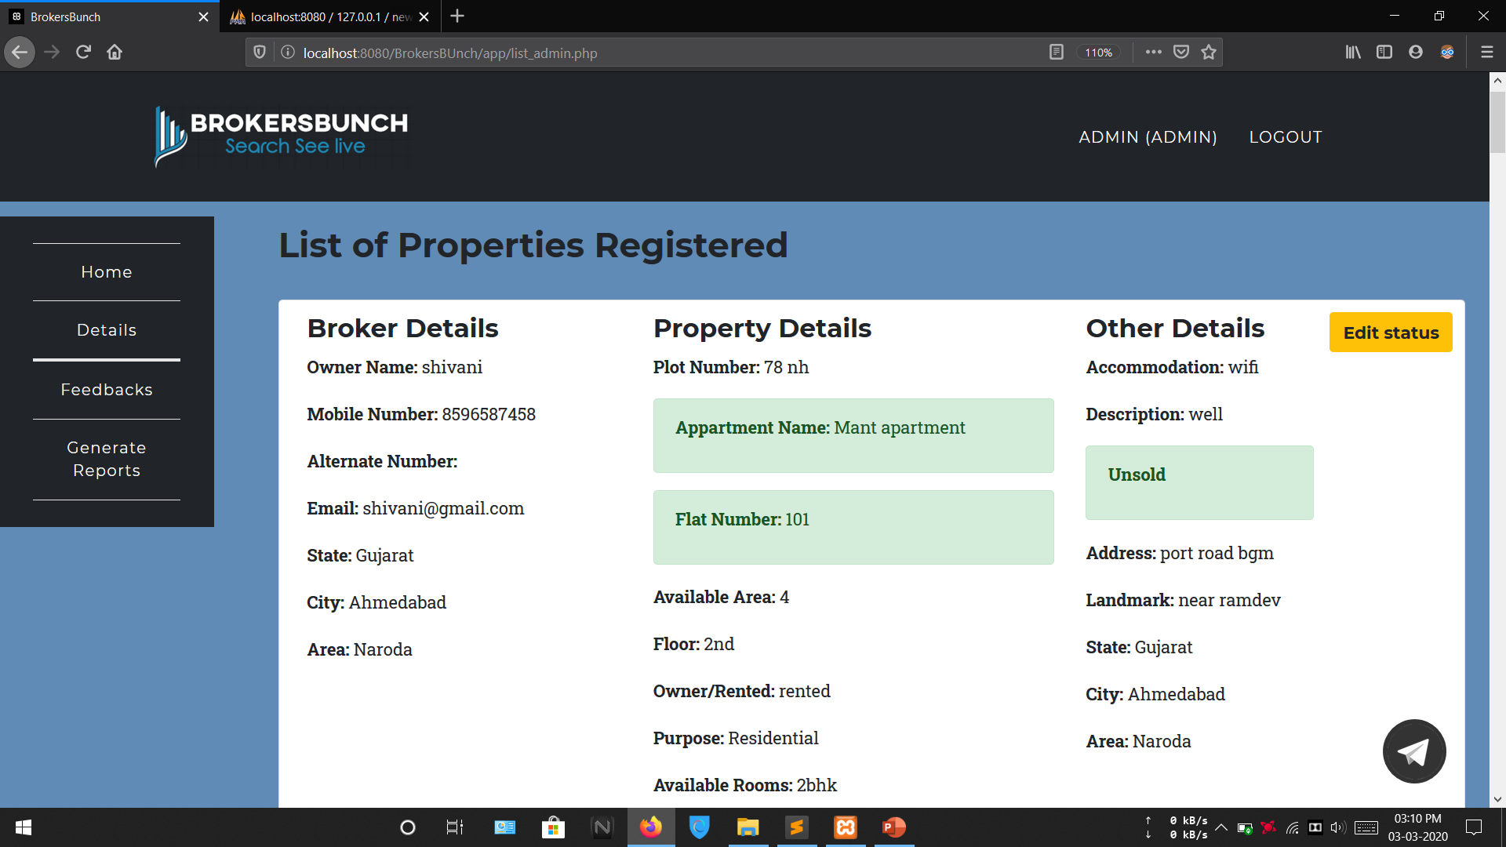

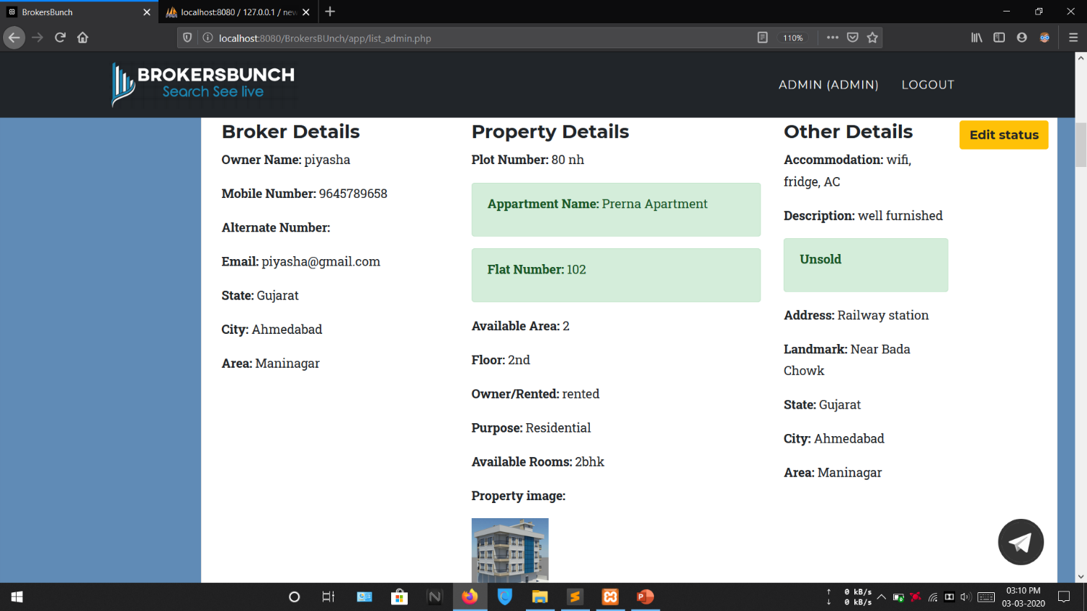

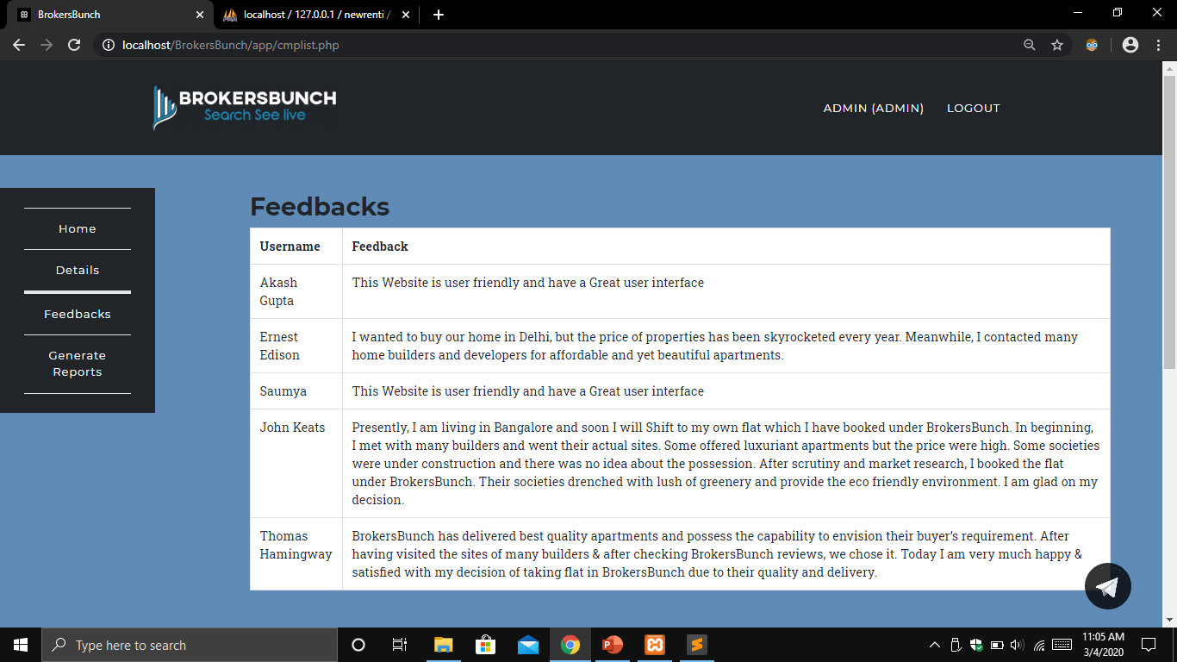**FEEDBACKS**

**BROKER LAYOUTS**

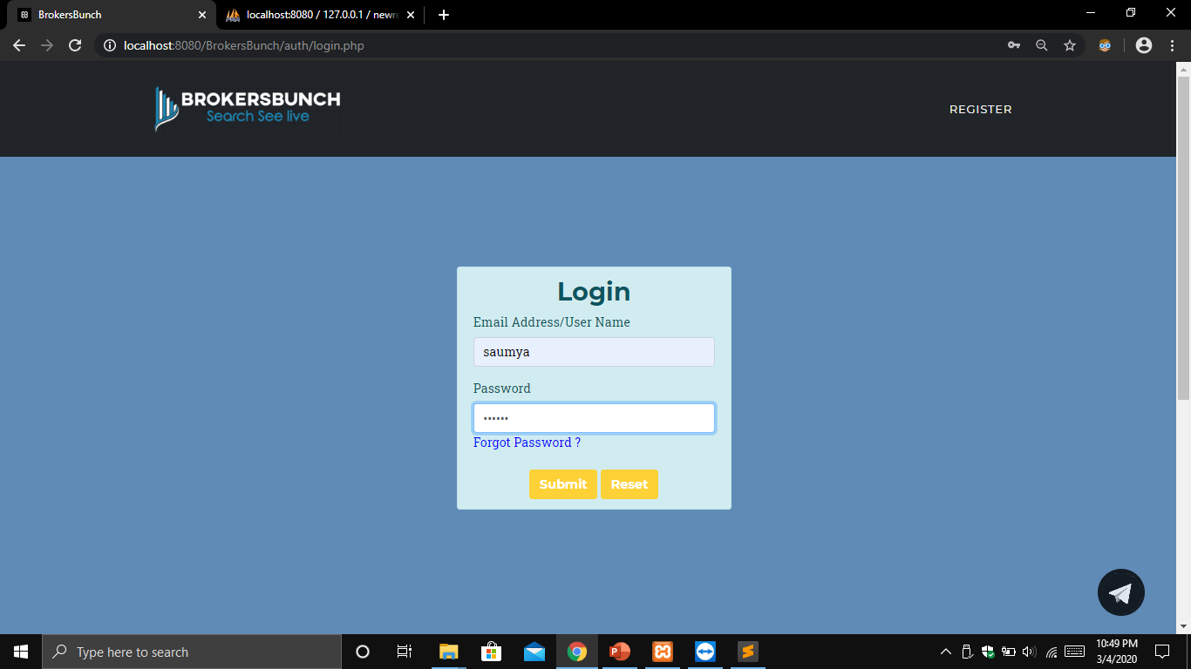**LOGIN**

This form allows broker to login by providing its credentials. Credentials are authenticated if true then redirected to broker’s dashboard.

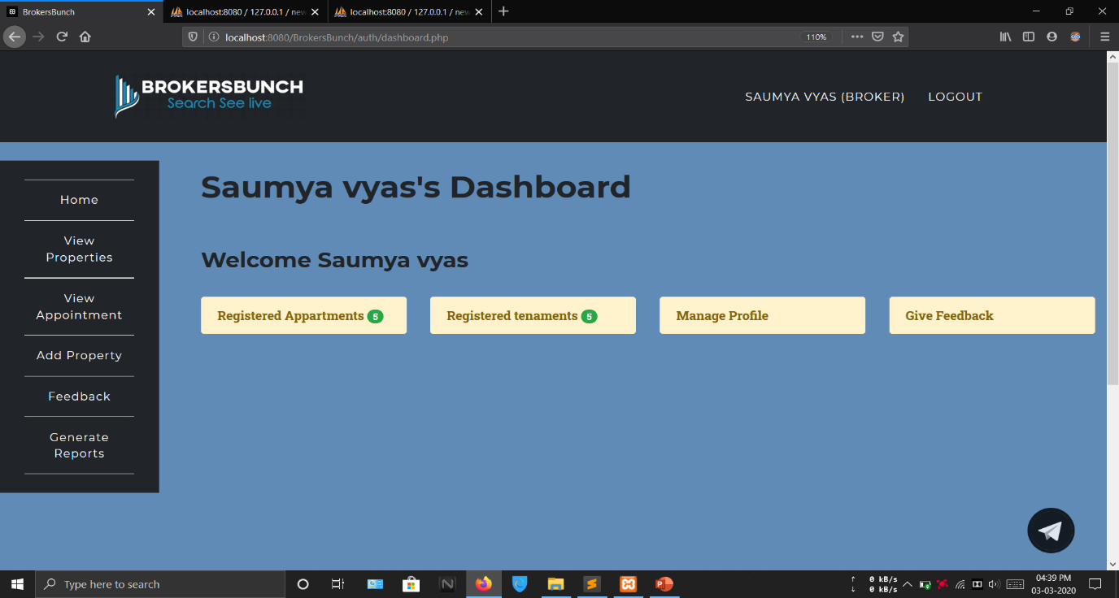**BROKER’S DASHBOARD**

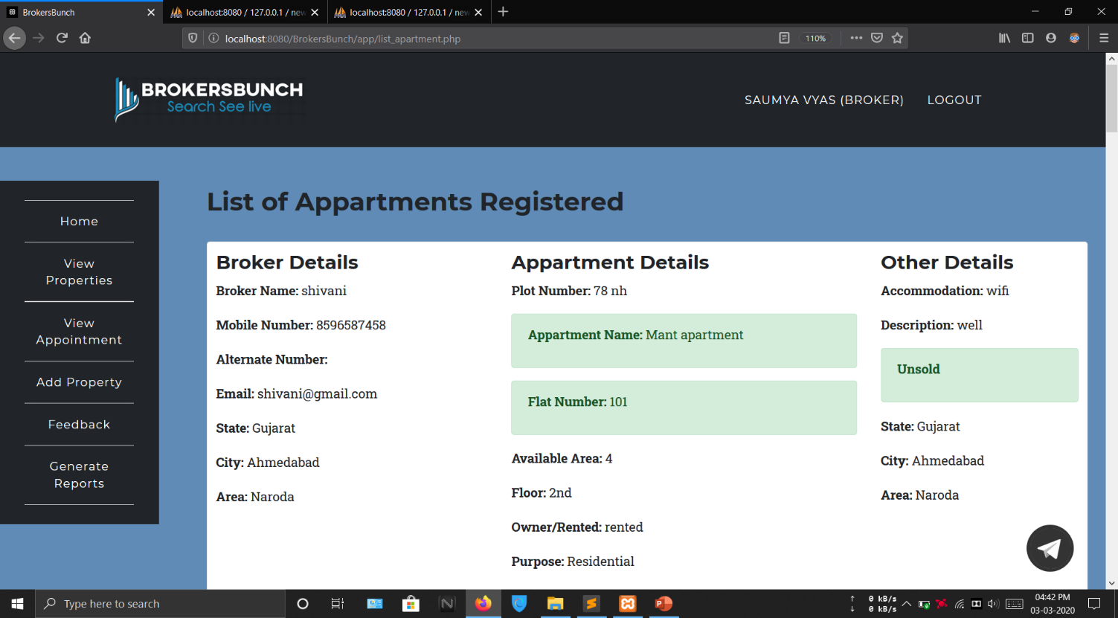**REGISTERED APPARTMENT**

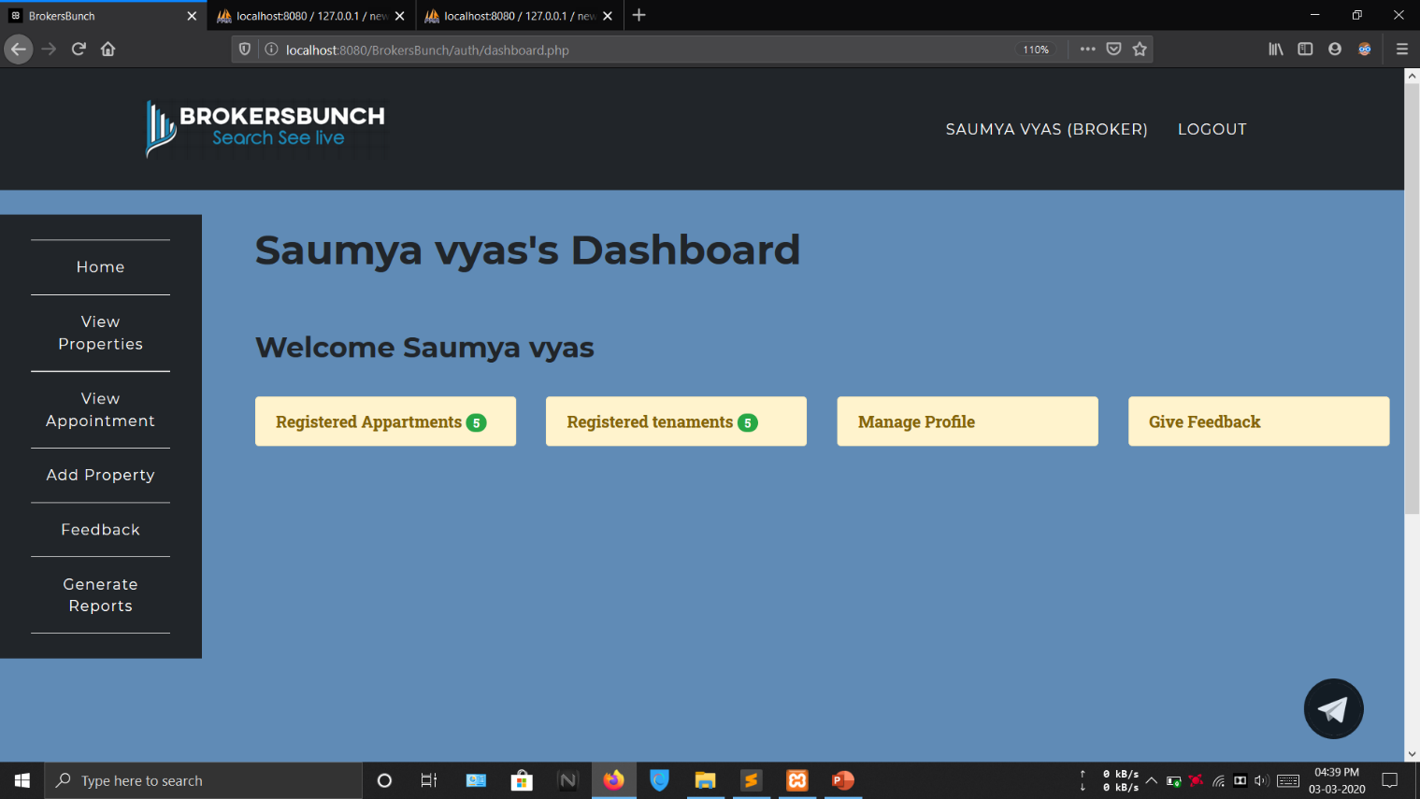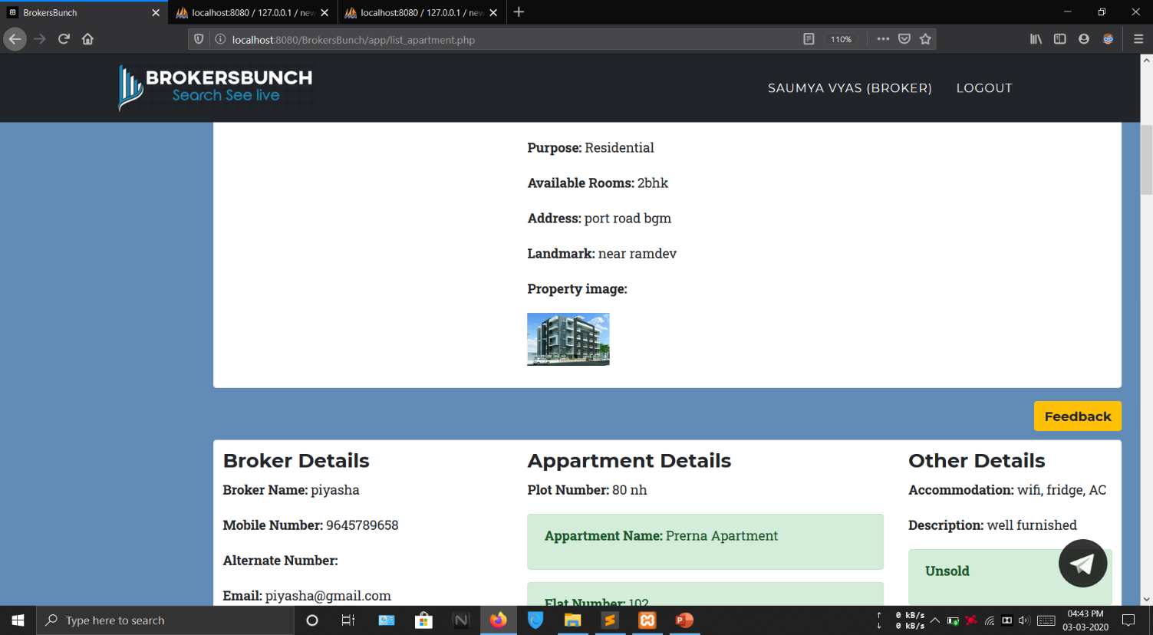

**REGISTERED TENAMENT**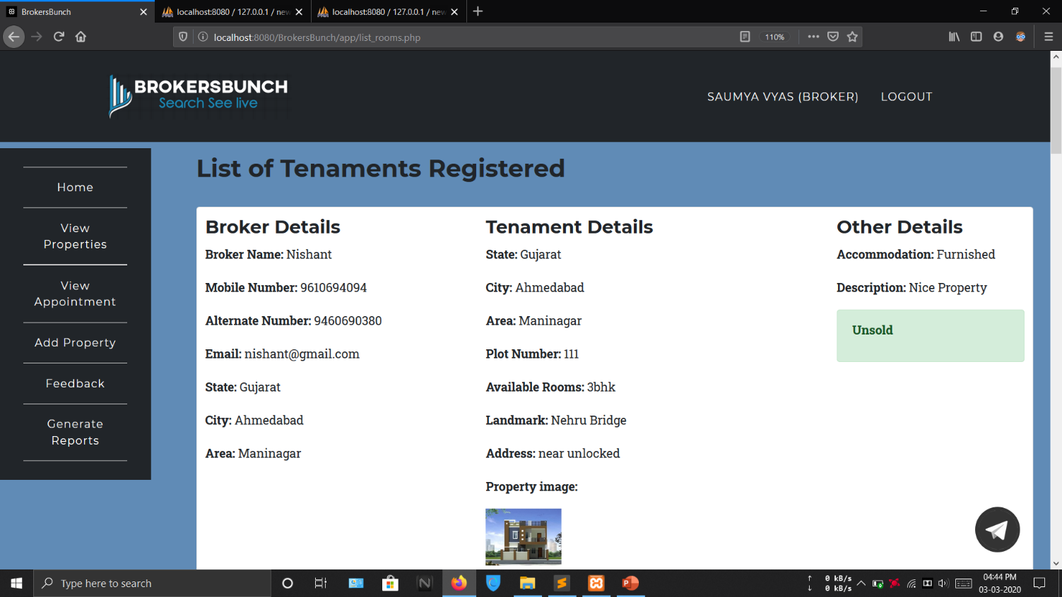

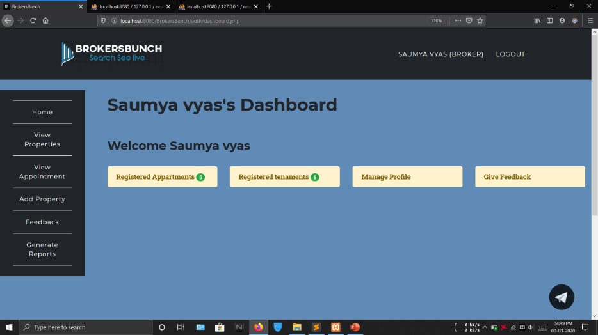

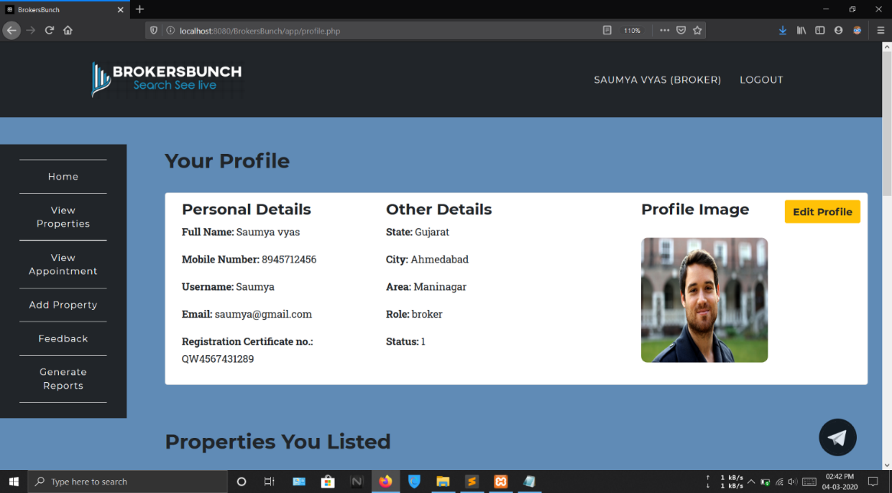**MANAGE PROFILE**

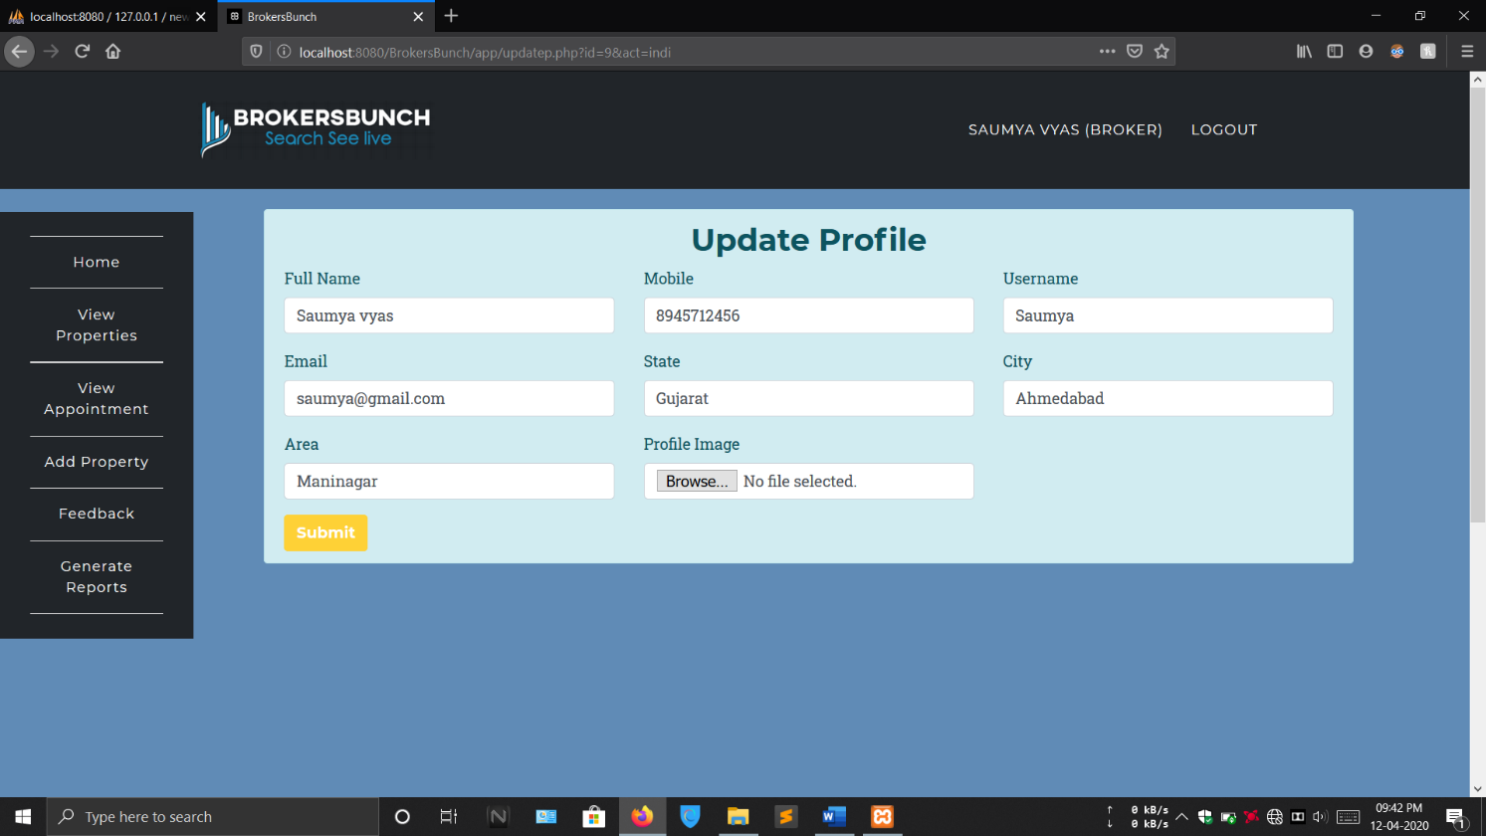

This form allows broker to update its personal details. Changes made are updated and saved.

**VIEW ALL PROPERTIES**

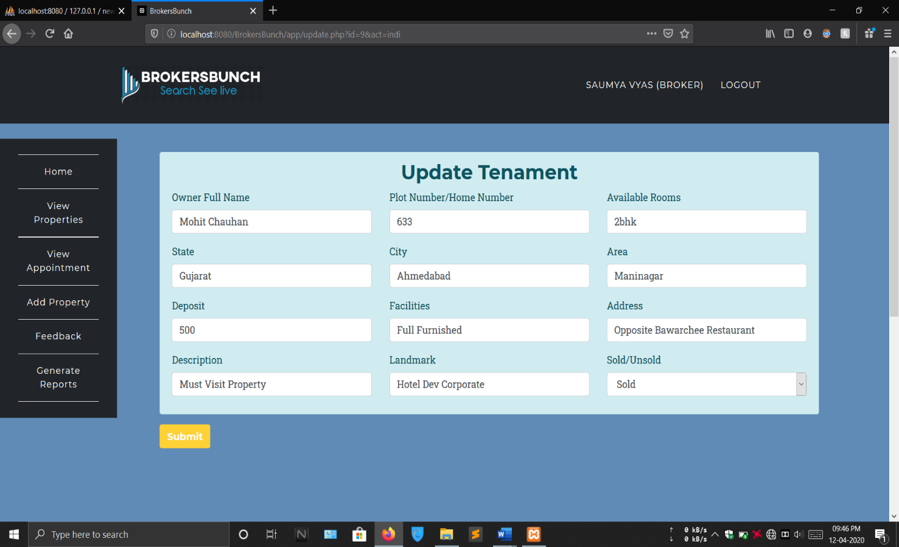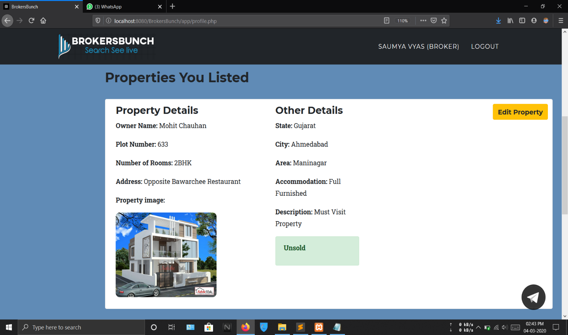This form allows broker to update property’s details. Any details of the property registered by him/her can be updated and saved.

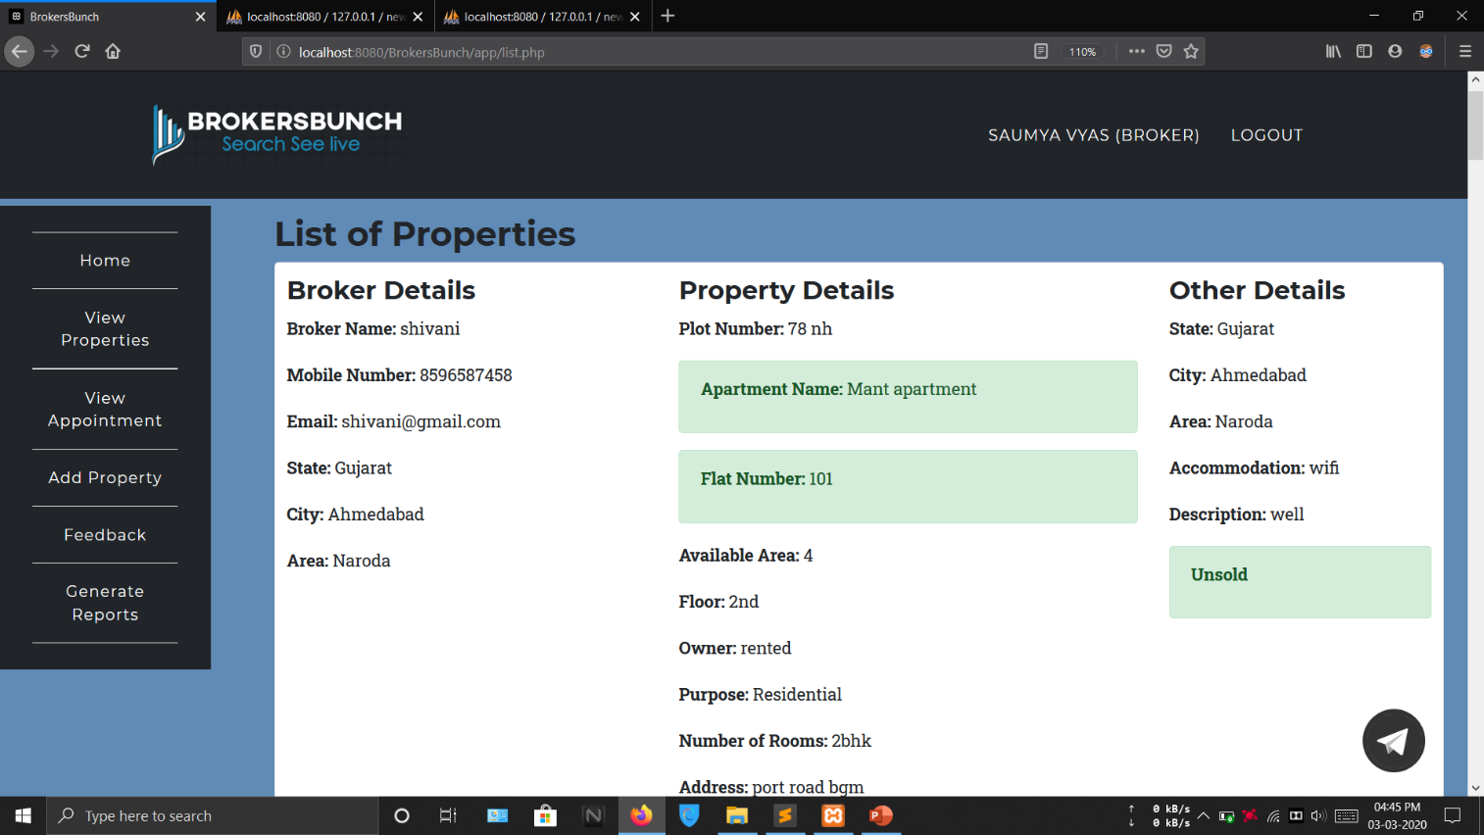

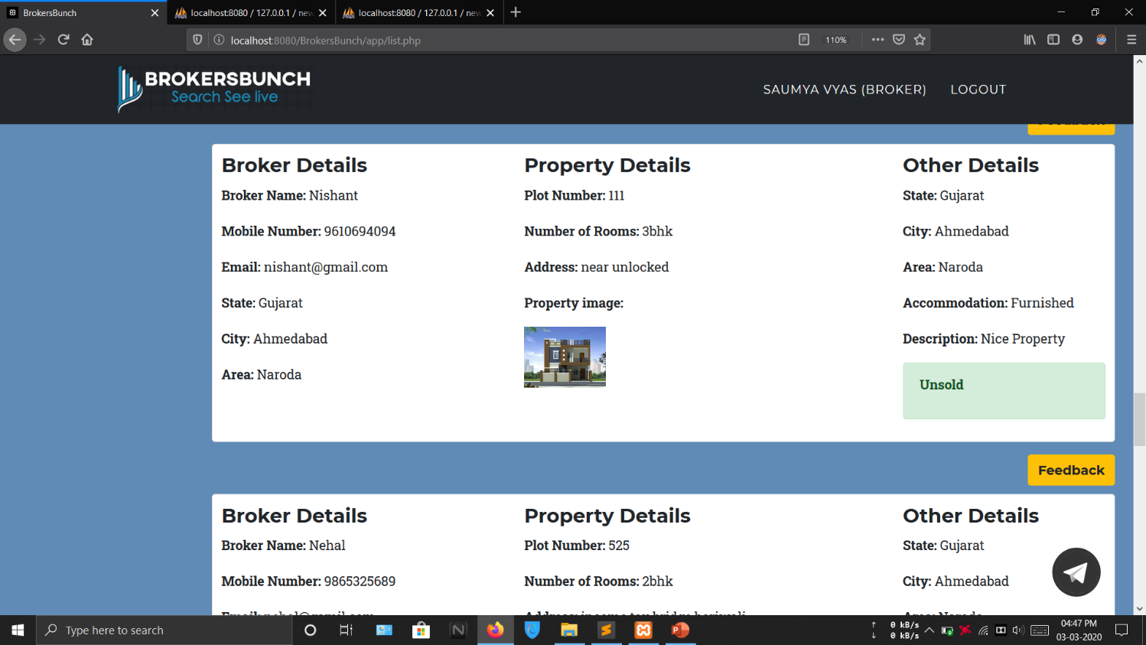

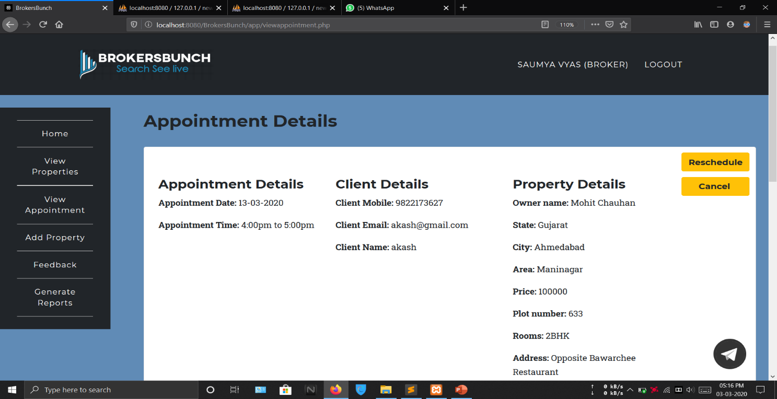**VIEW APPOINTMENT**

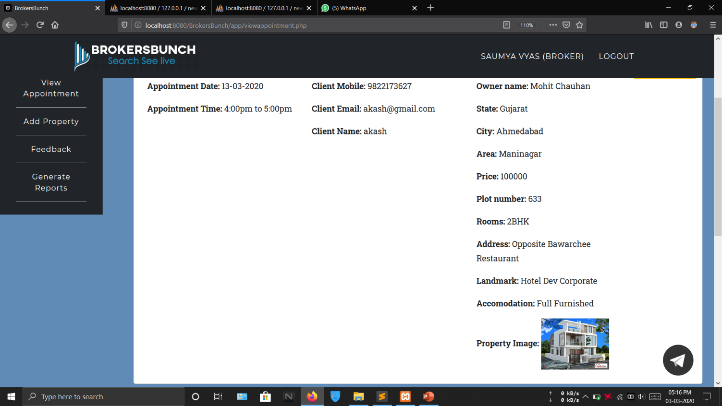

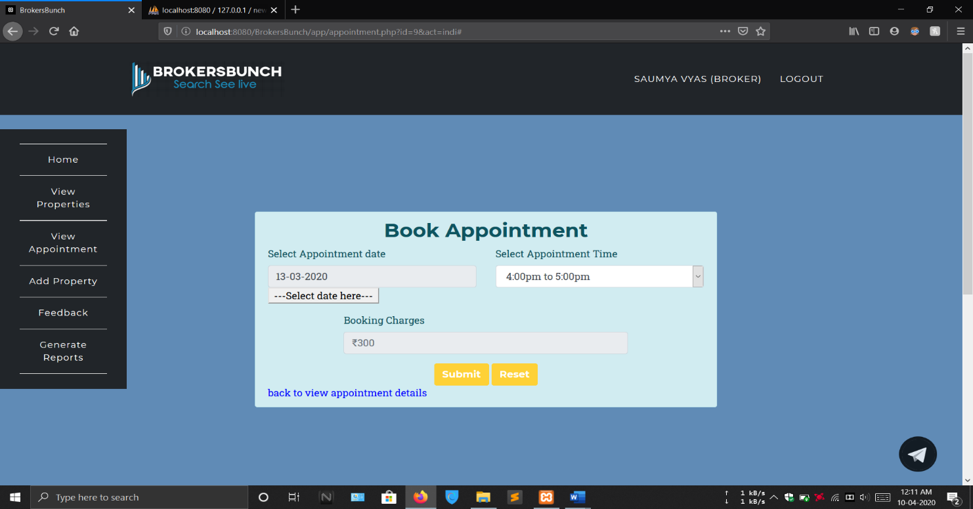****This form allows broker to reschedule the appointment set by the client. He/she can change date and time in order to reschedule the appointment. Any other fields will not be accessible.

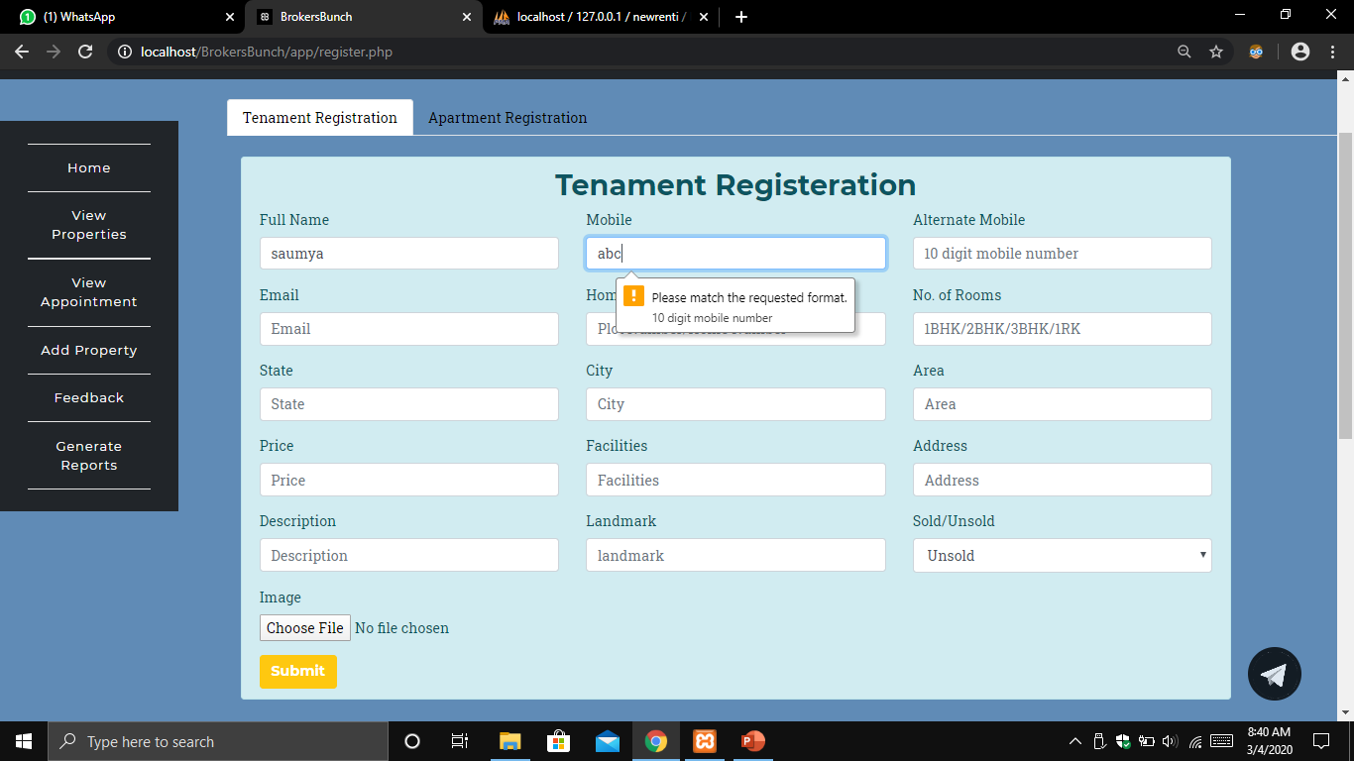**ADD PROPERTY**

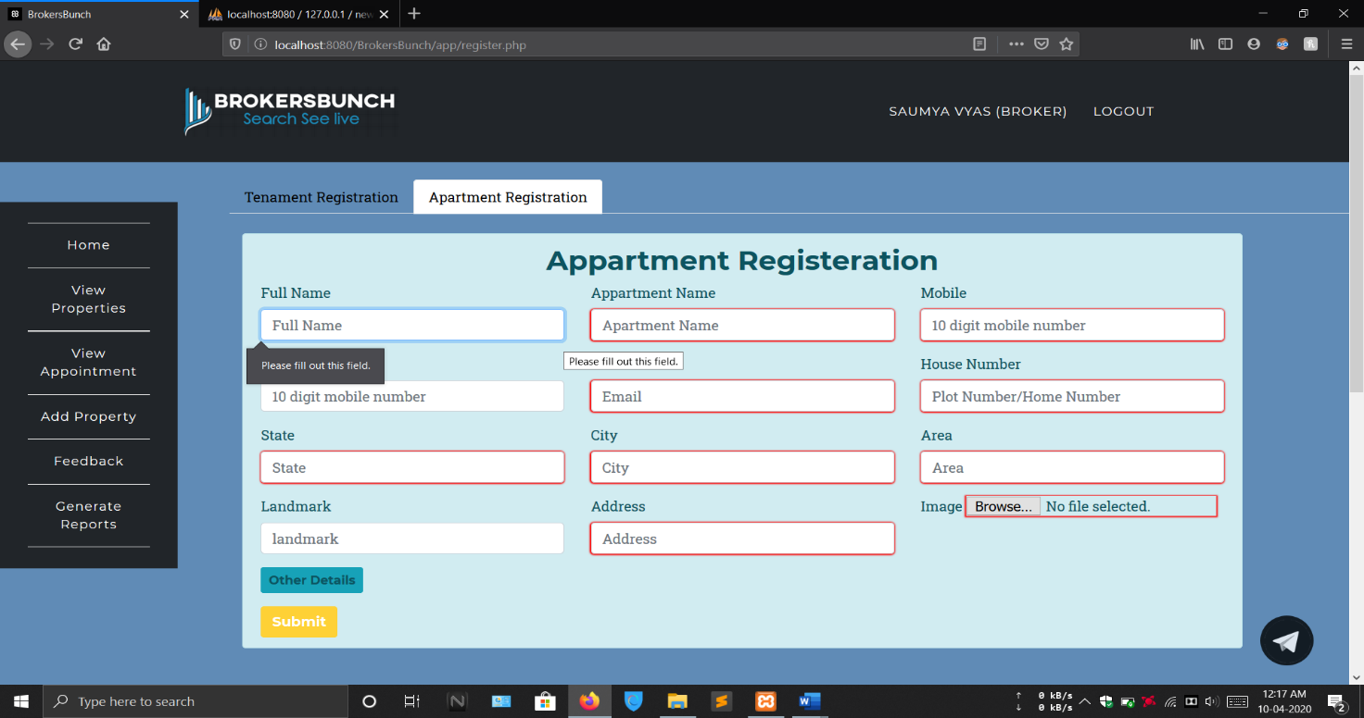This form allows broker to add tenement by entering all the details as asked.

This form allows broker to add apartment by entering all the details as asked.

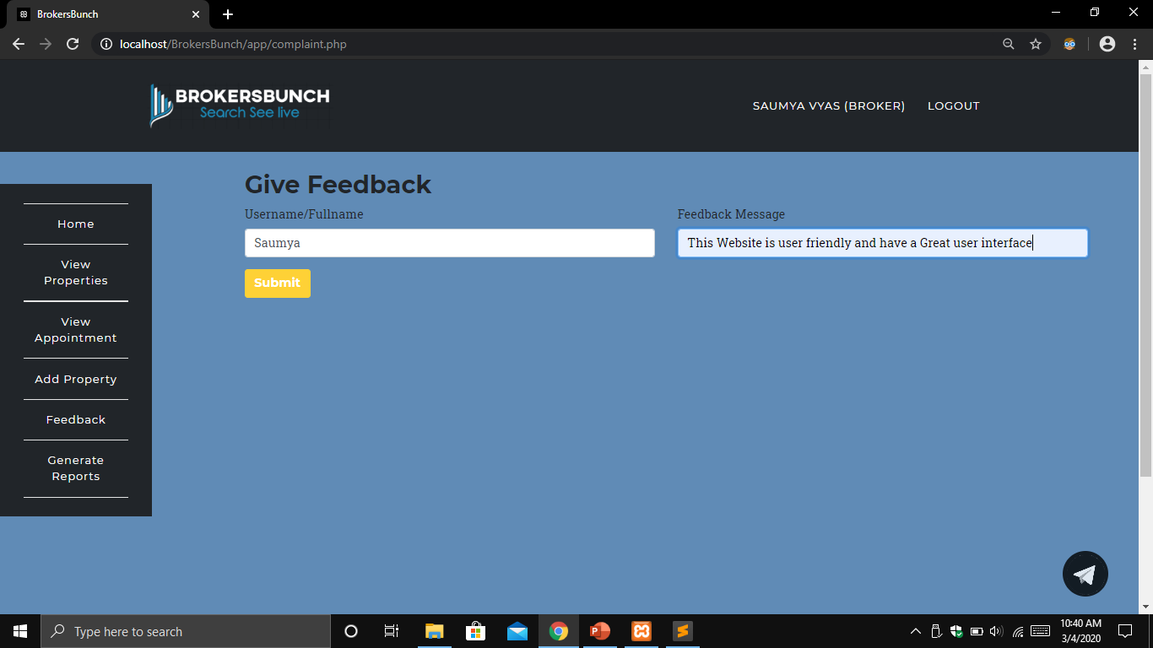**GIVE FEEDBACK**

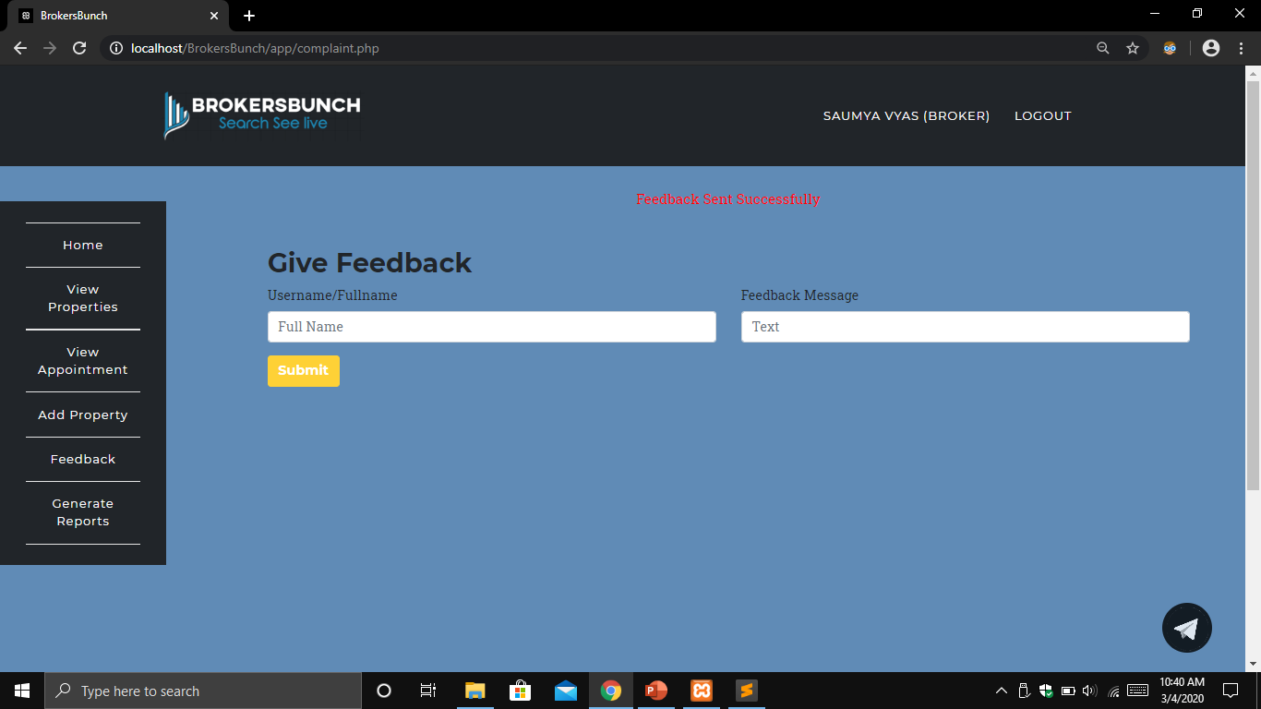This form allows broker to give feedbacks about his experience of the application. These feedbacks will appear on homepage and as well as to admin.

**CLIENT LAYOUTS**

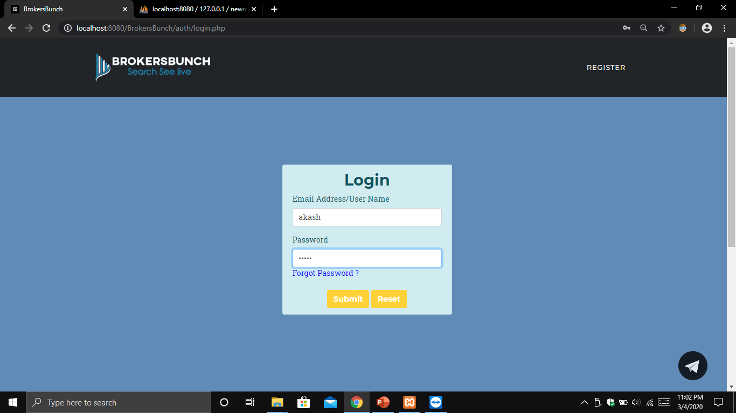**LOGIN**

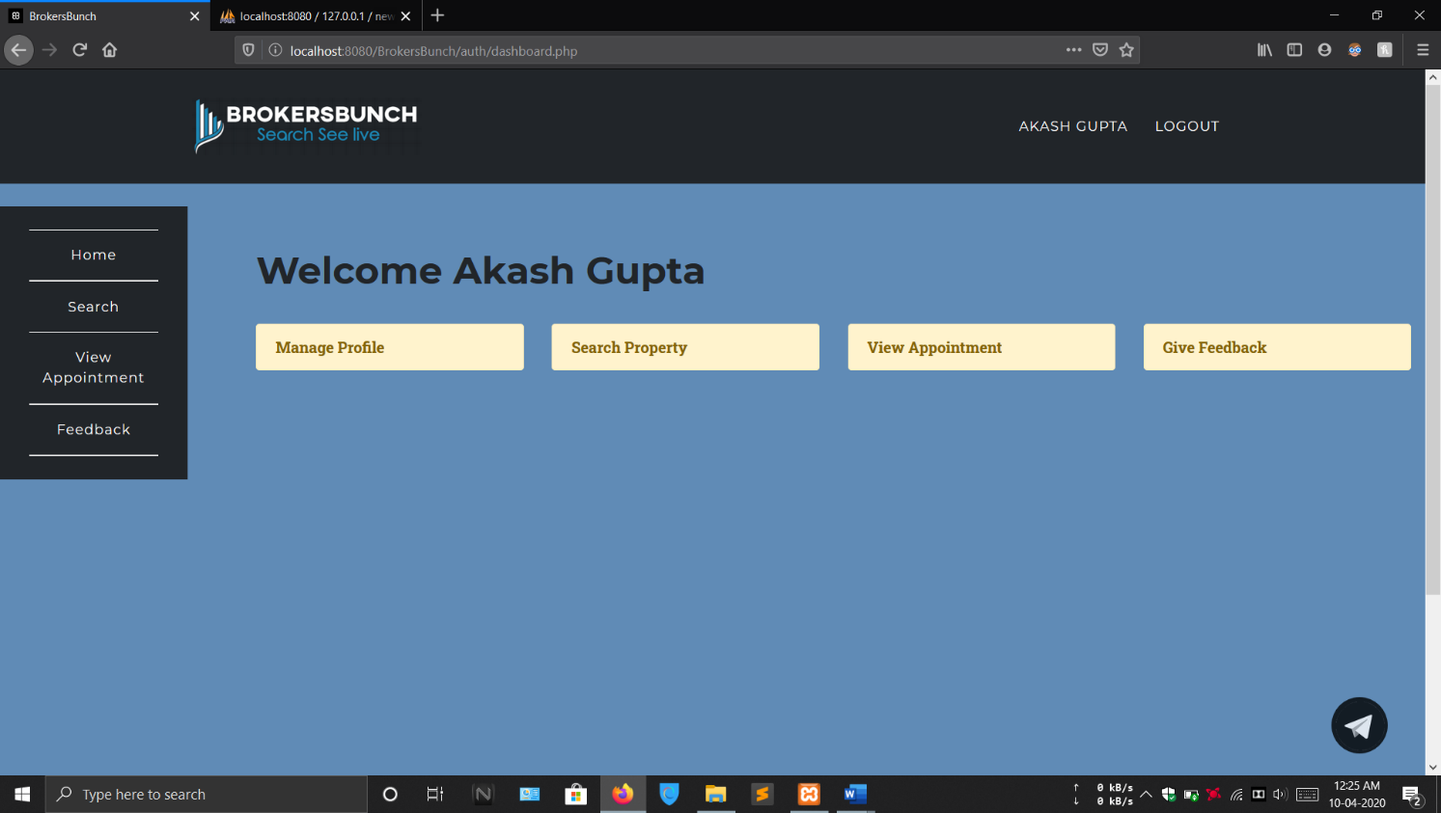This form allows client to login by accepting and authenticating the credentials like username and password.

**CLIENT’S DASHBOARD**

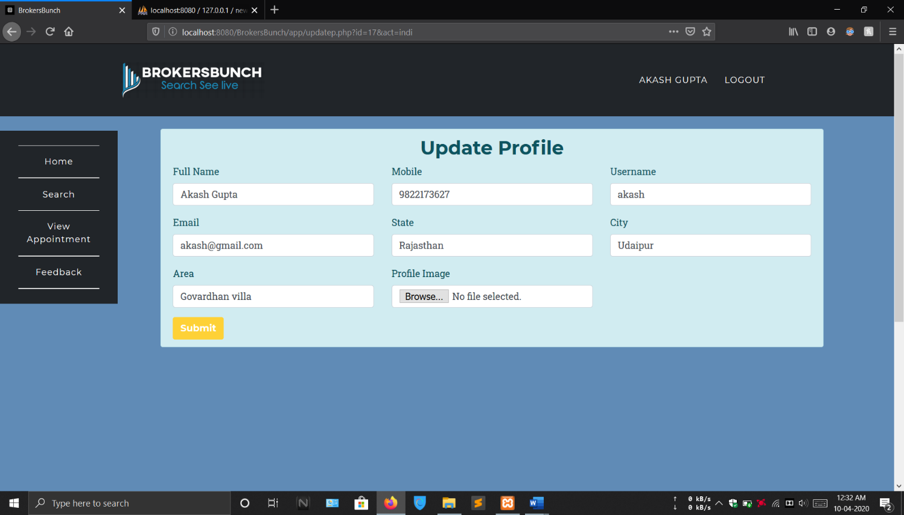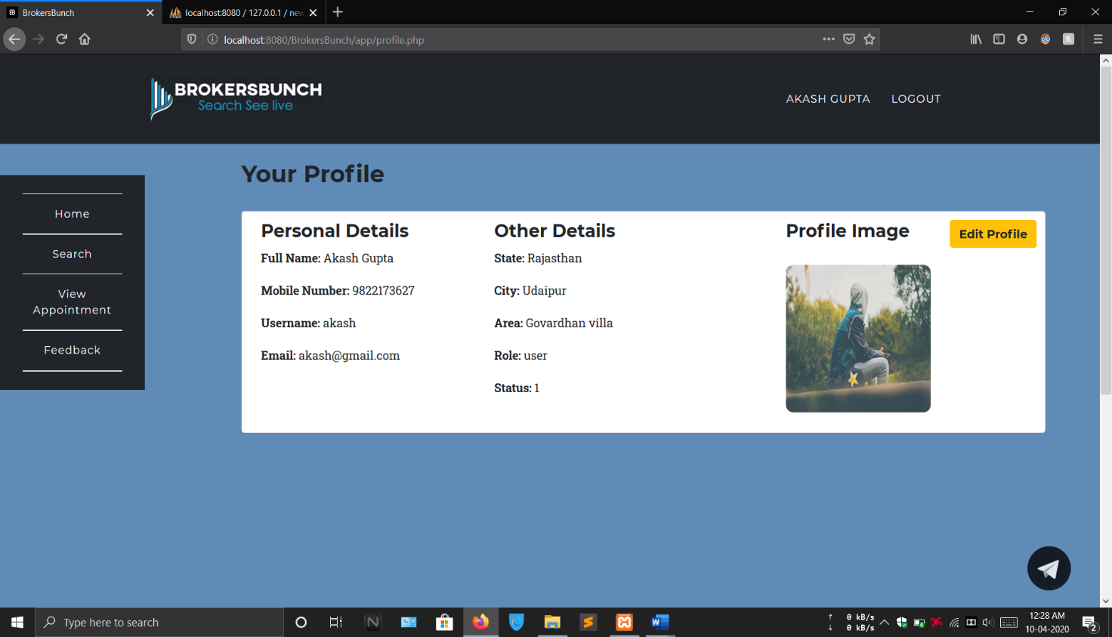**MANAGE PROFILE**

This form allows the client to update his personal details. Any changes made will be updated and saved.

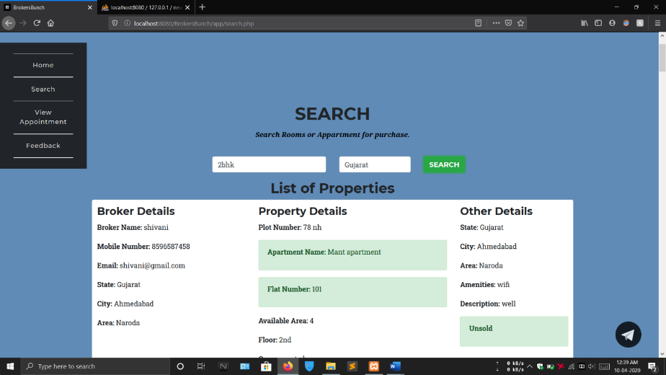**SEARCH PROPERTY**

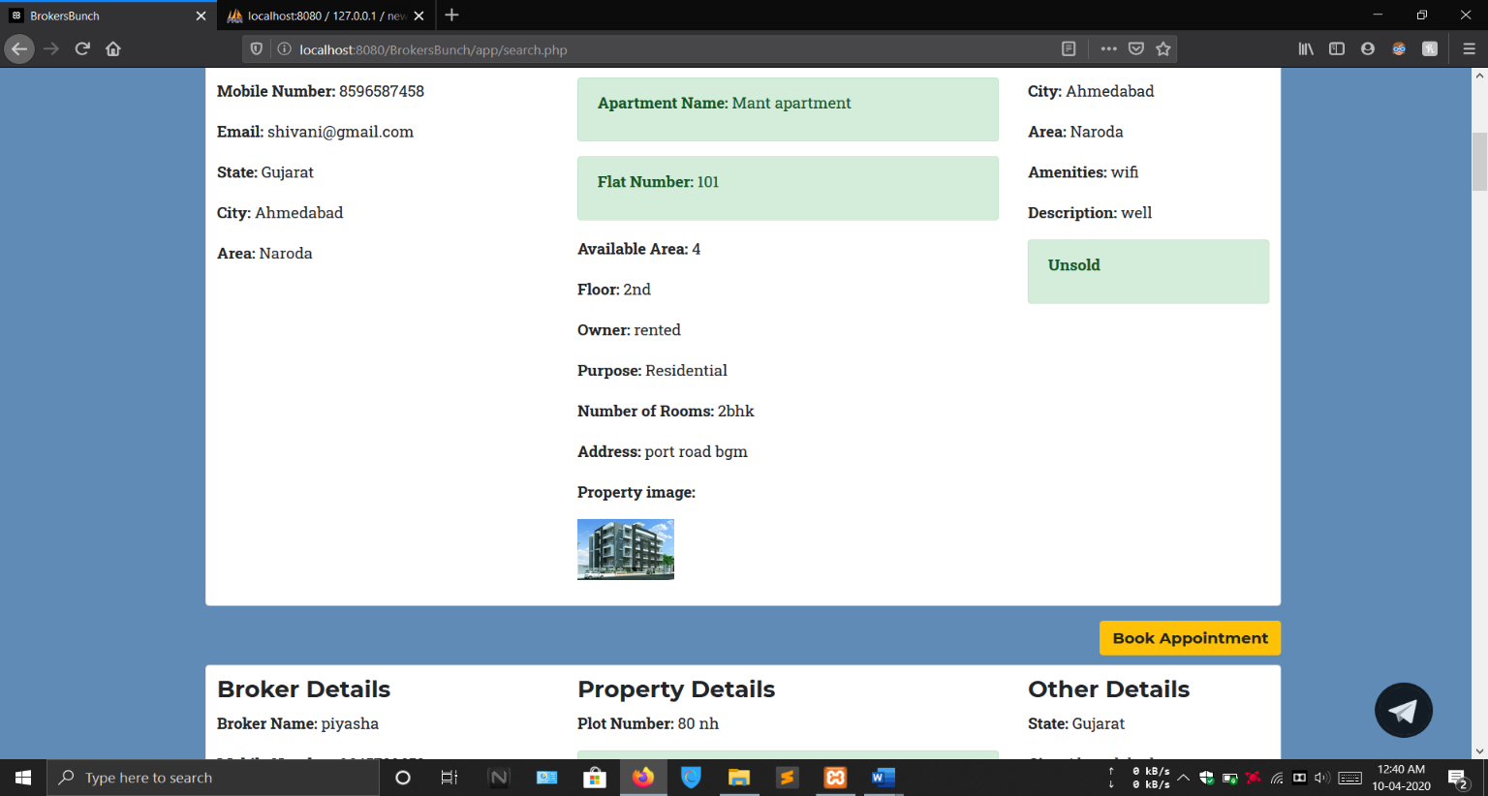 If client wants to search properties by using the any specific conditon then he/she can provide it through this form.

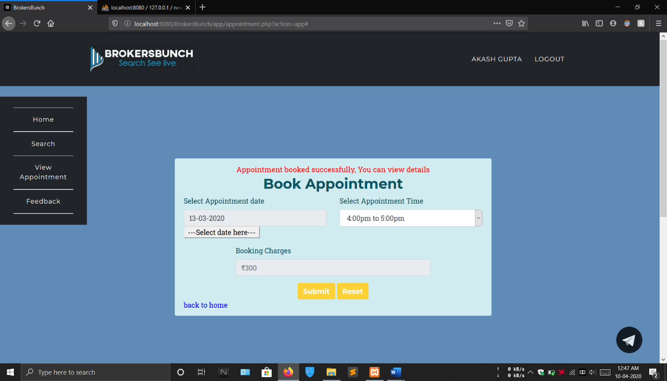  **BOOK APPOINTMENT**

This form allows the client to book appointment with broker for property. He/she can access the fields like date and time.

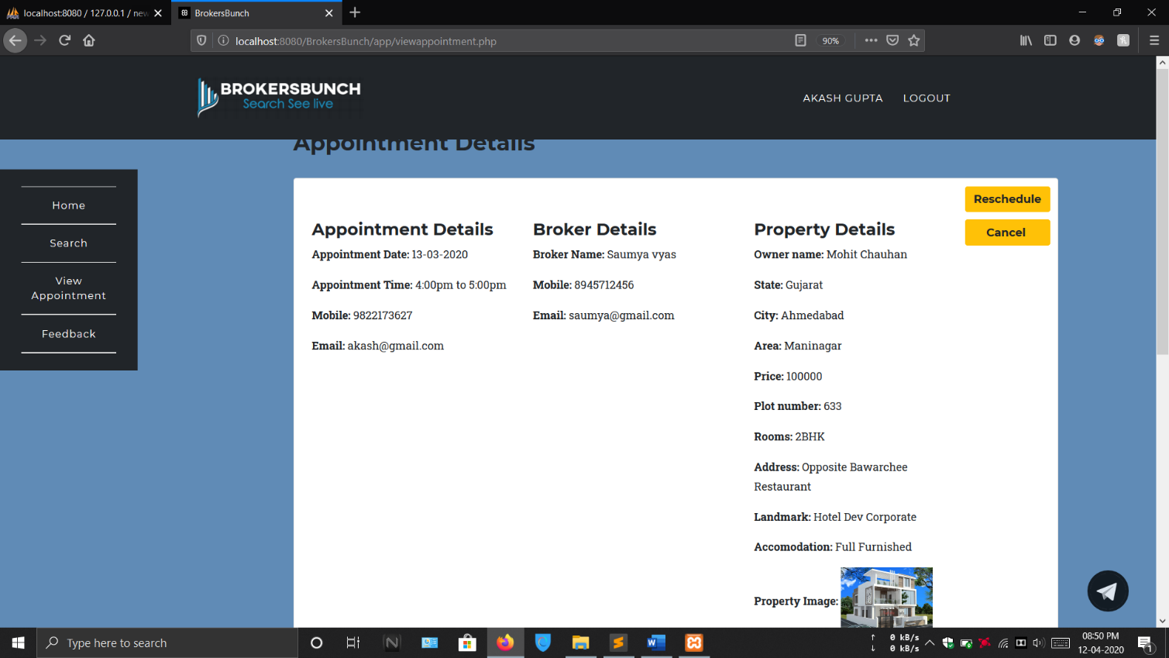**VIEW APPOINTMENT DETAILS**

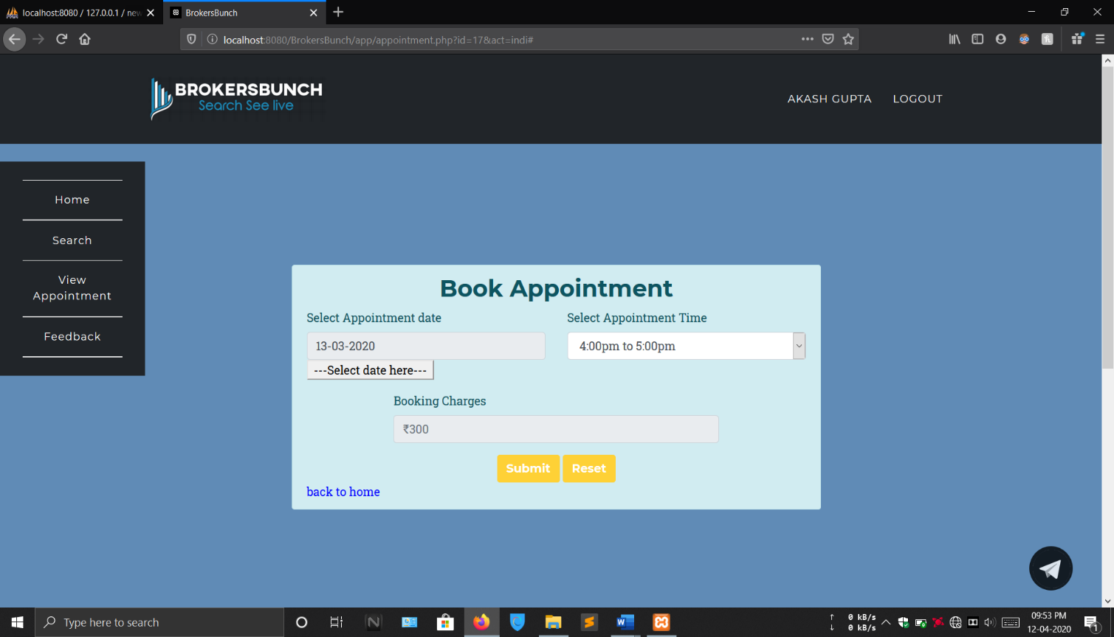**RESCHEDULE APPOINTMENT**

This form allows the client to reschedule appointment.

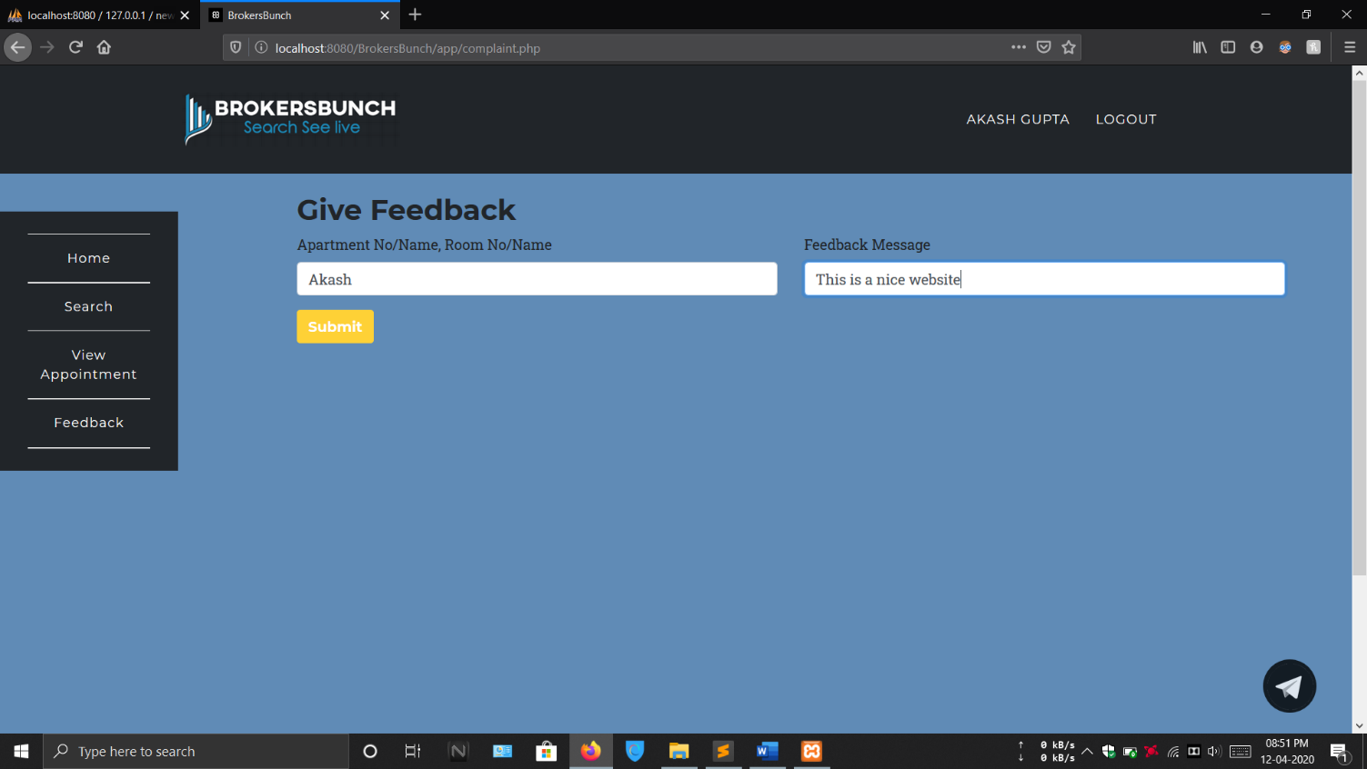 **GIVE FEEDBACK**

This form allows to give feedback by asking property details or username and feedback message.

**Report Layout**

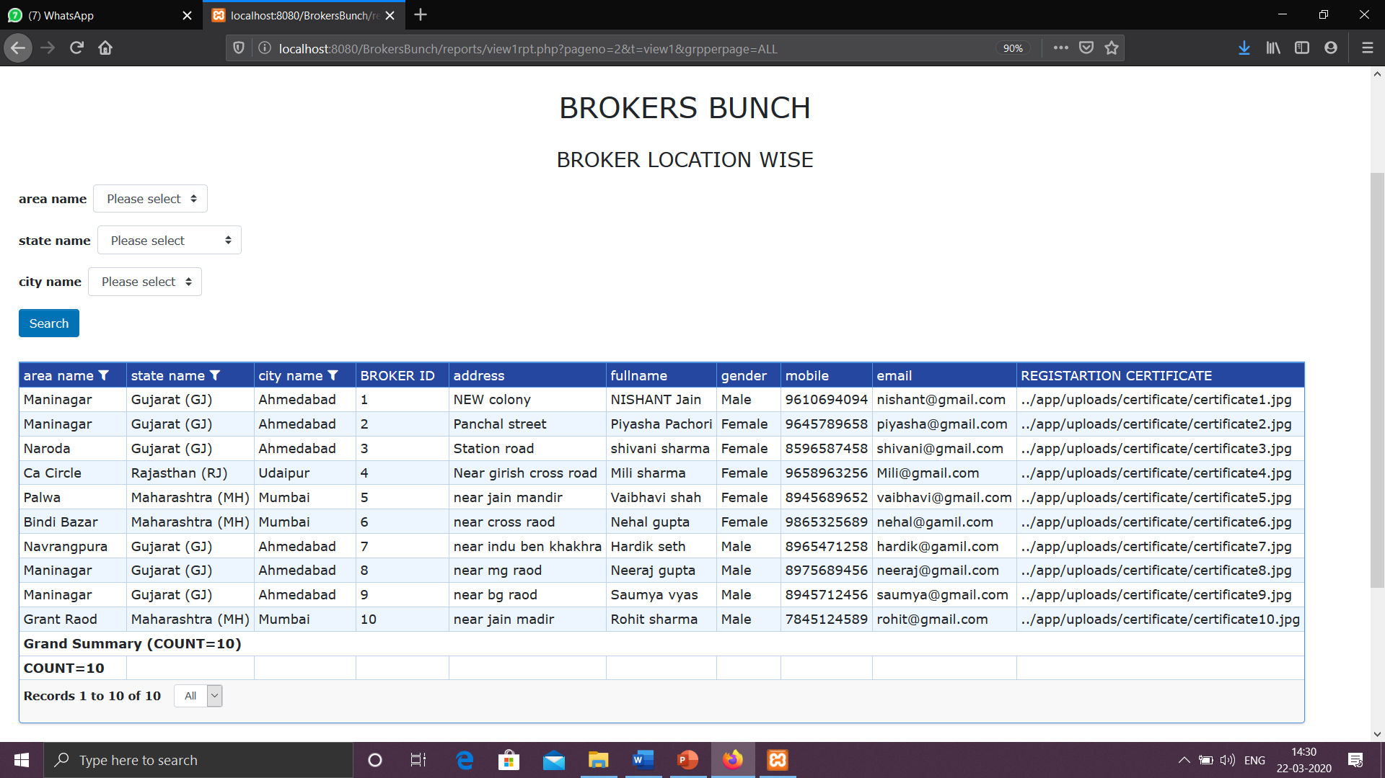**BROKER LOCATION WISE**

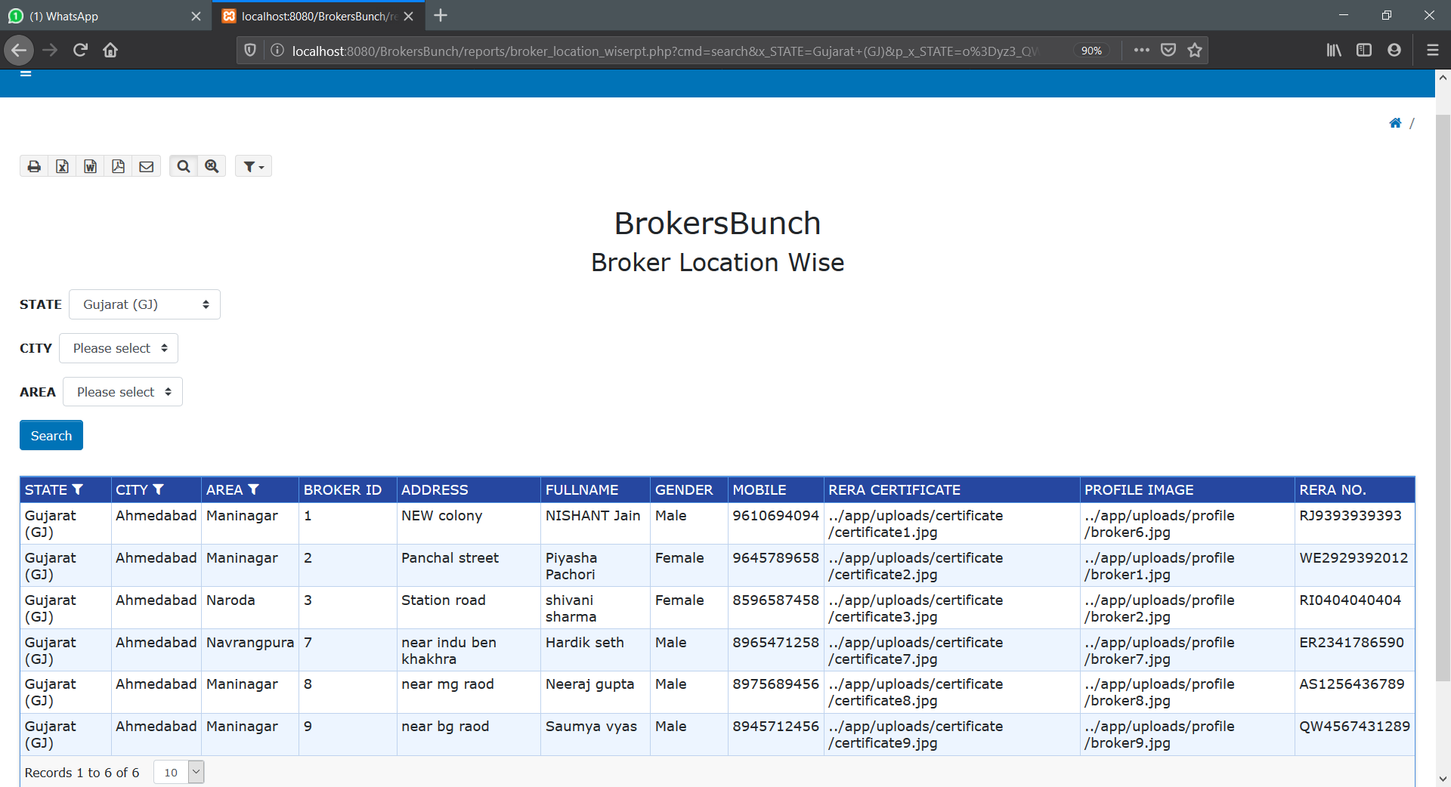**WITH FILTERS**

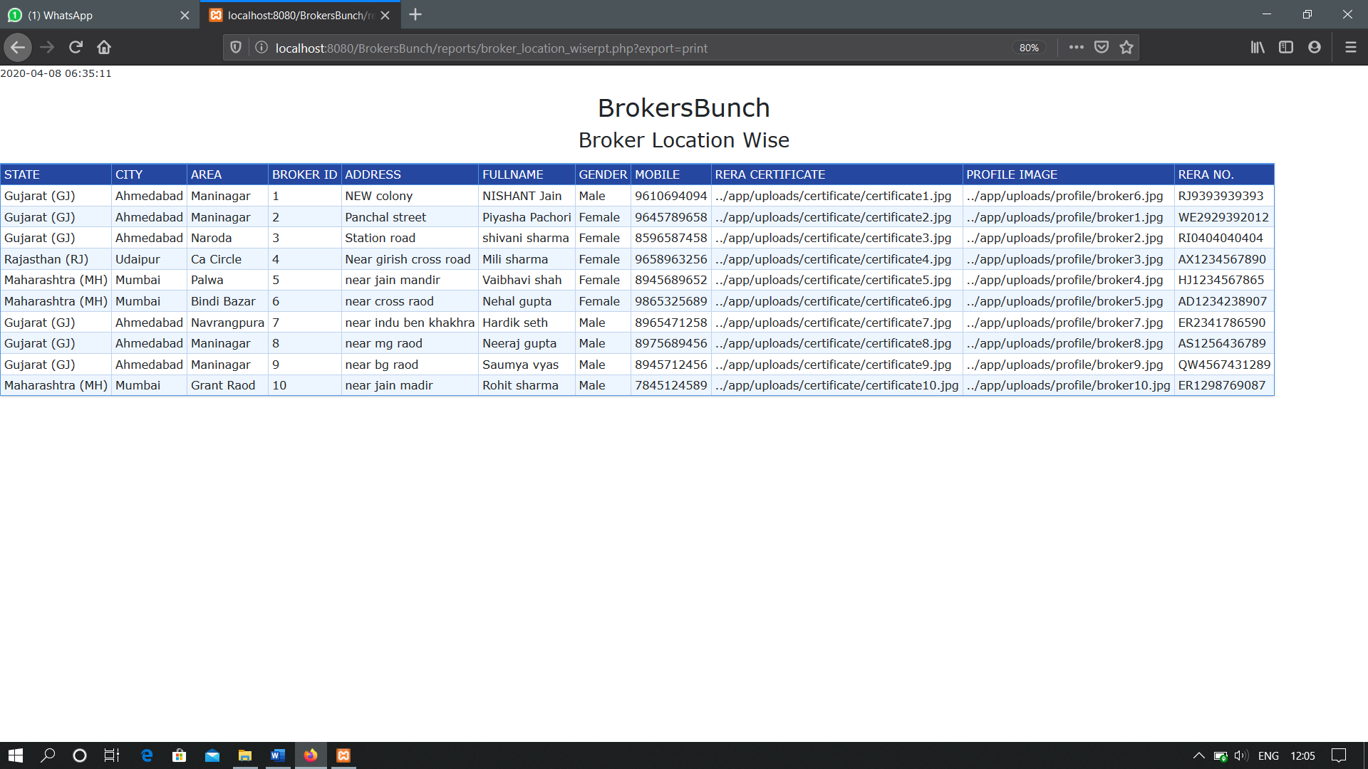**PRINT OPTION**

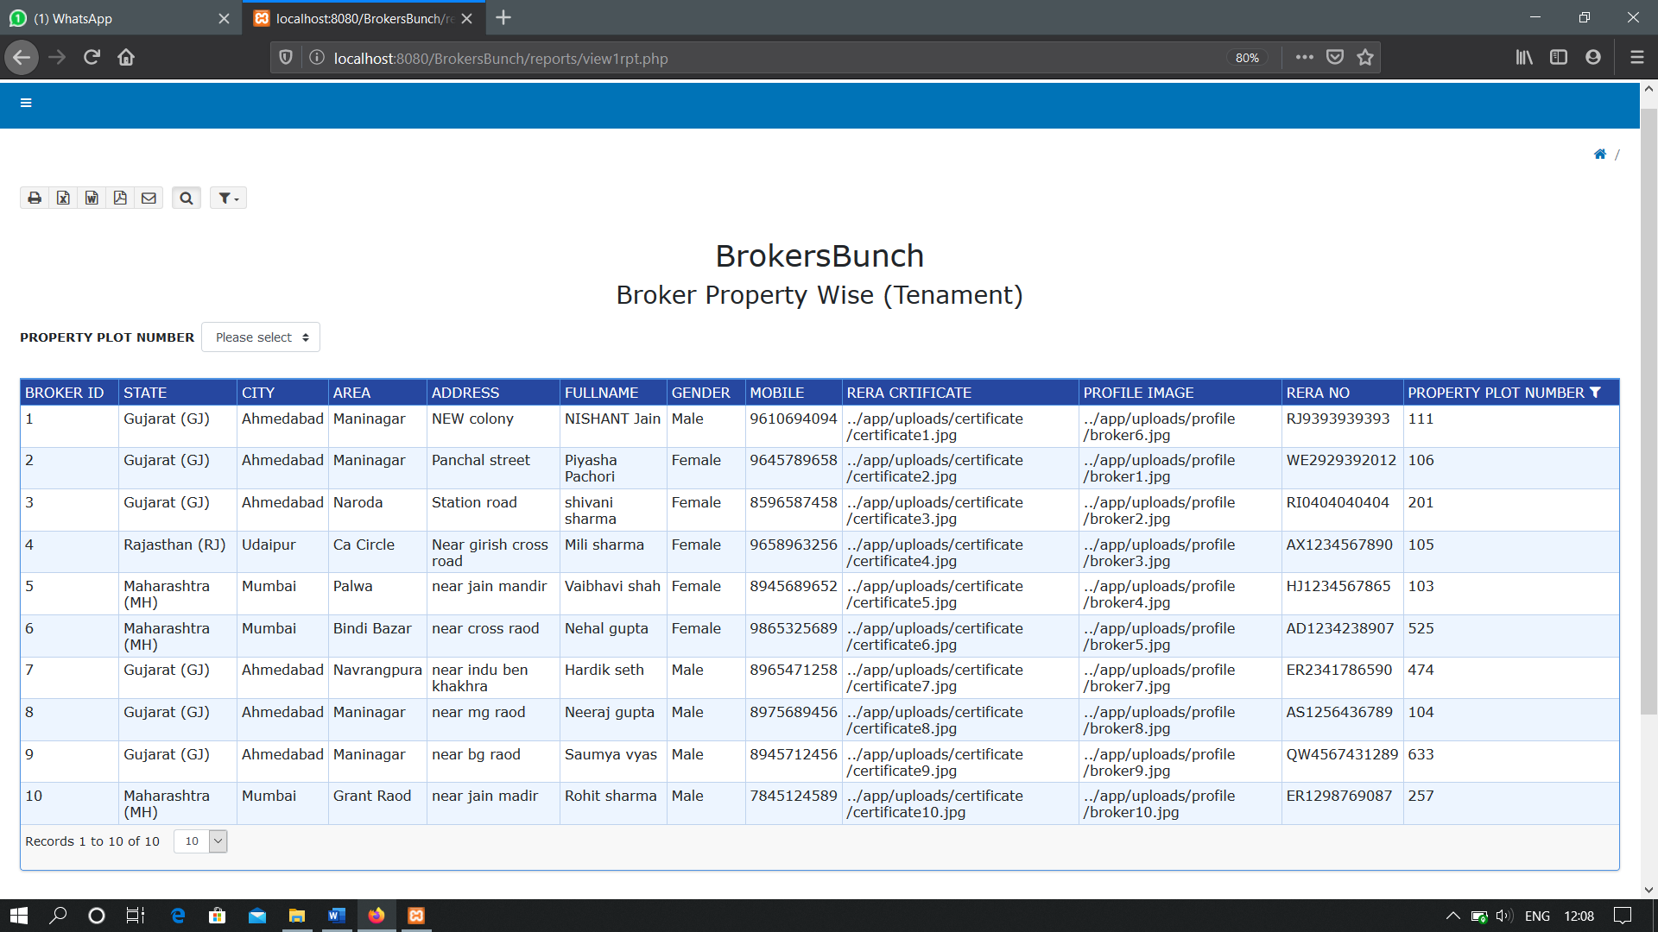**BROKER PROPERTY WISE (TENAMENT)**

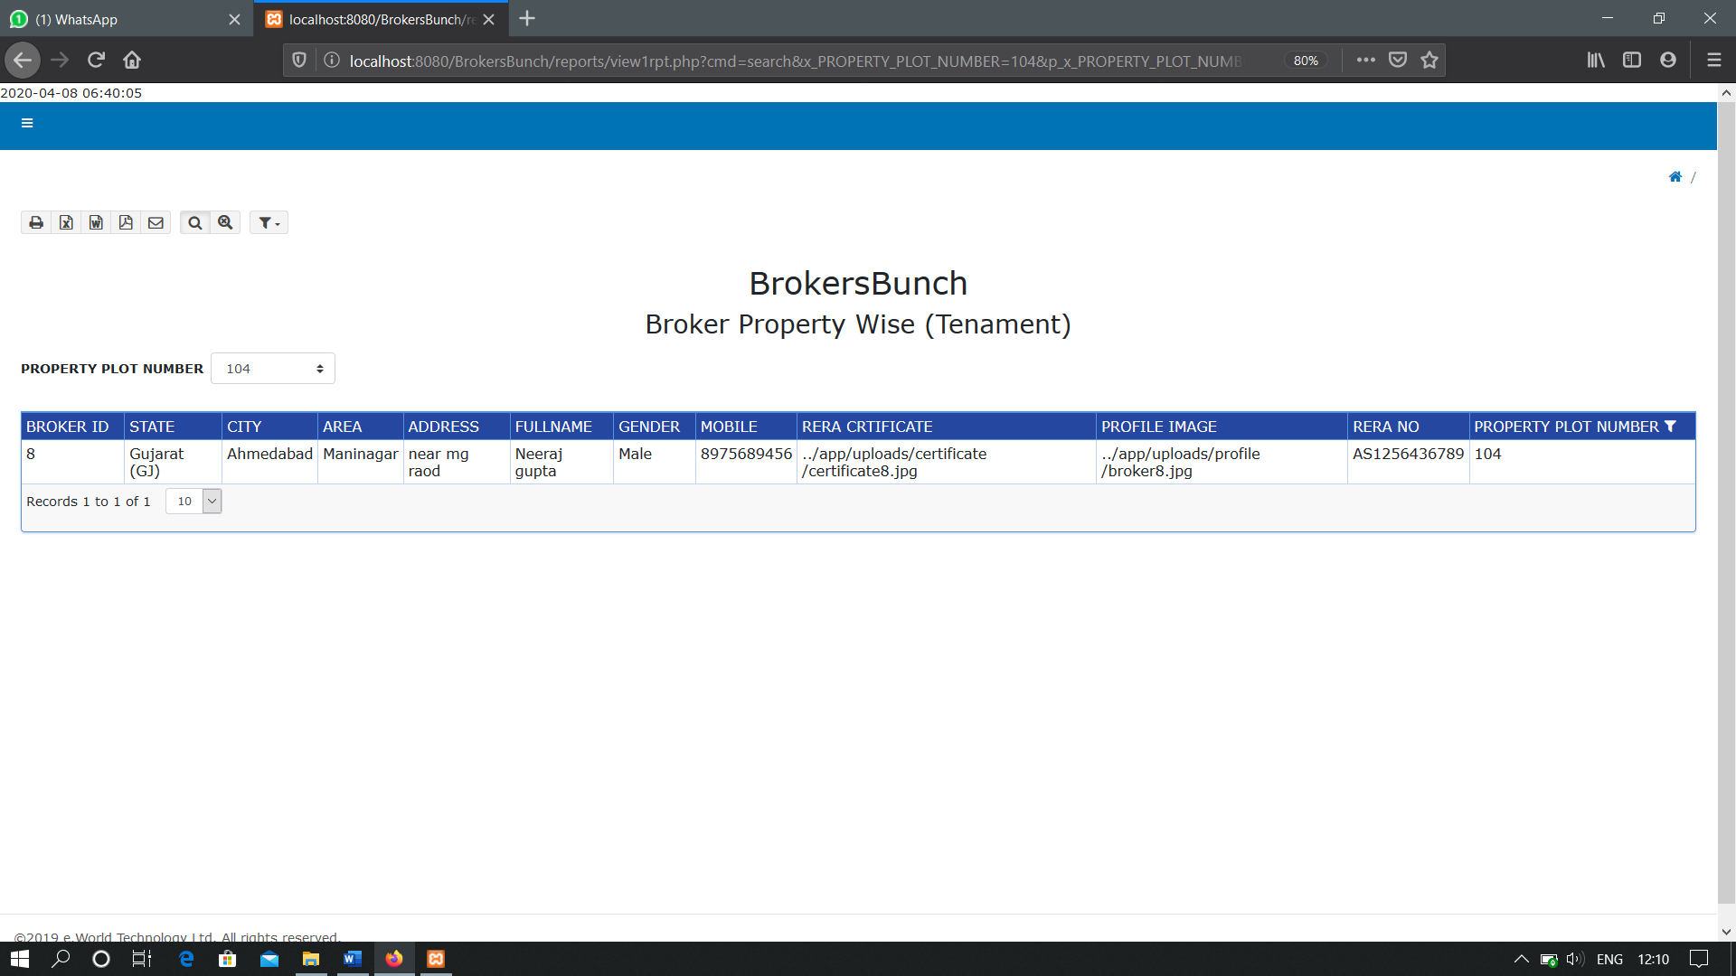**WITH FILTERS**

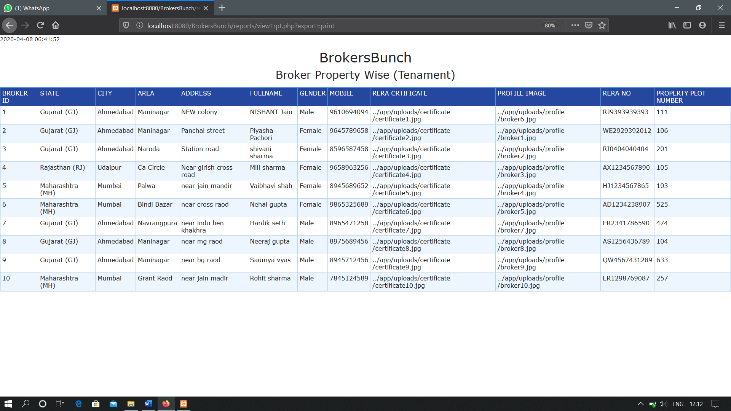**PRINT OPTION**

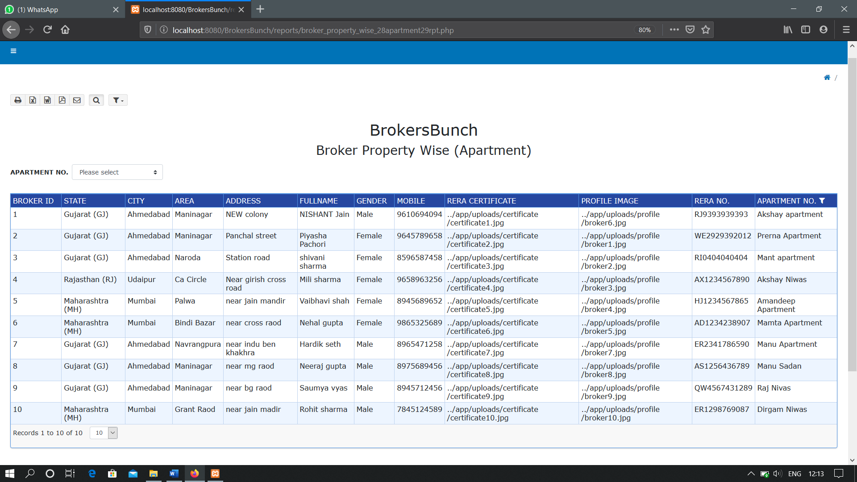**BROKER PROPERTY WISE (APARTMENT)**

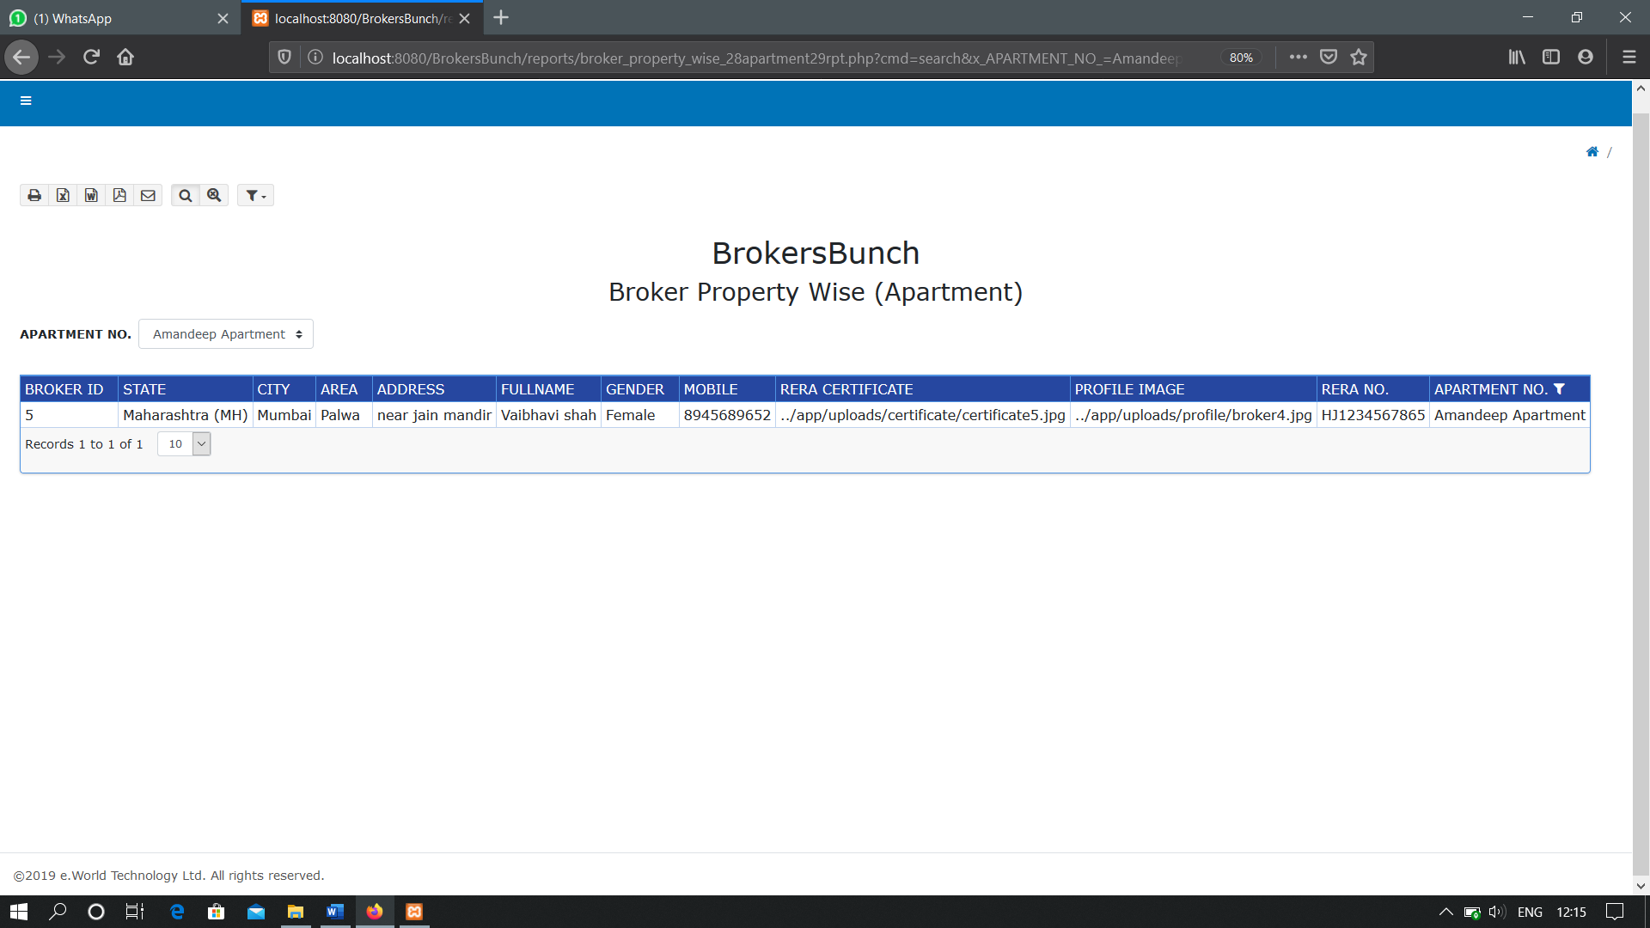 **WITH FILTER**

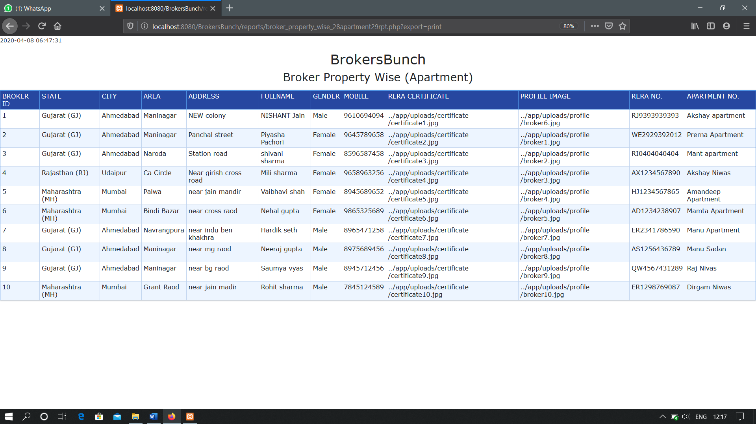 **PRINT OPTION**

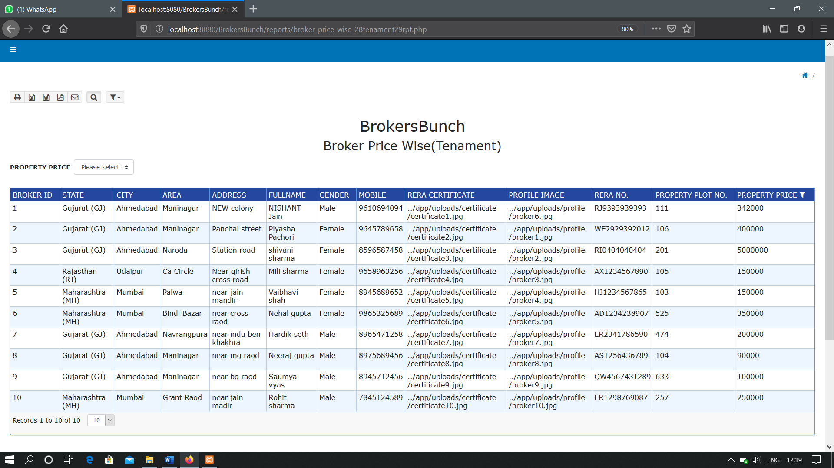 **BROKER PRICE WISE(TENAMENT)**

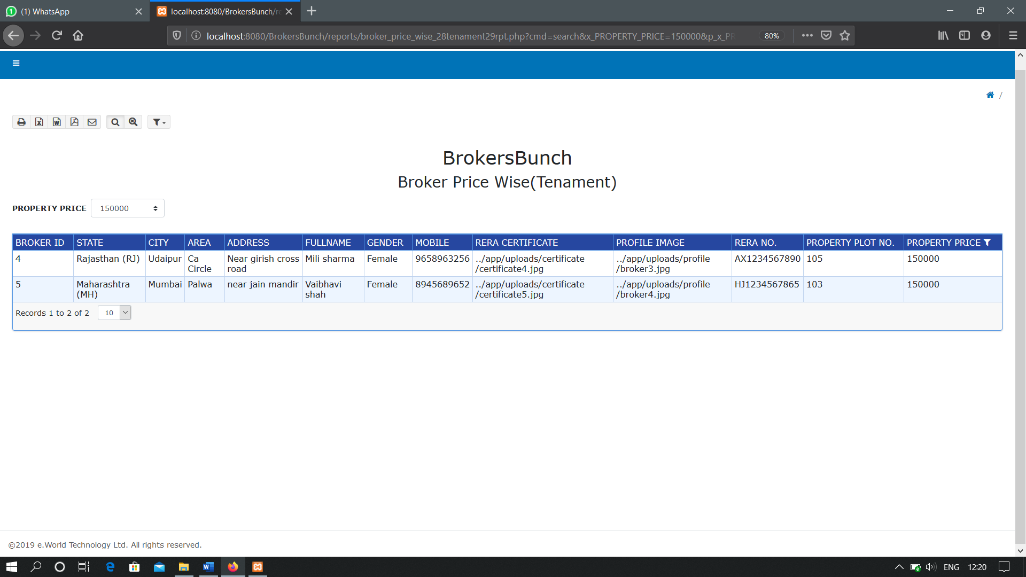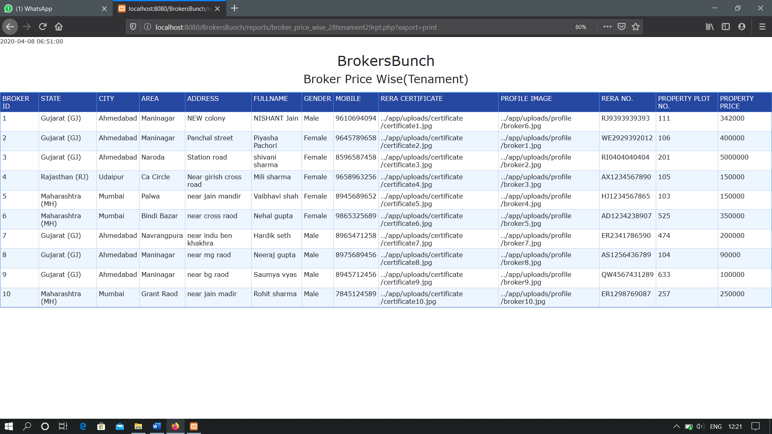 **WITH FILTER**

**PRINT OPTION**

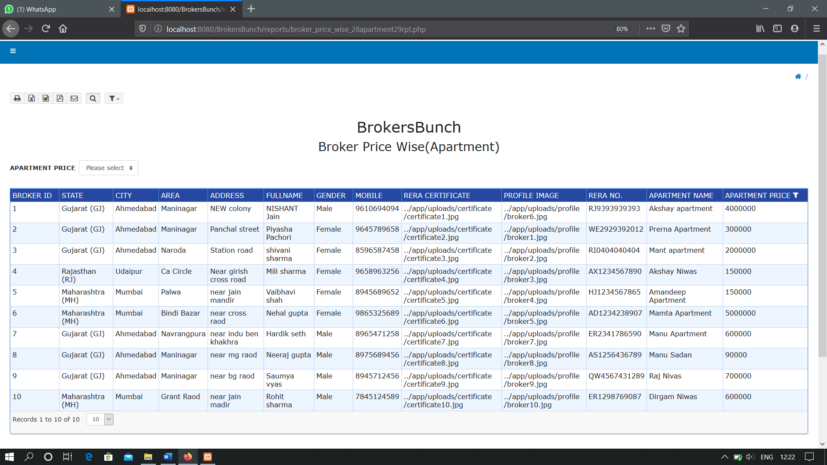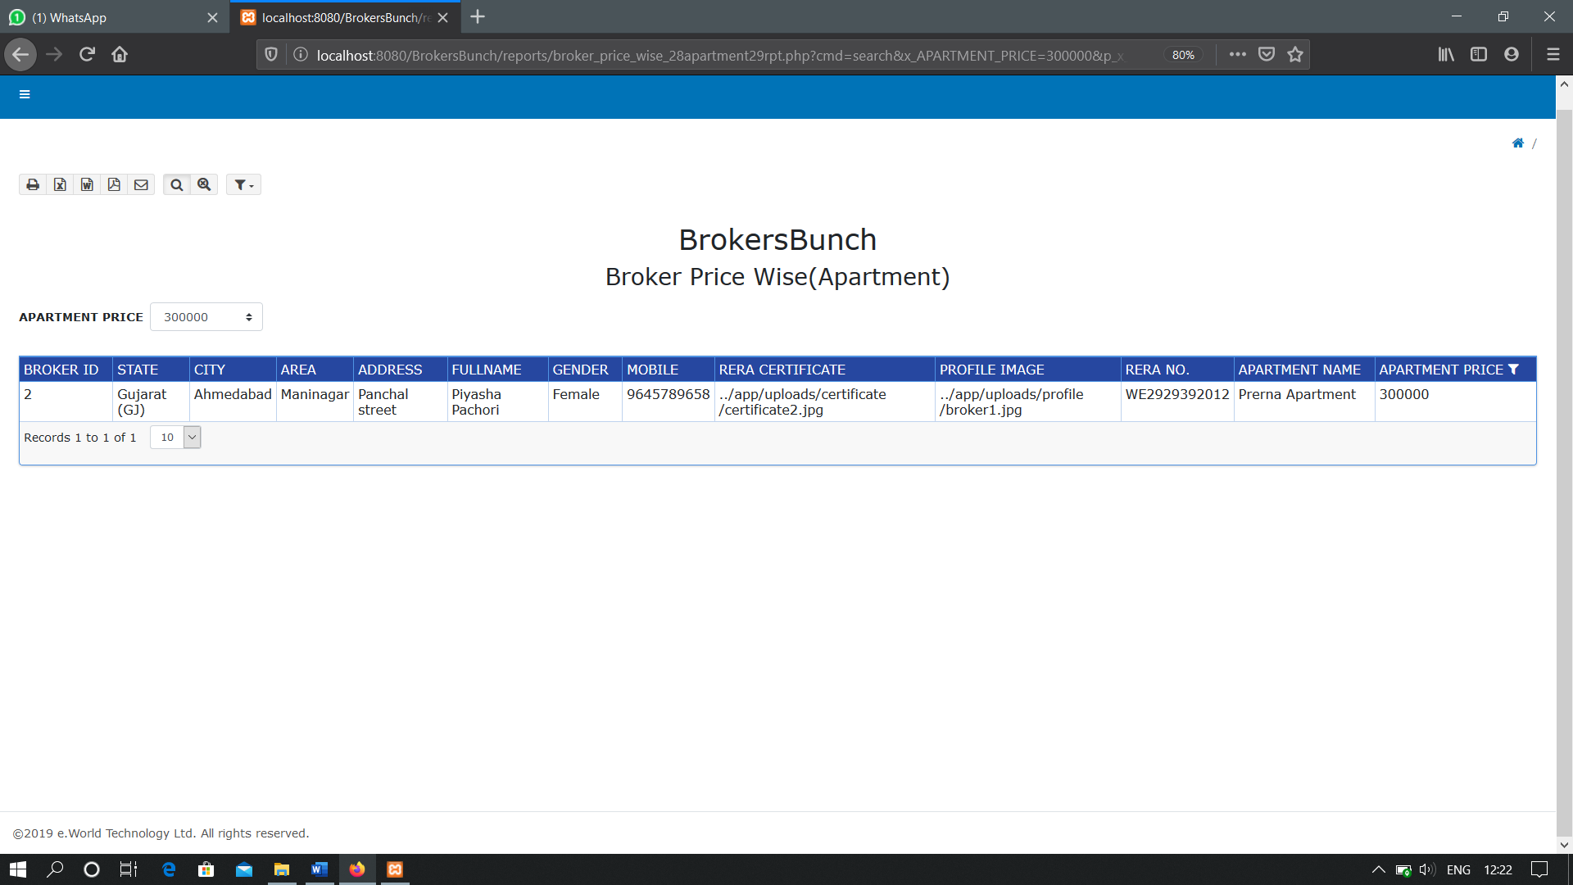**BROKER PRICE WISE(APARTMENT)**

**WITH FILTER**

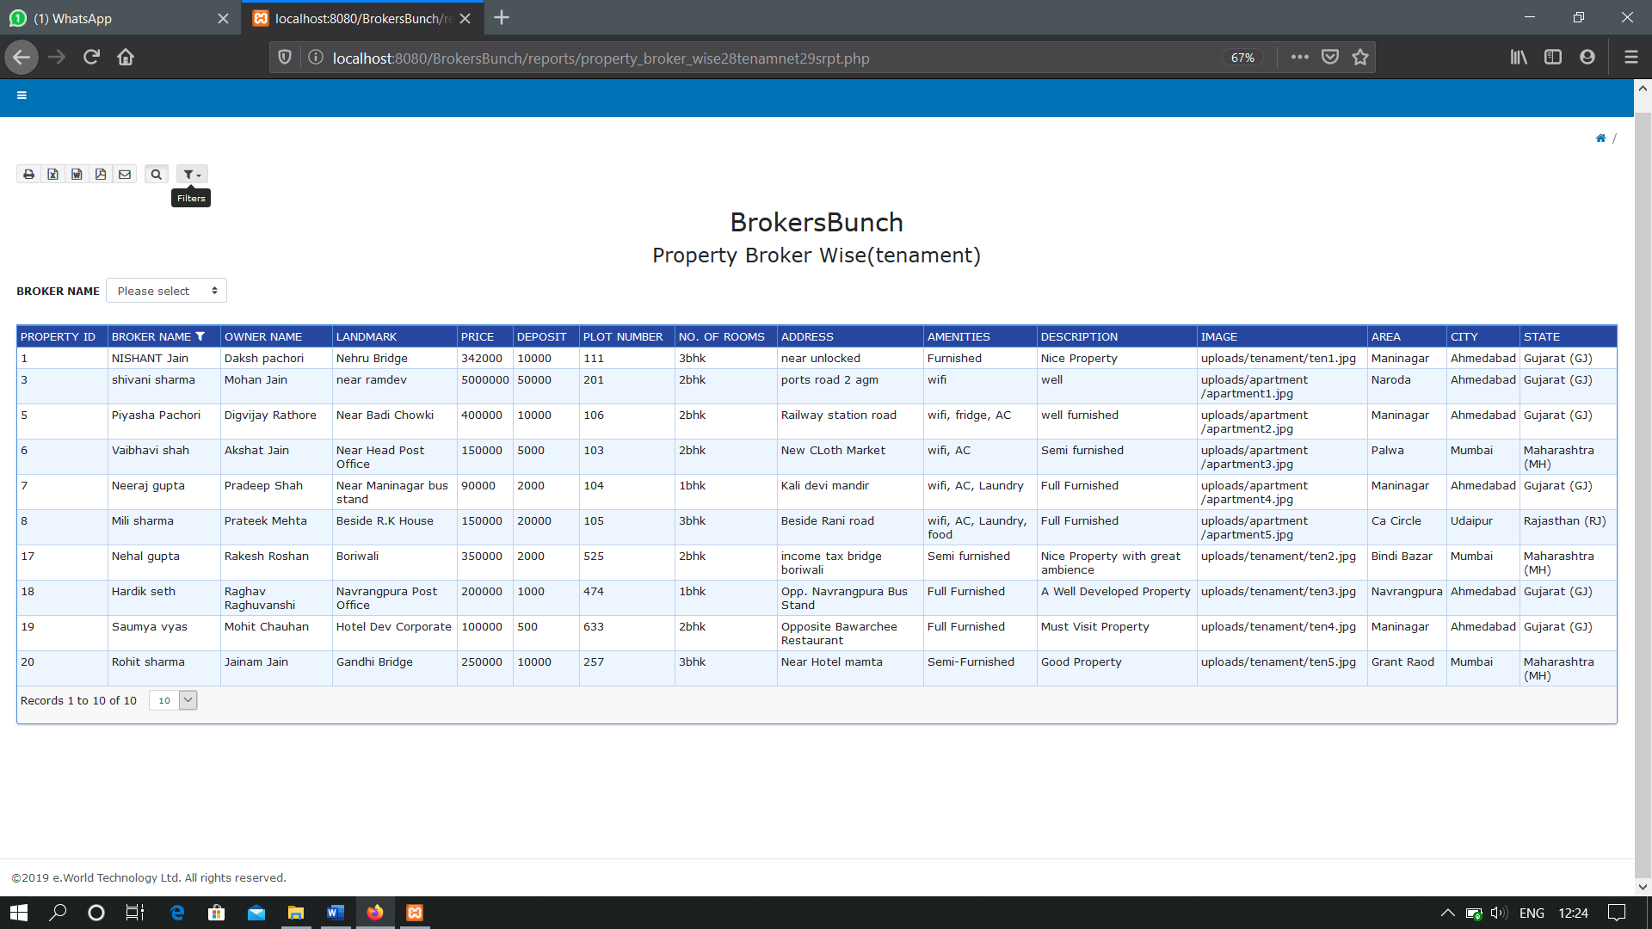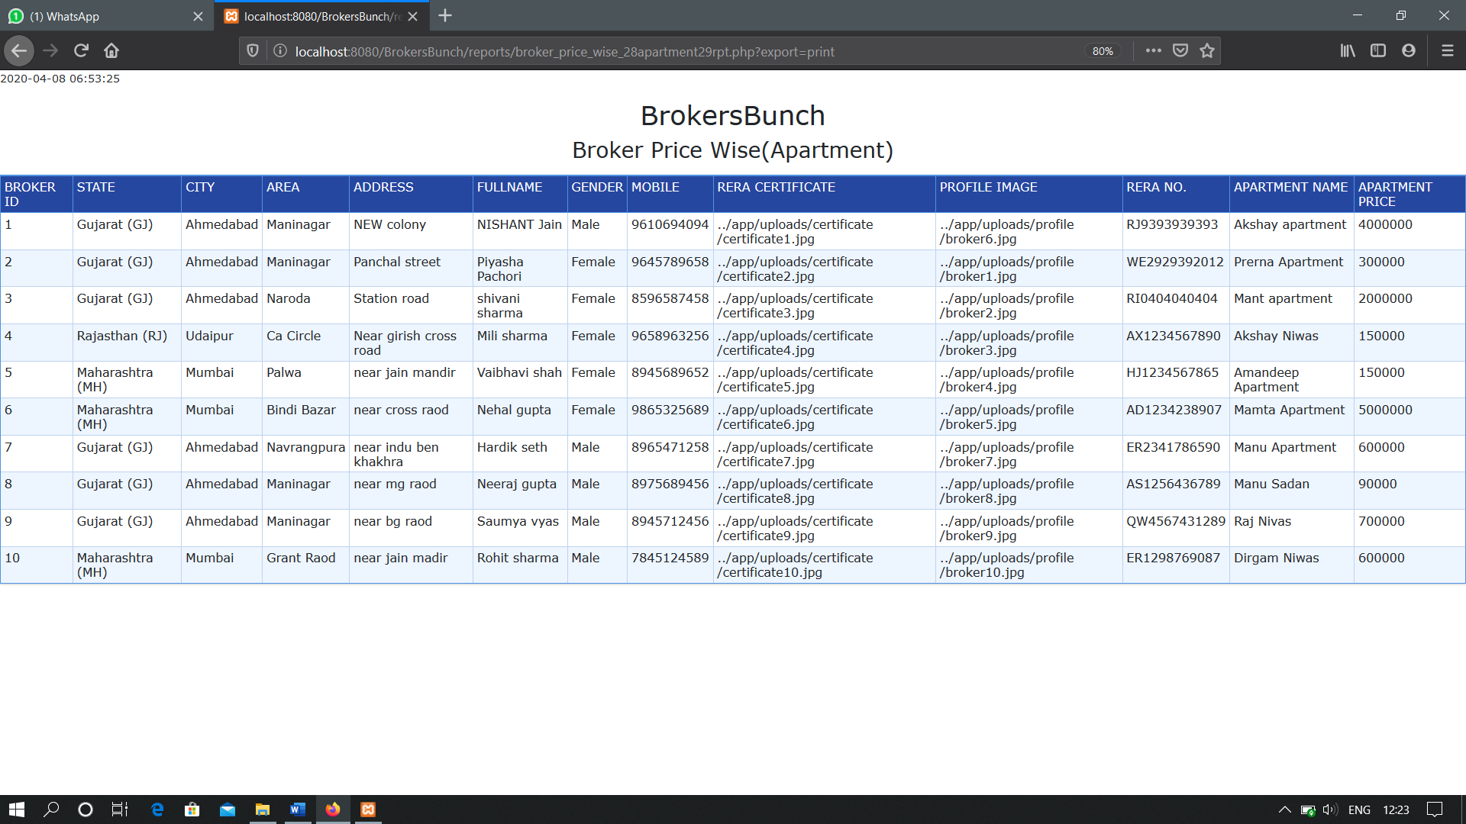**PRINT OPTION**

**PROPERTY BROKER WISE(TENAMENT)**

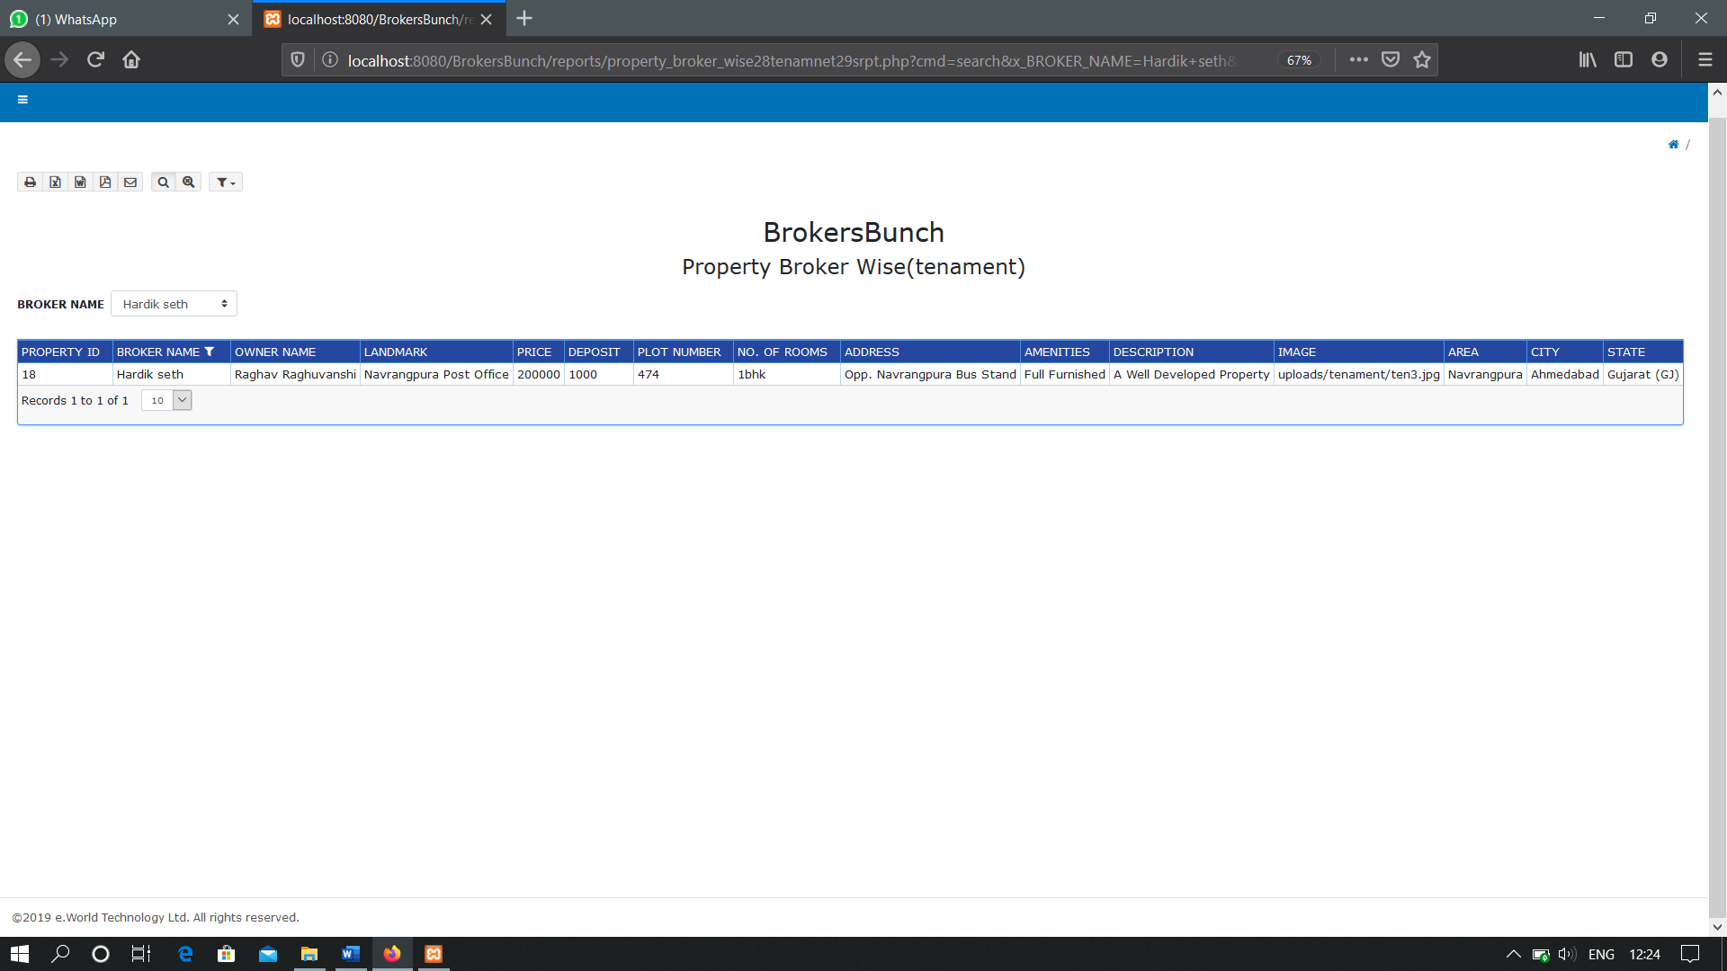**WITH FILTER**

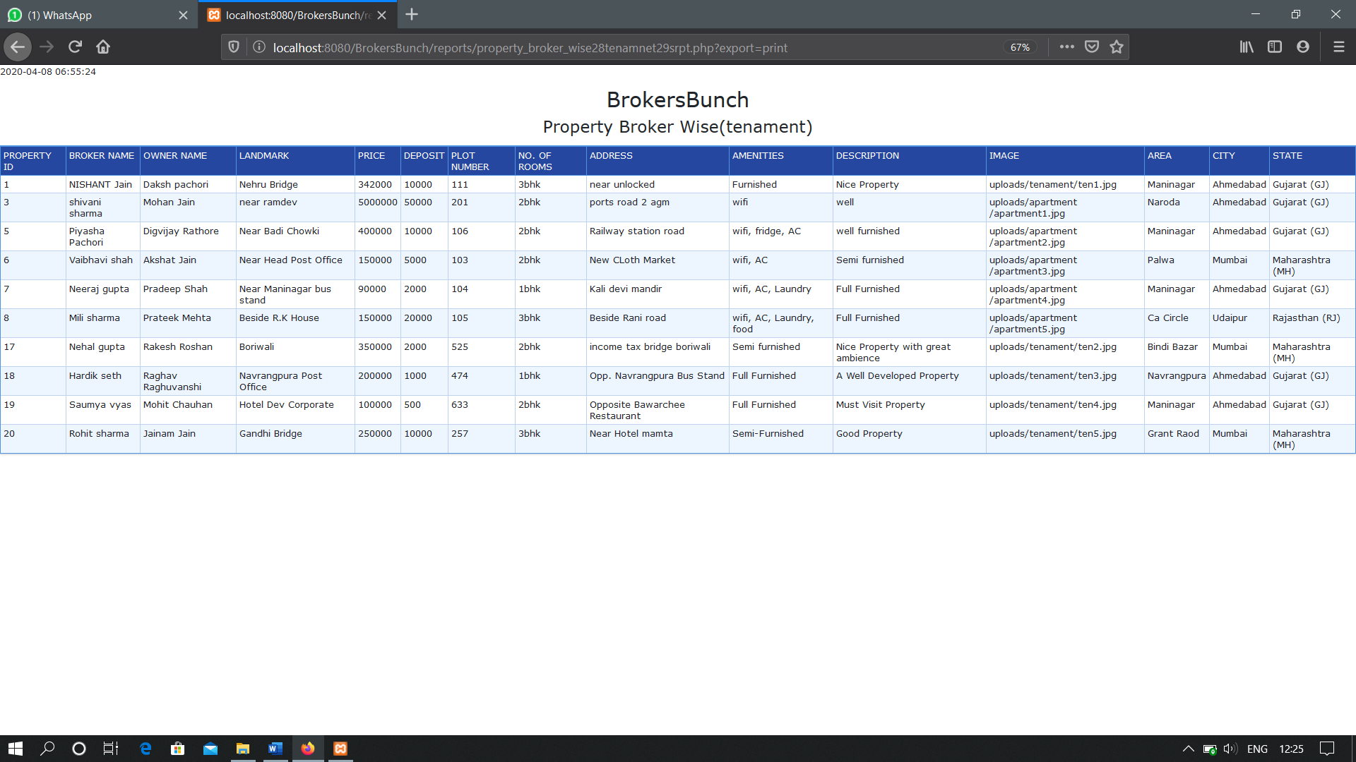**PRINT OPTION**

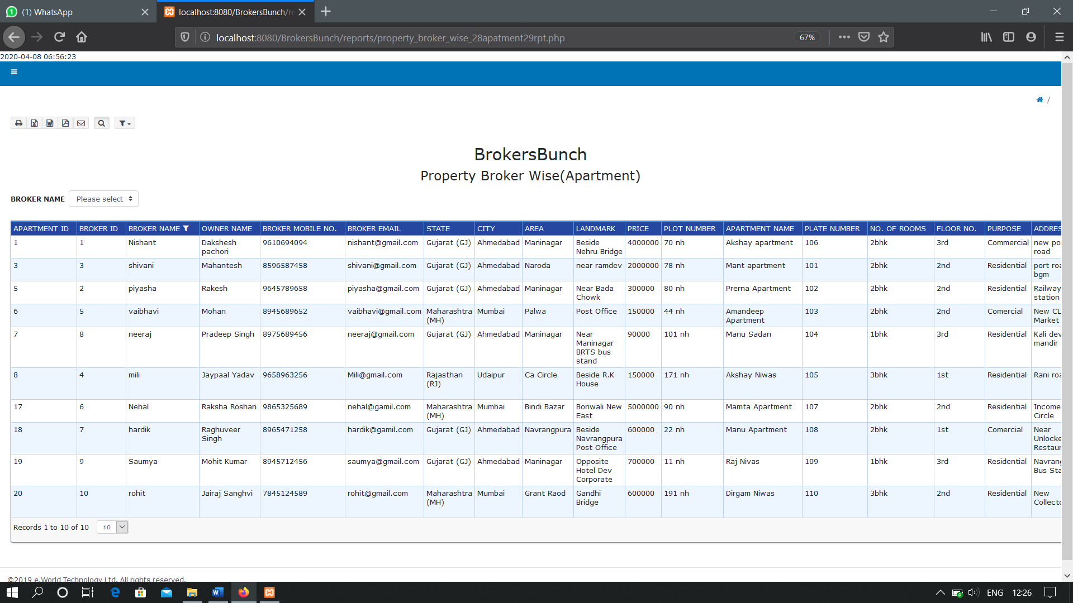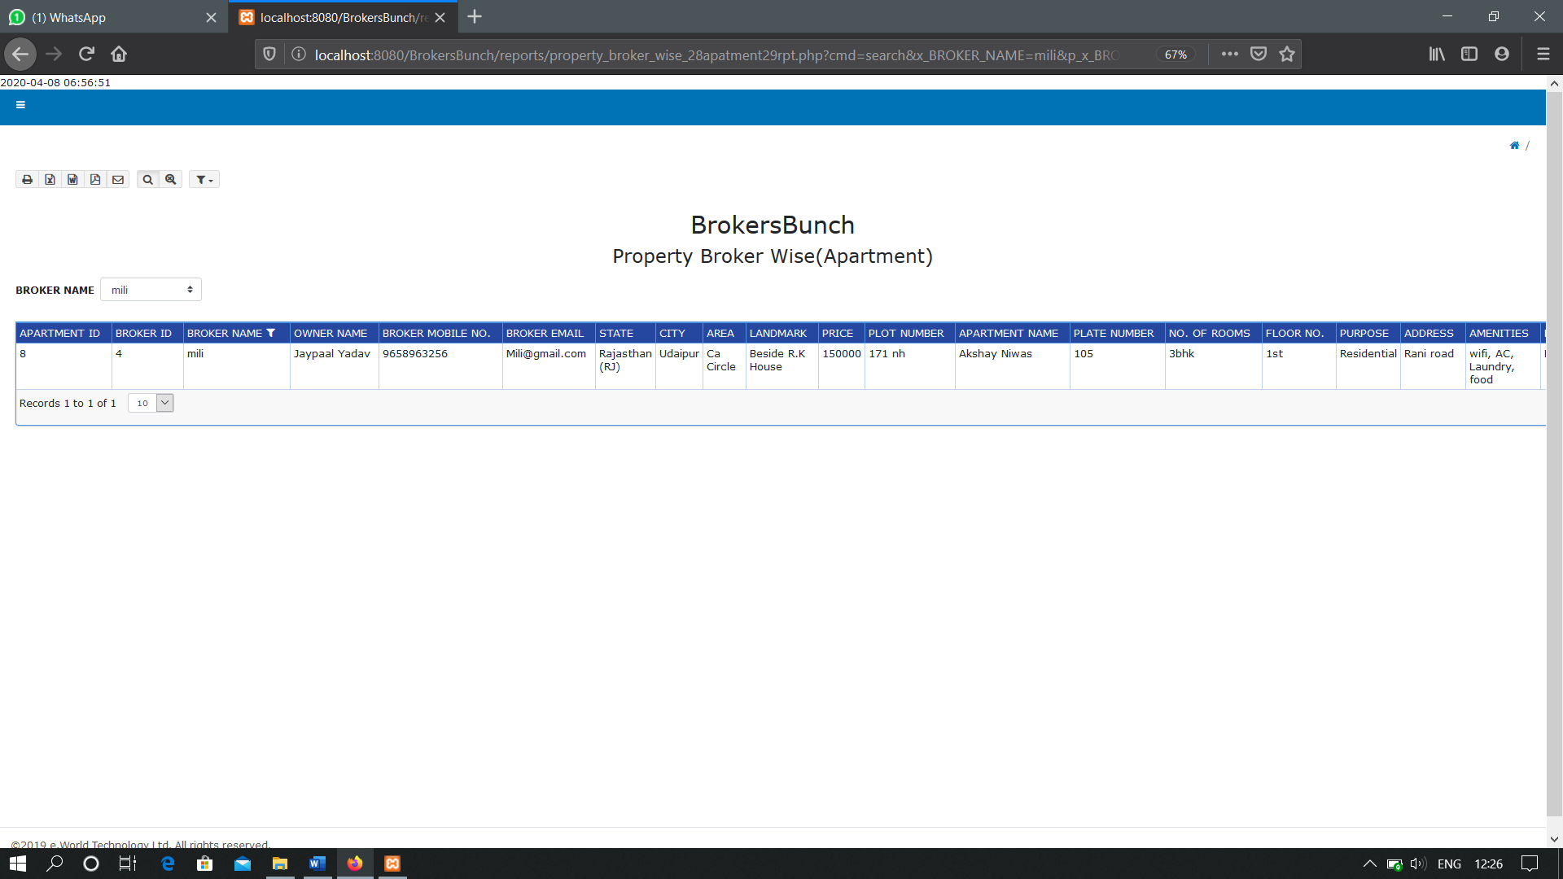**PROPERTY BROKER WISE(APARTMENT)**

**WITH FILTER**

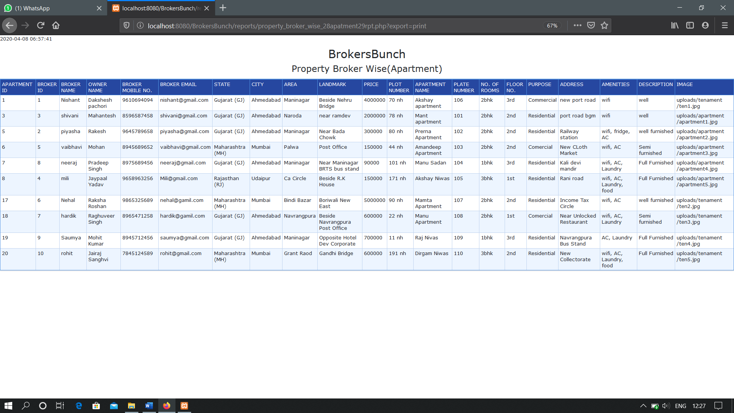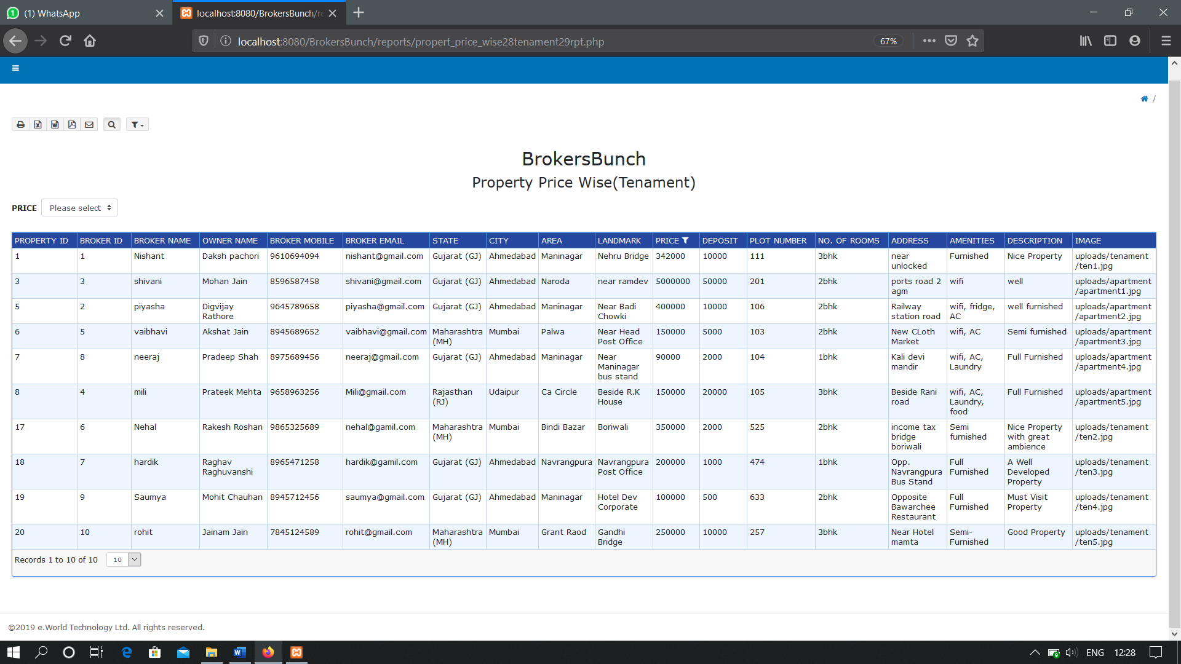**PRINT OPTION**

**PROPERTY PRICE WISE(TENAMENT)**

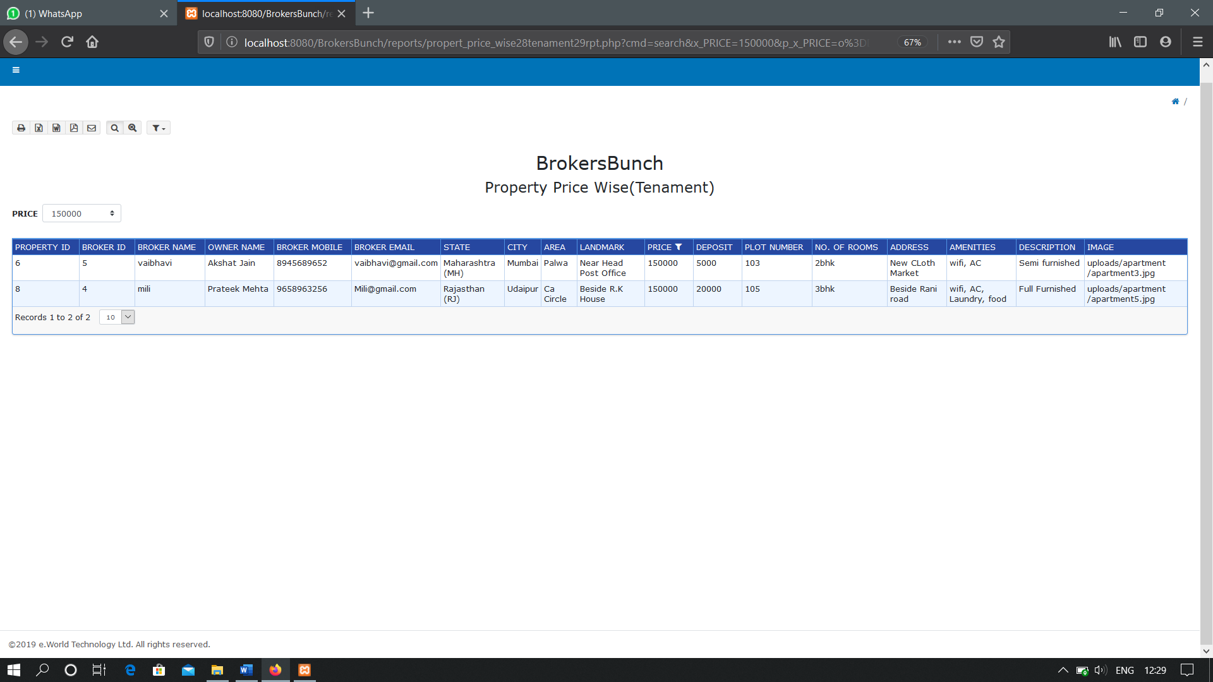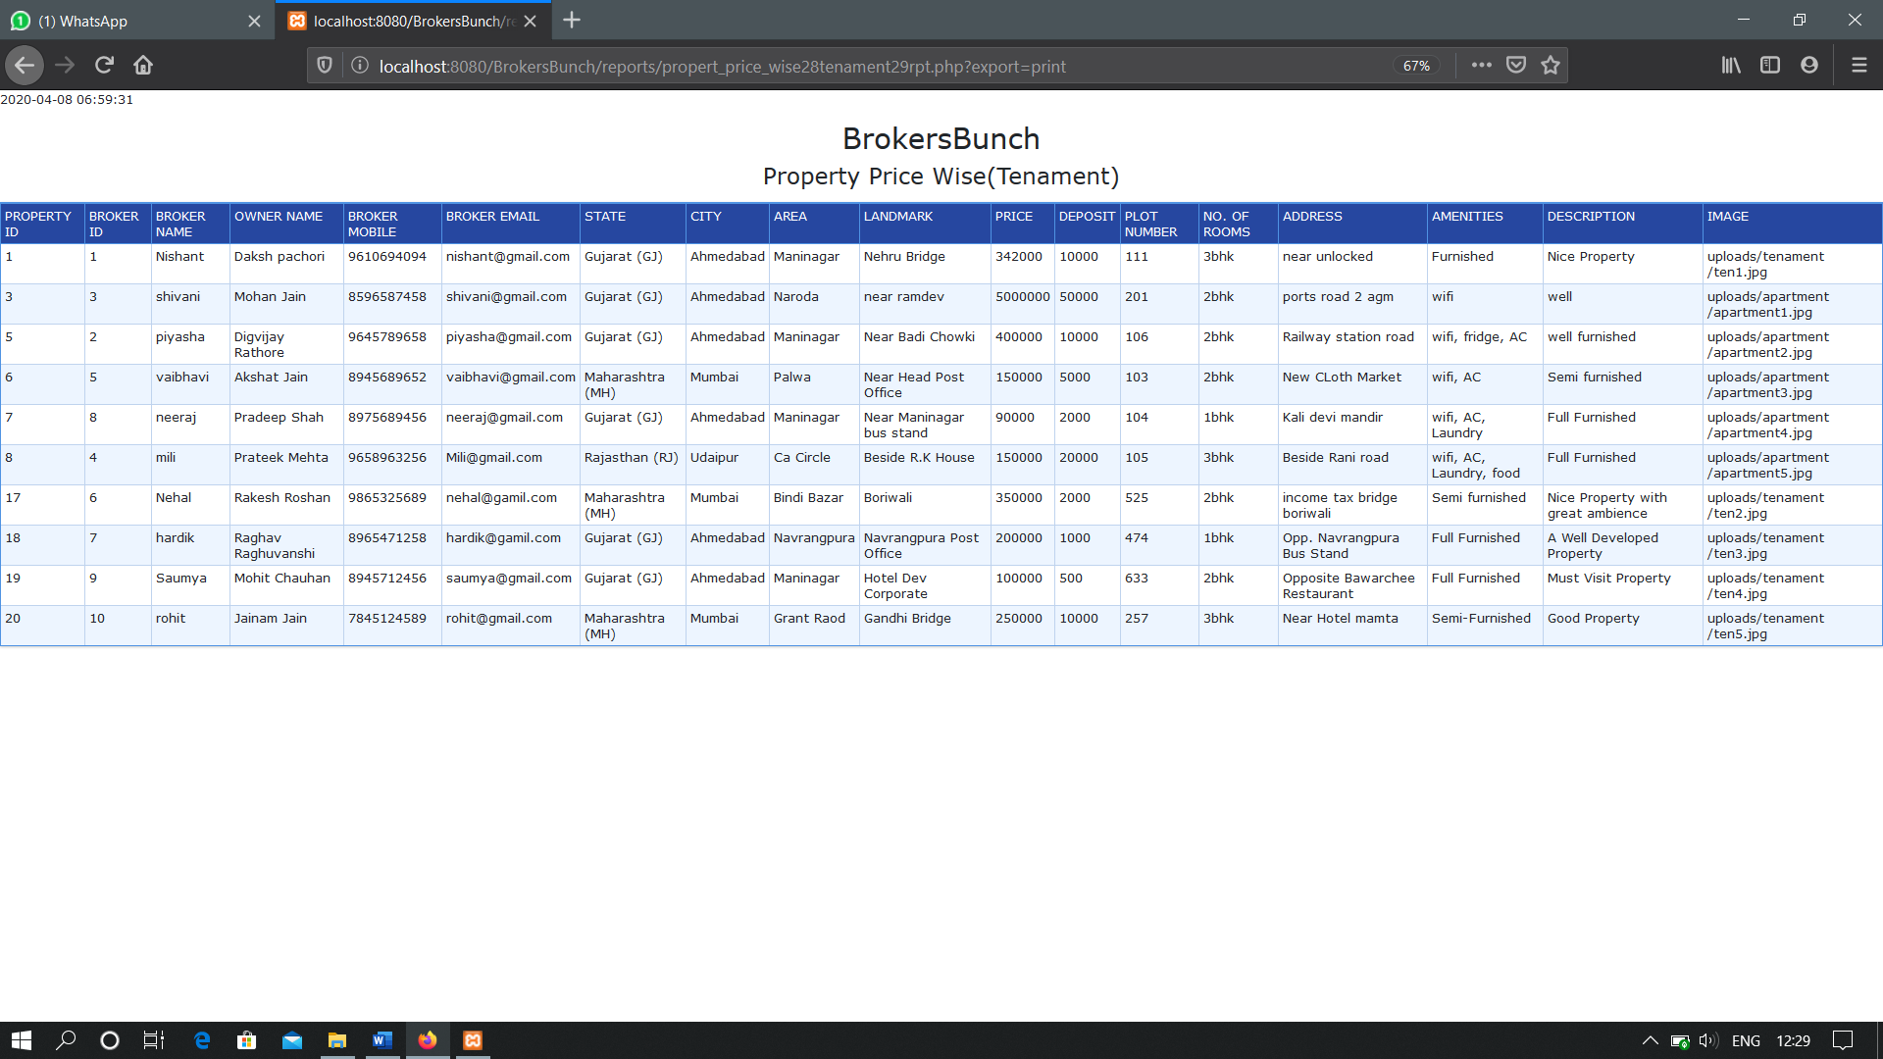**WITH FILTER**

**PRINT OPTION**

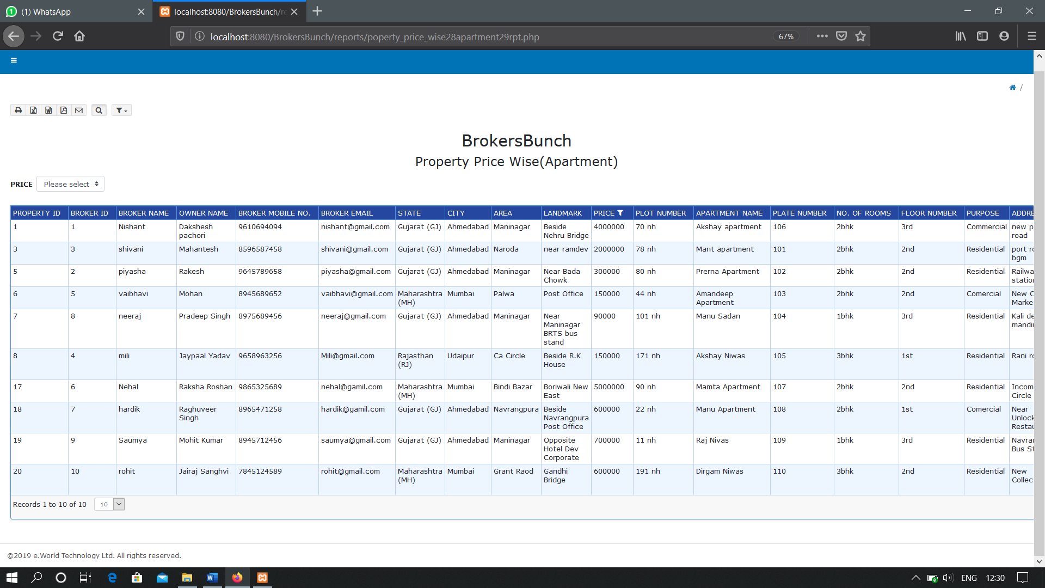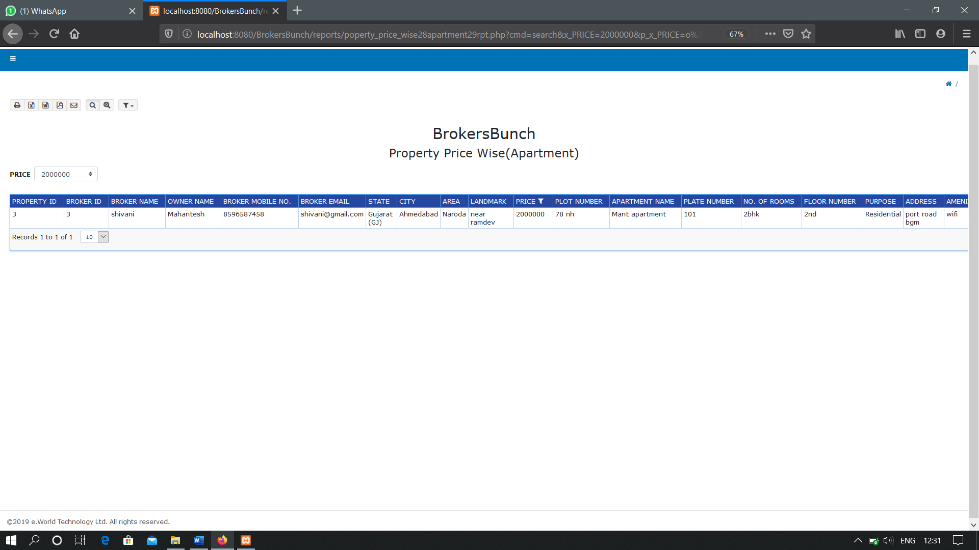**PROPERTY PRICE WISE(APARTMENT)**

**WITH FILTER**

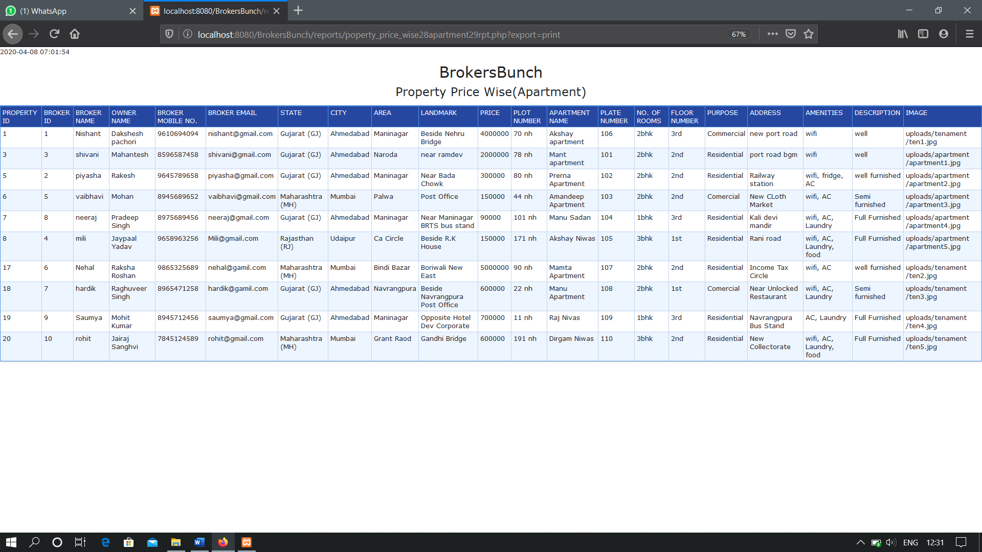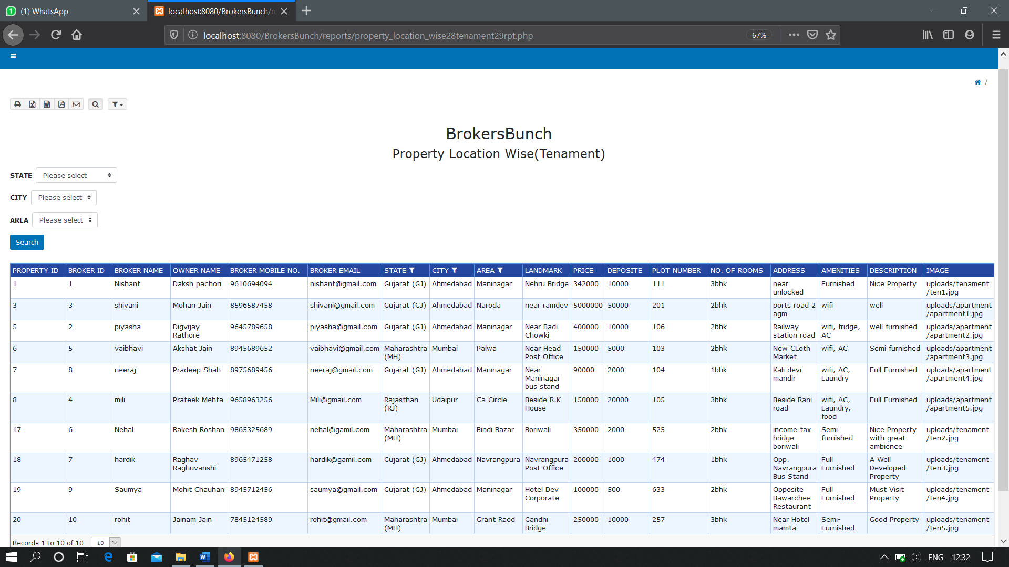**PRINT OPTION**

**PROPERTY LOCATION WISE(TENAMENT)**

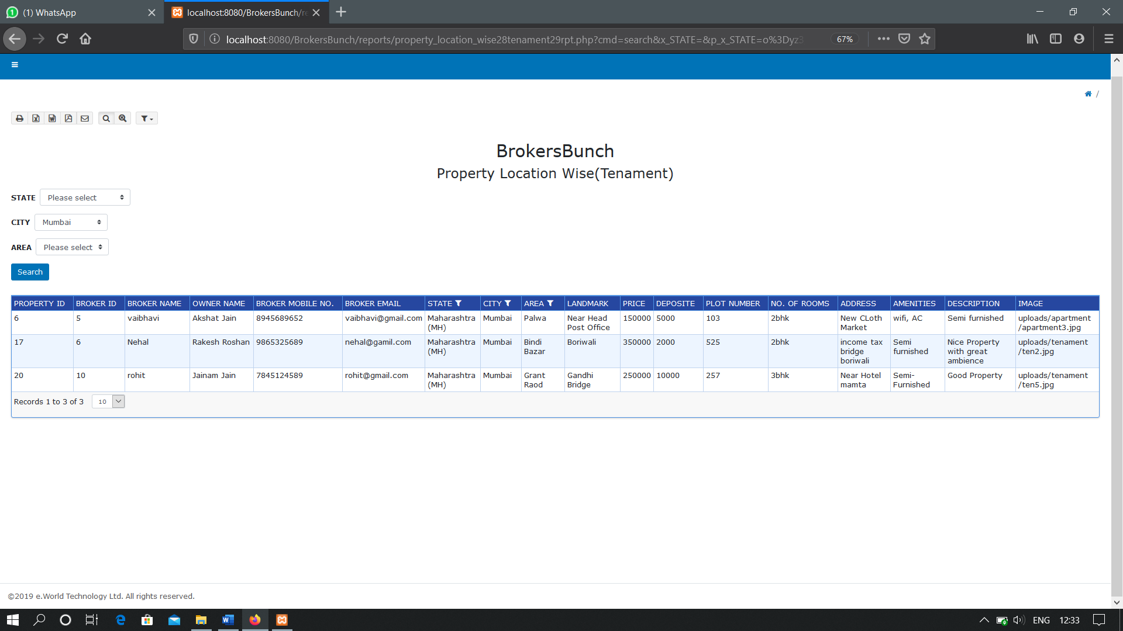**WITH FILTER**

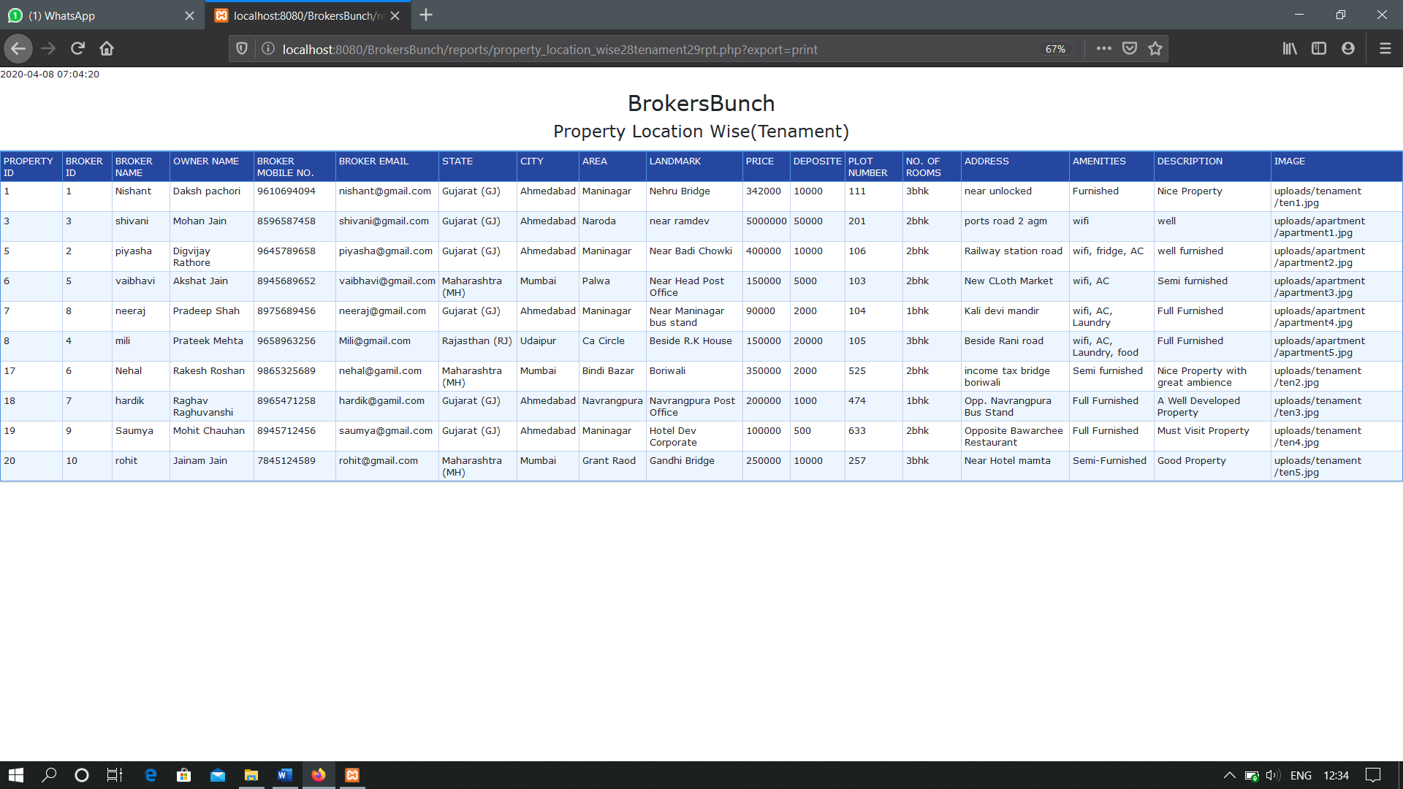**PRINT OPTION**

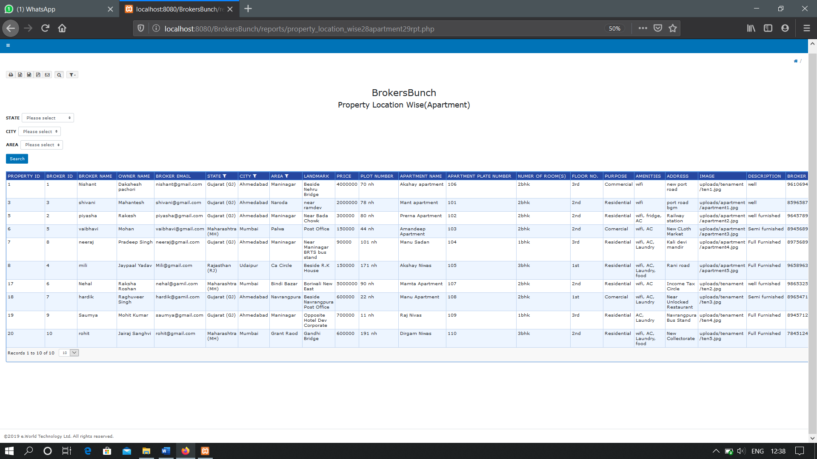**PROPERTY LOCATION WISE(APARTMENT)**

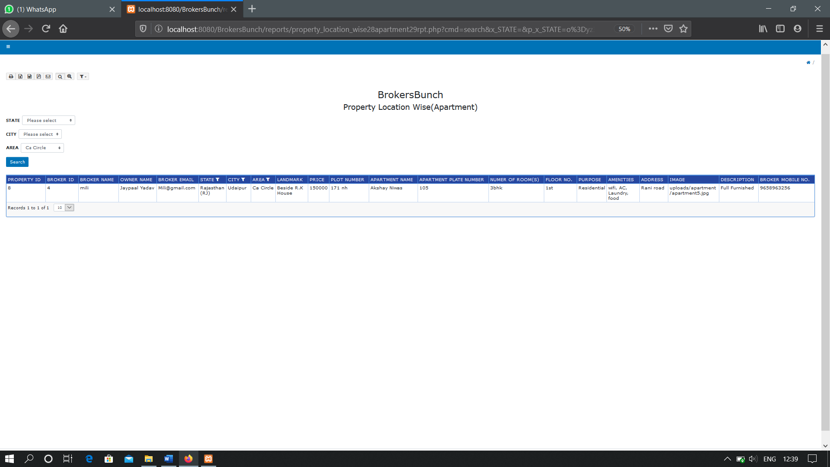**WITH FILTER**

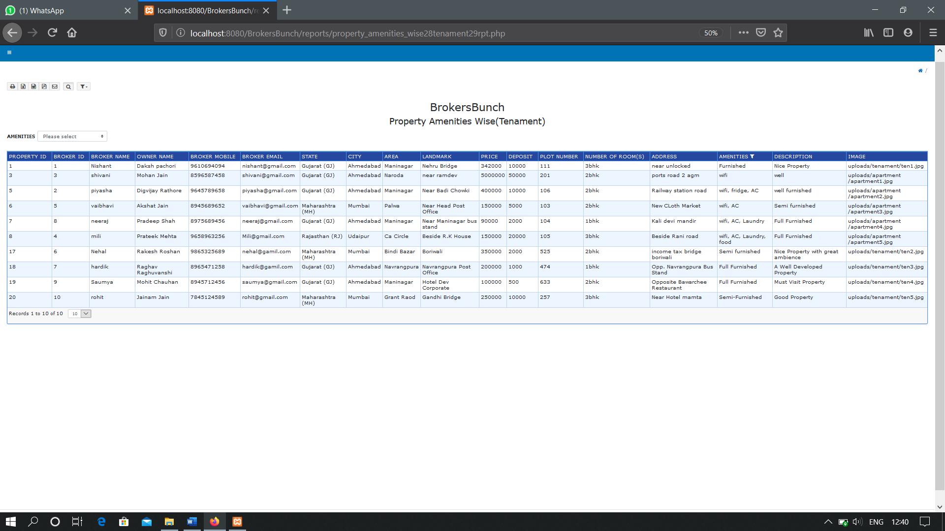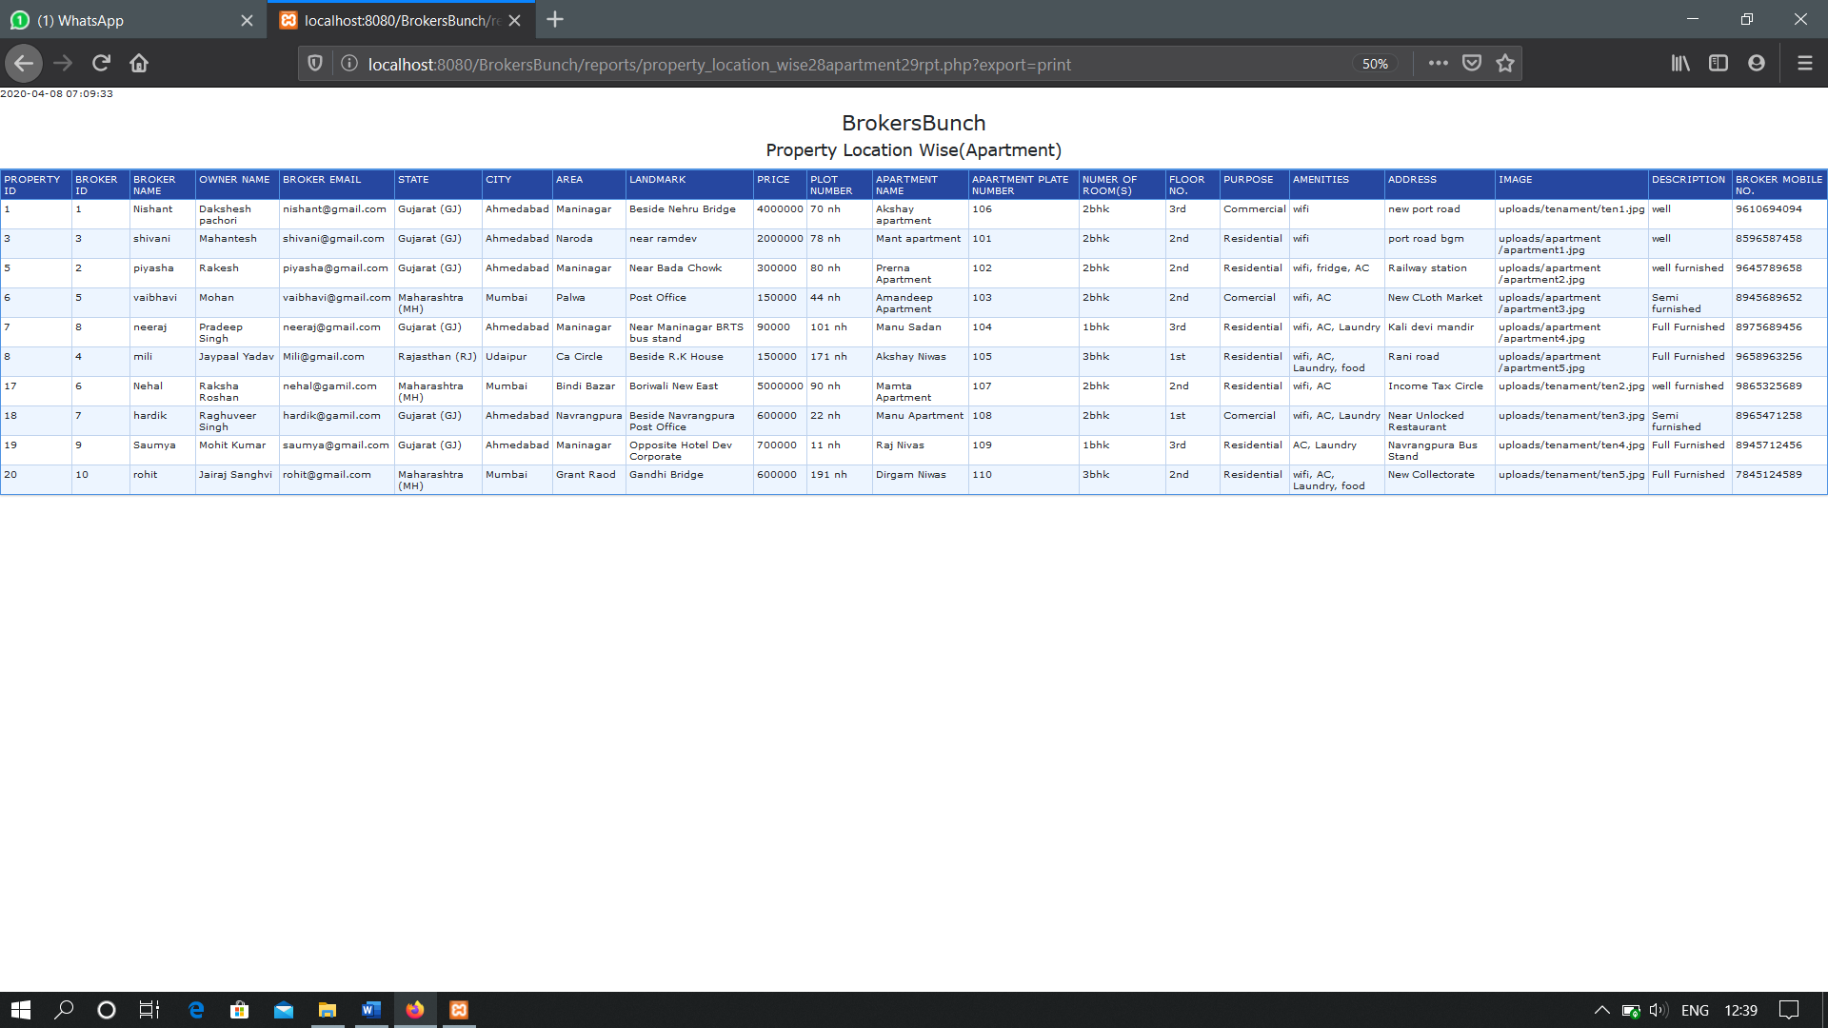**PRINT OPTION**

**PROPERTY AMENITIES WISE(TENAMENT)**

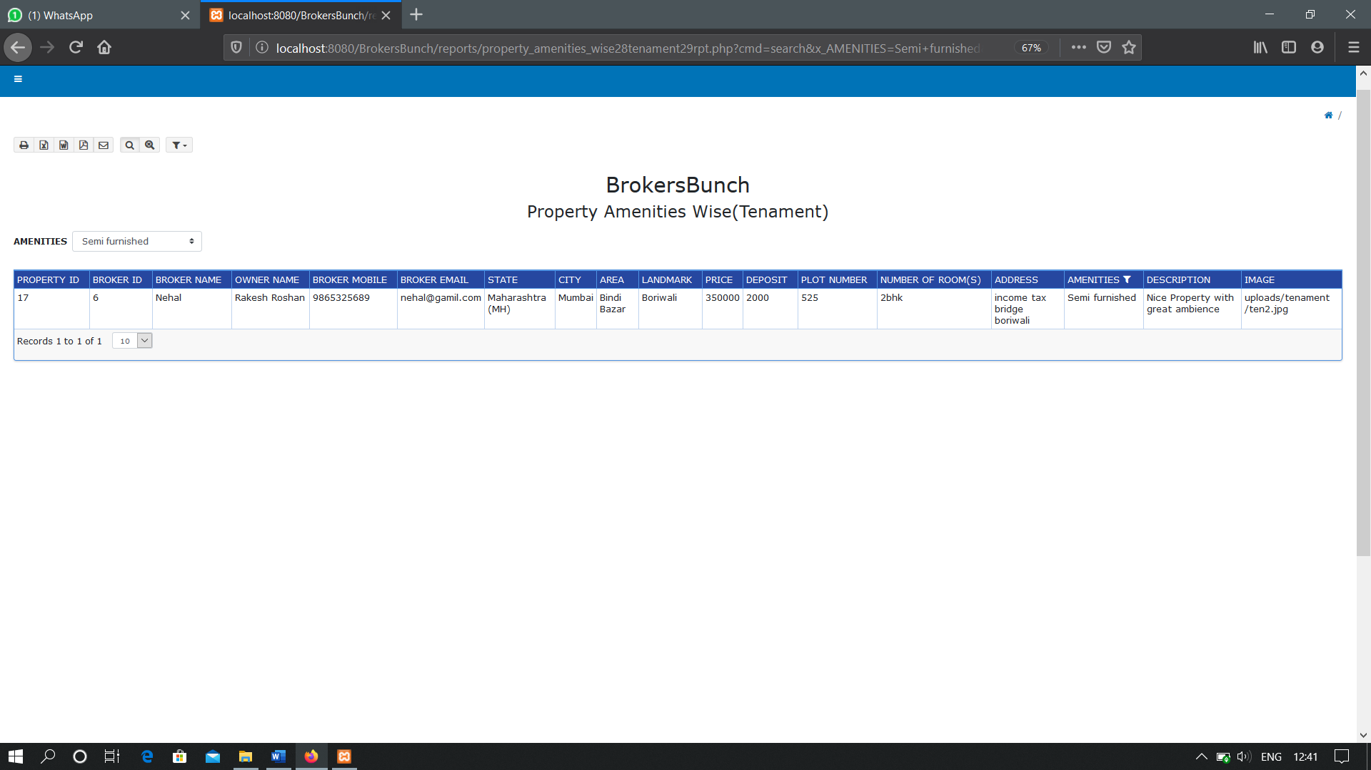**WITH FILTER**

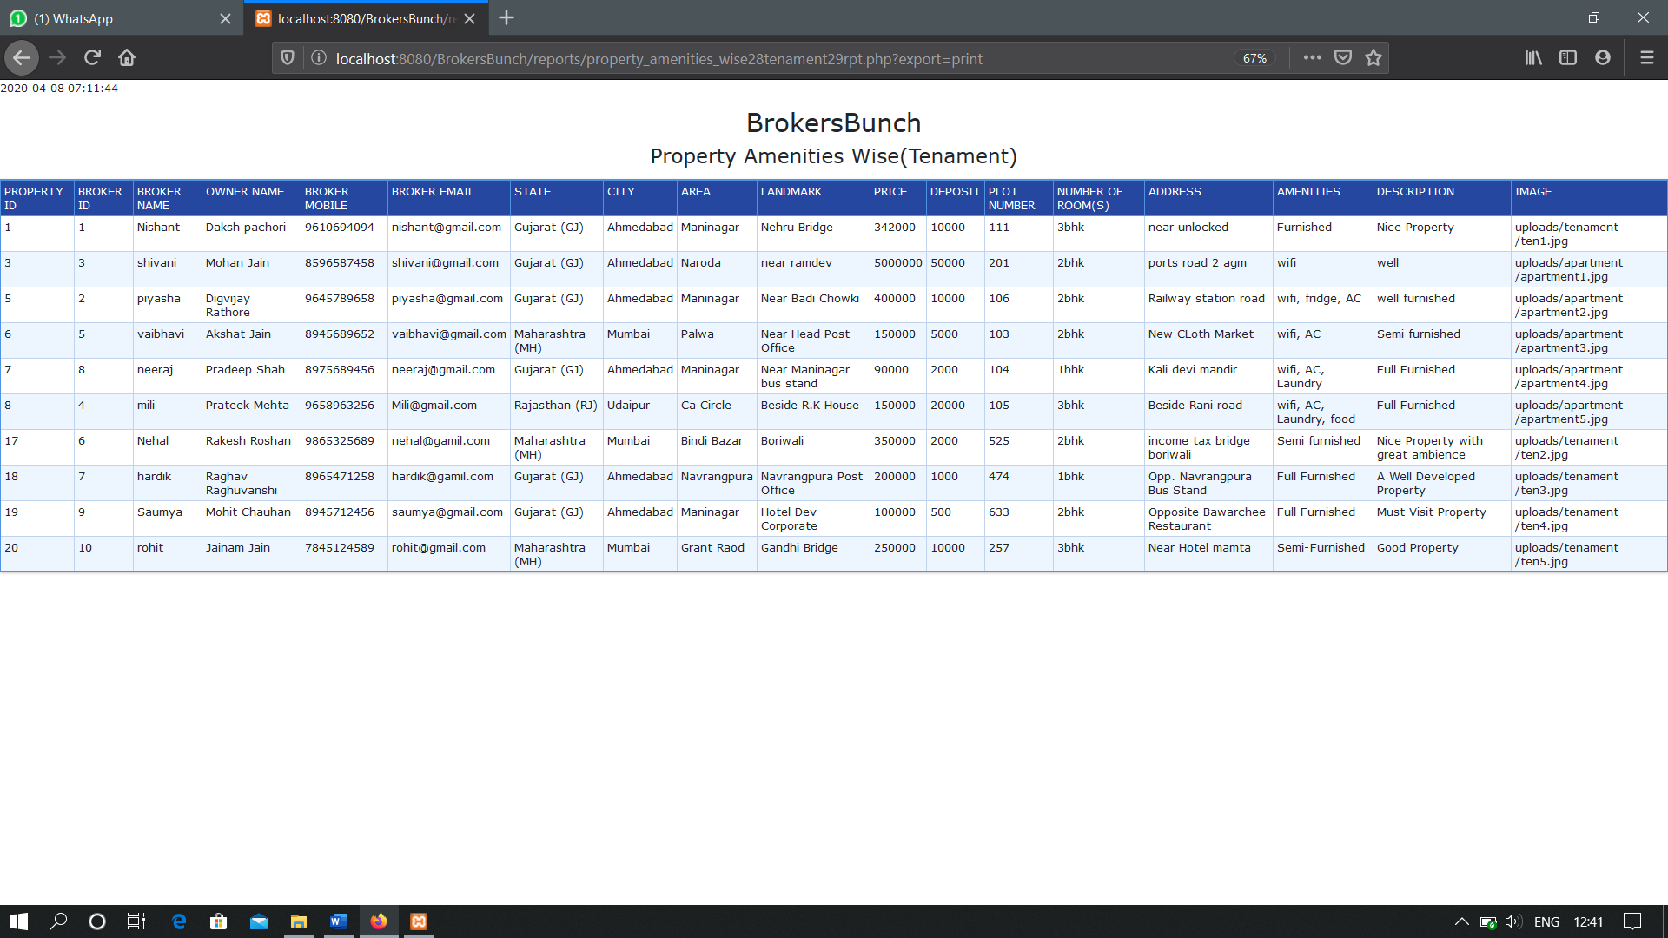**PRINT OPTION**

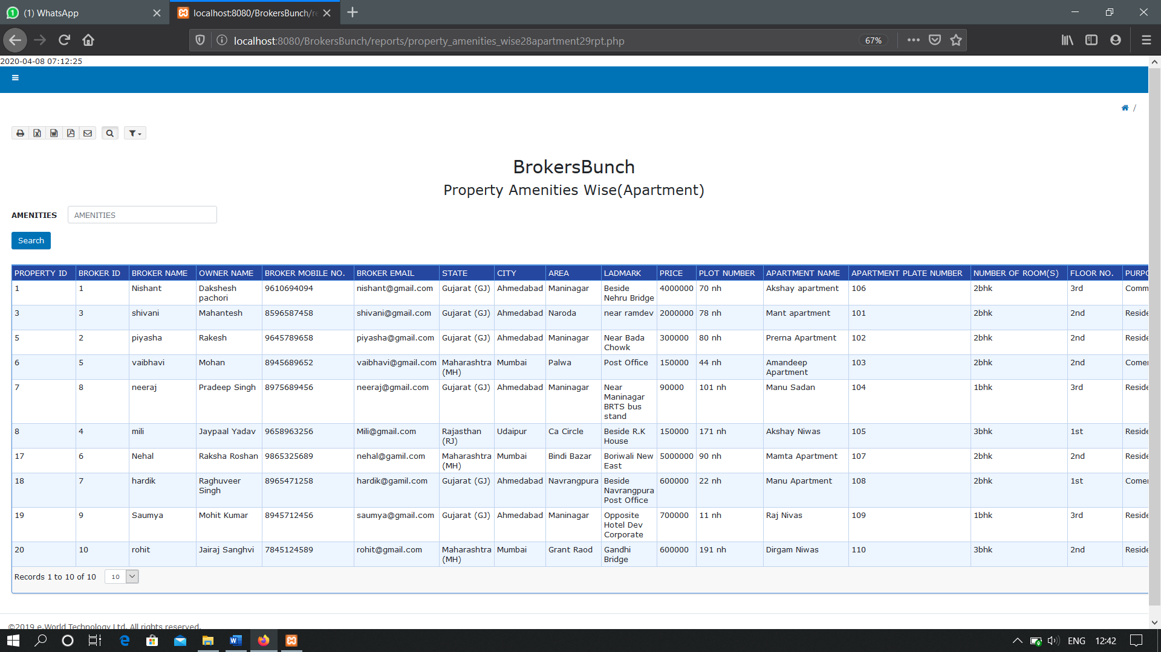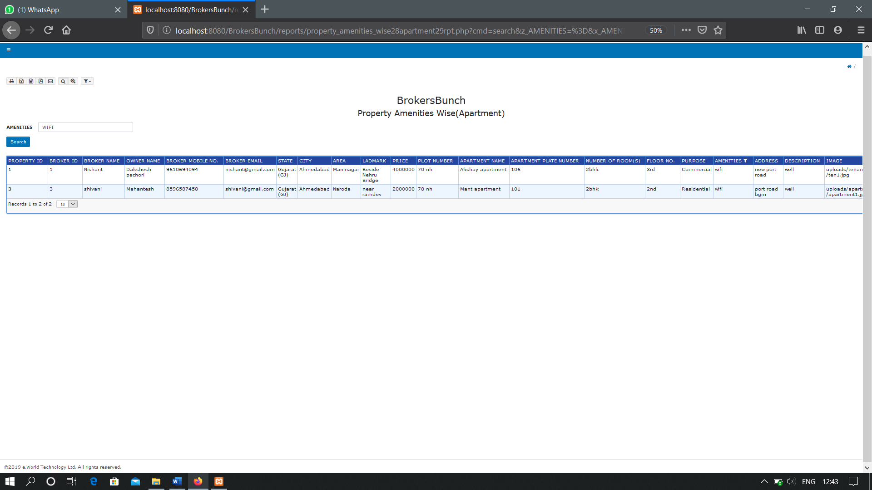**PROPERTY AMENITIES WISE(APARTMENT)**

**WITH FILTER**

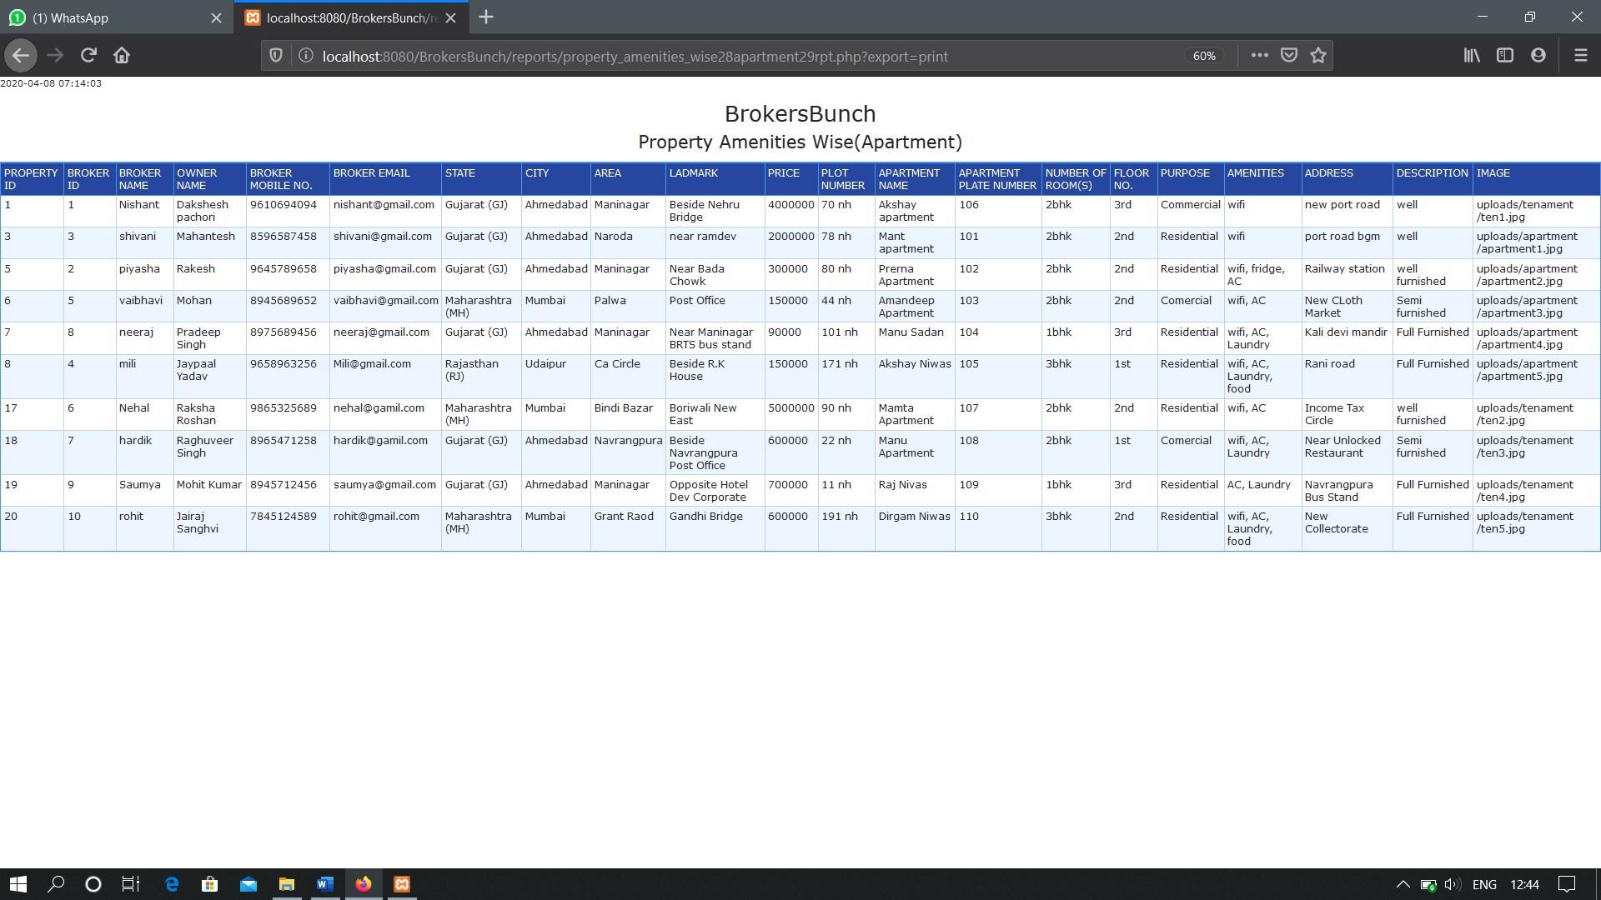**PRINT OPTION**

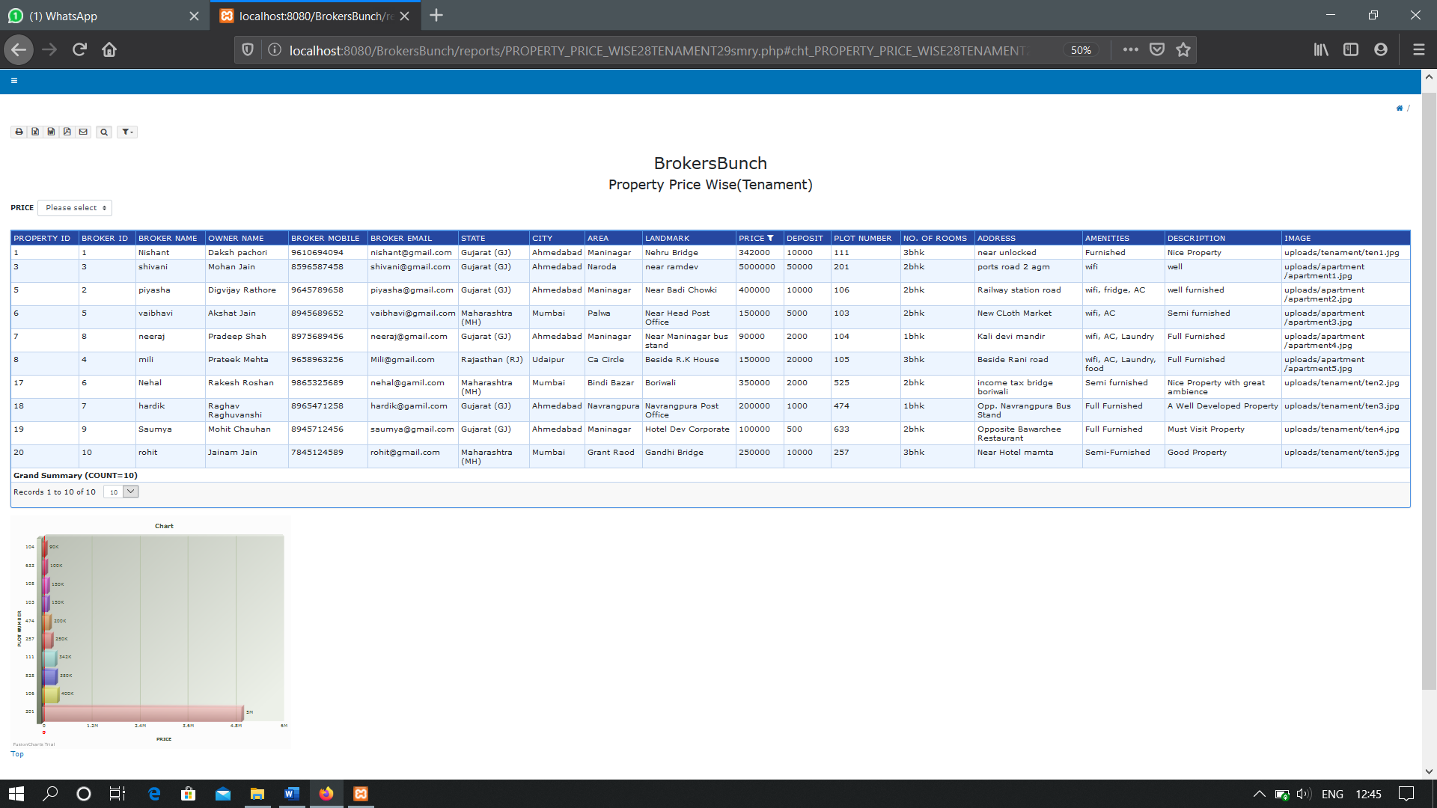**PROPERTY PRICE WISE(TENAMENT) (GRAPHICAL REPRESENTATION)**

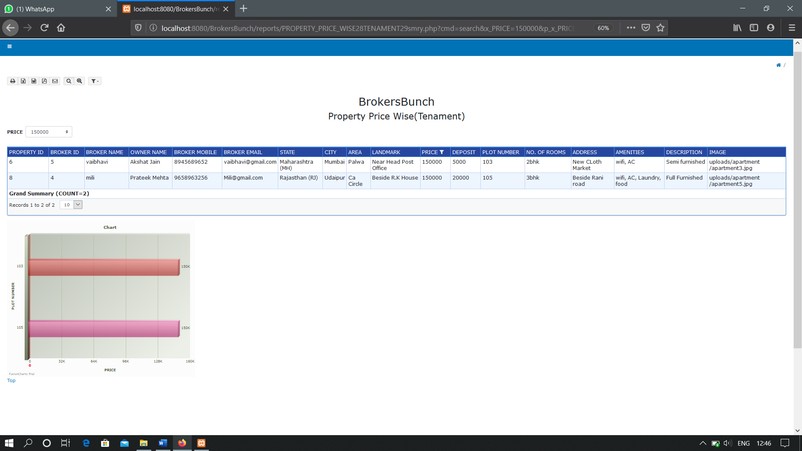**WITH FILTER**

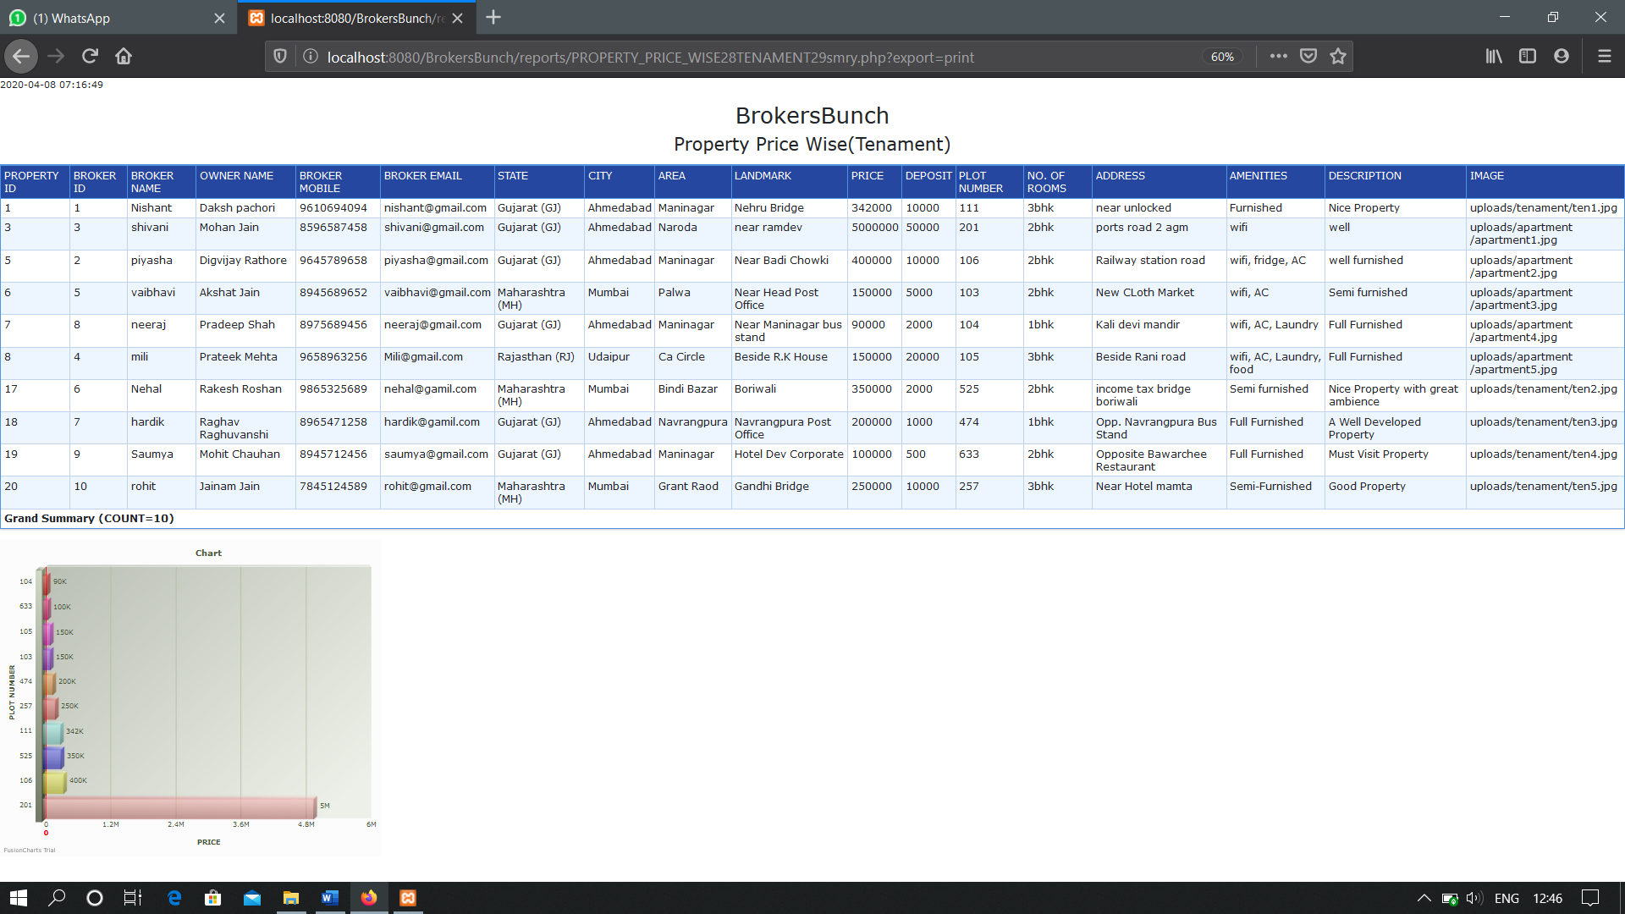**PRINT OPTION**

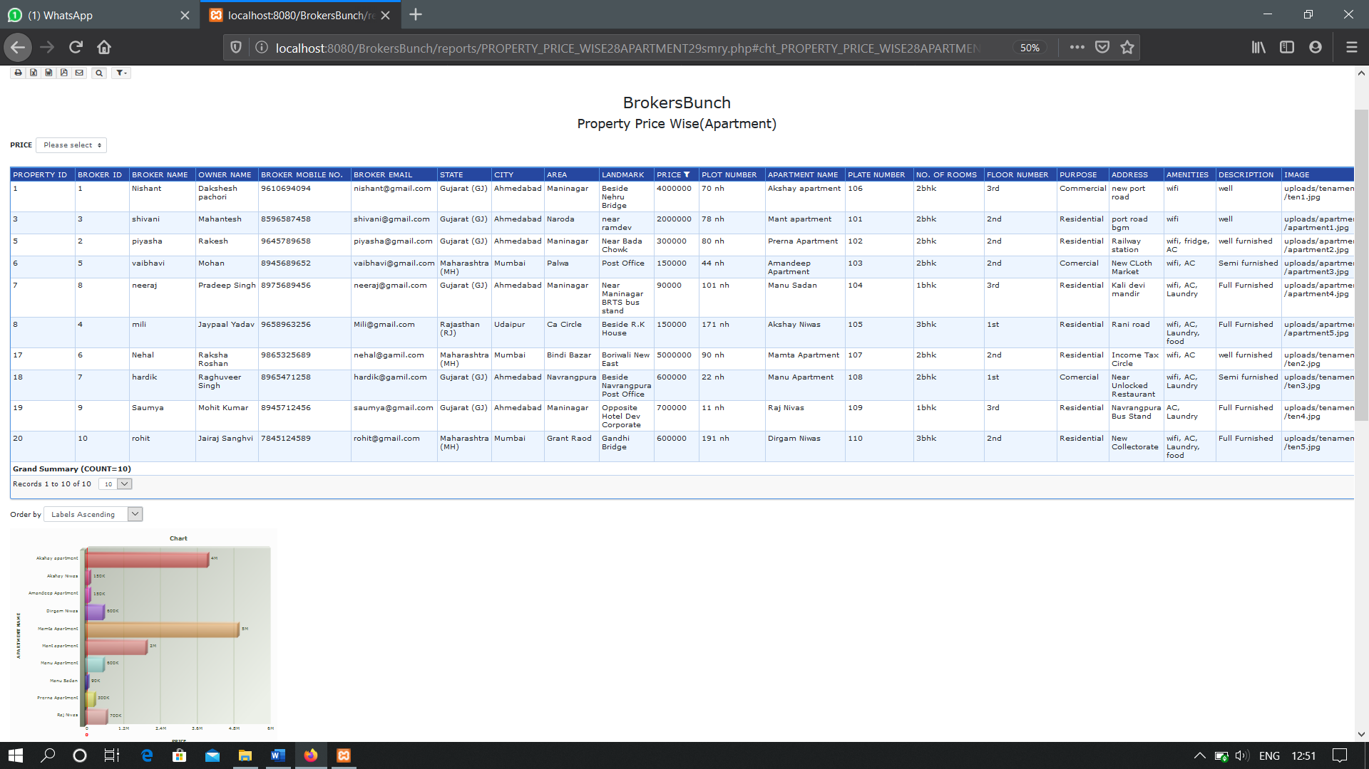**PROPERTY PRICE WISE(APARTMENT)(GRAPHICAL REPRESENTATION)**

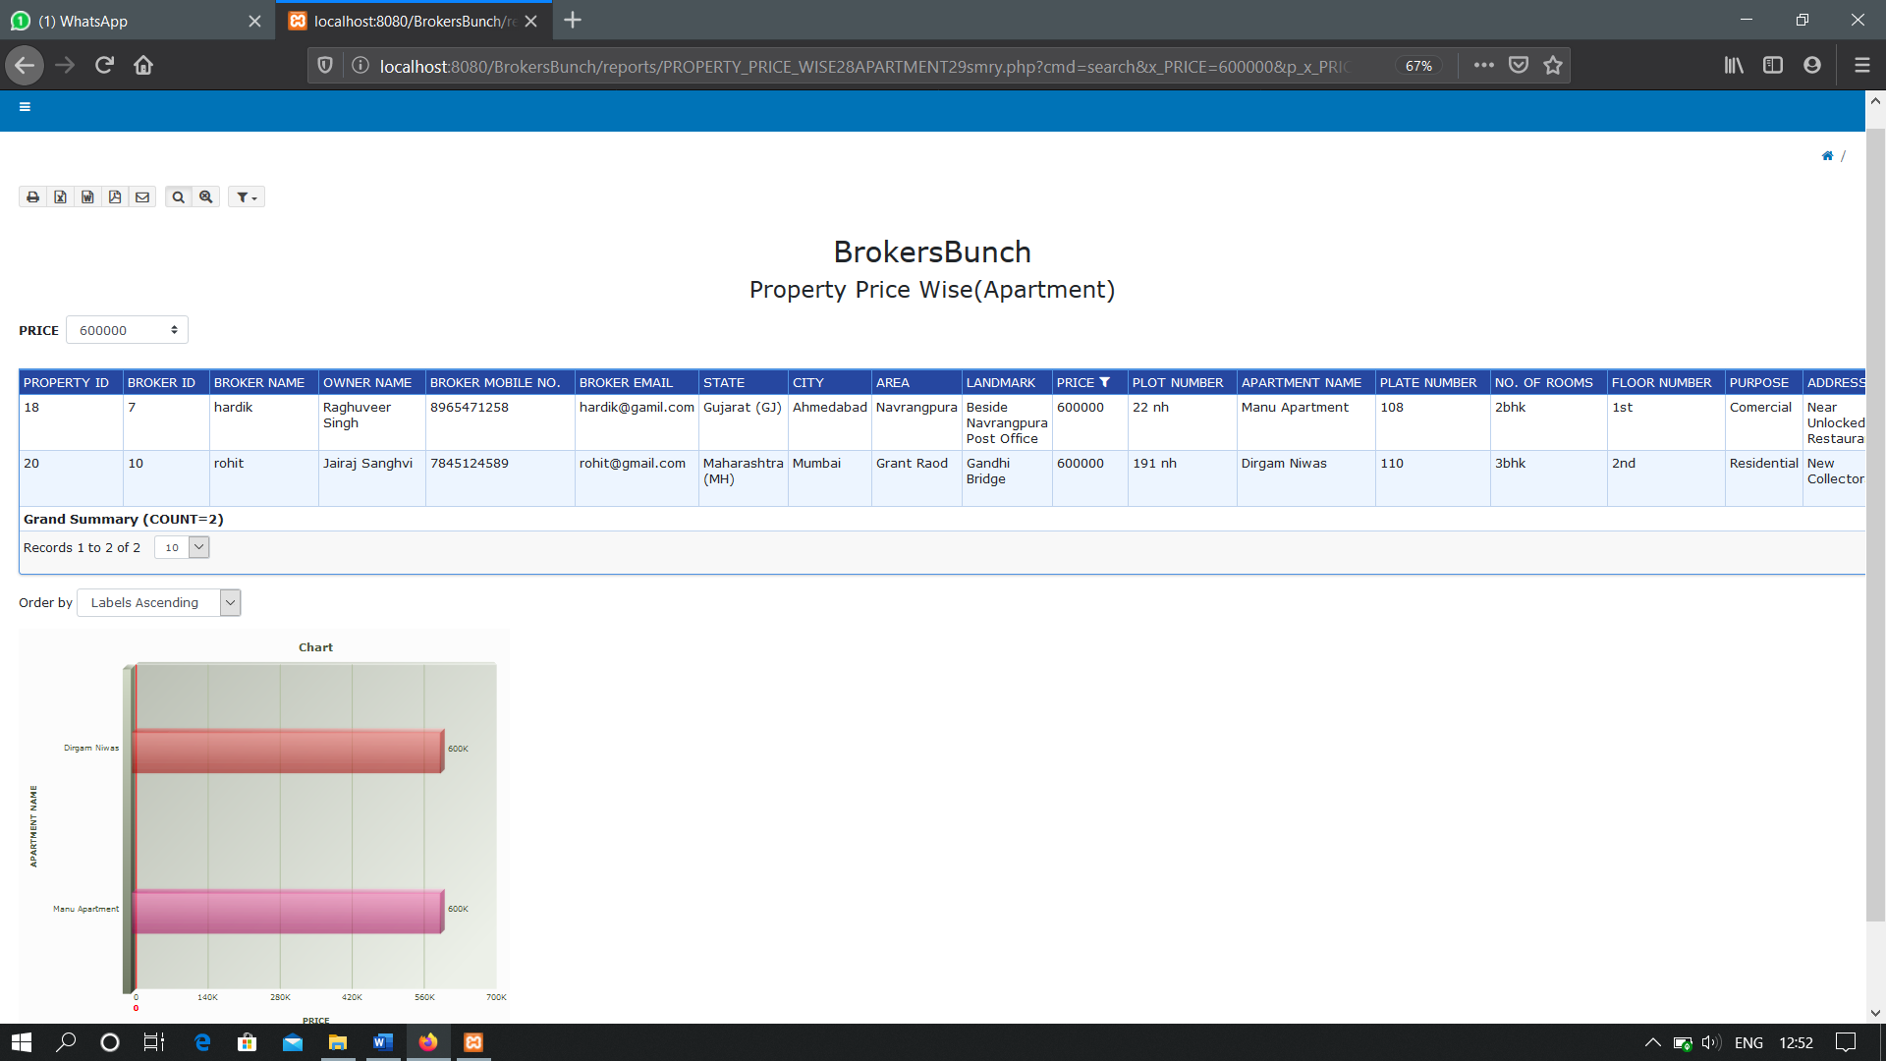**WITH FILTER**

**PRINT OPTION**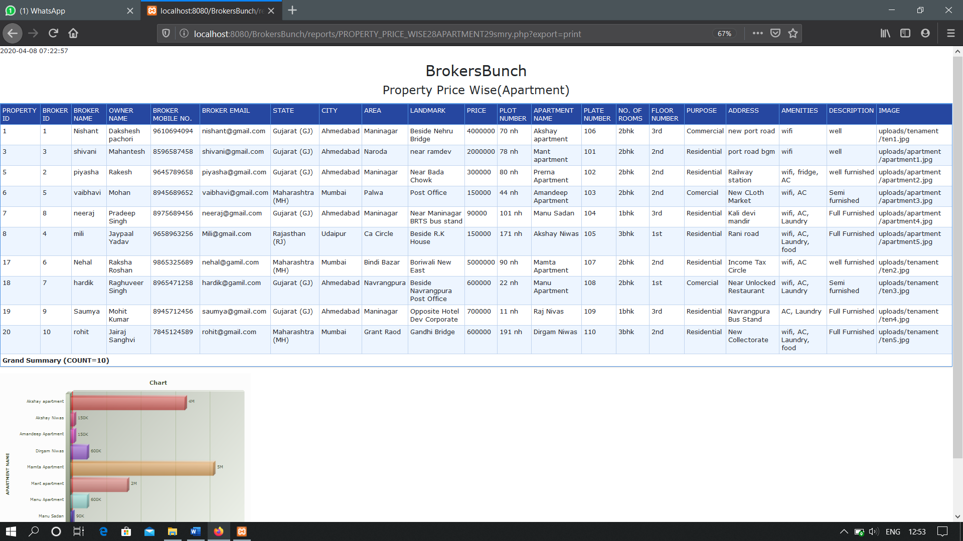

**Conclusion**

The whole duration of this project has been a great learning experience from us. It has introduced us more to the working of the real wold projects and the problems that we face while developing them.

By development of this website, we here by conclude that at BrokersBunch we have achieved our aim at creating a platform where we have created and promoted a healthy environment for the interaction of the community of Brokers and Clients.

We also conclude that our project makes it easy for the Clients to purchase properties and Brokers to list the properties, register themselves on the website as well as clients can book appointment for brokers for different properties.

We also hope to expand the scale of the project and make it ubiquitous by developing it for all digital platforms.

**Bibliography**

**Website references :-**

Tutorials point: www.tutorialspoint.com

W3Schools: www.w3school.com

StackOverflow: www. stackoverflow.com

